



Control of MNCs

________________________________________________________________________________________________________________________________________________________________________________________________________________________________________________________________________________________________________________________________________

**Political influence**

Political influence to control MNC activity

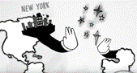

________________________________________________________________________________________________________________________________________________________________________________________________________________________________________________________________________________________________________________________________________

Benefits of the use of political influence to control MNC activity

________________________________________________________________________________________________________________________________________________________________________________________________________________________________________________________________________________________________________________________________________

Drawbacks of the use of political influence to control MNC activity

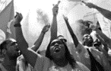

________________________________________________________________________________________________________________________________________________________________________________________________________________________________________________________________________________________________________________________________________

**Legal control**

Legal controls to control MNC activity

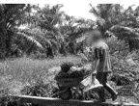

Benefits of the use of legal controls to control MNC activity



McLibel

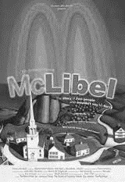

Drawbacks of the use of legal controls to control MNC activity

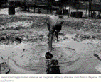

**Pressure groups**

Pressure groups to control MNC activity



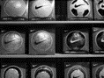



Drawbacks of the use of pressure groups to control MNC activity



**Social media**

Social media to control MNC activity

[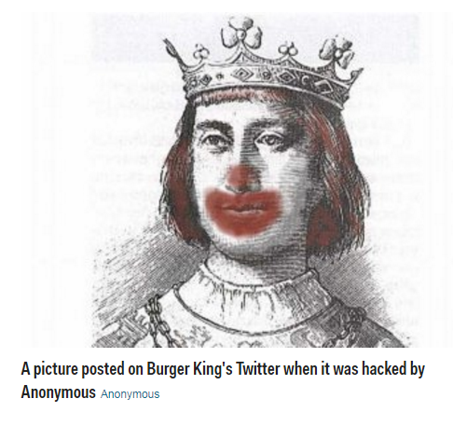](http://www.businessinsider.com/the-top-10-corporate-social-media-disasters-2013-11?IR=T)

Benefits of the use of social media to control MNC activity

________________________________________________________________________________________________________________________________________________________________________________________________________________________________________________________________________________________________________________________________________

Drawbacks of the use of social media to control MNC activity

________________________________________________________________________________________________________________________________________________________________________________________________________________________________________________________________________________________________________________________________________

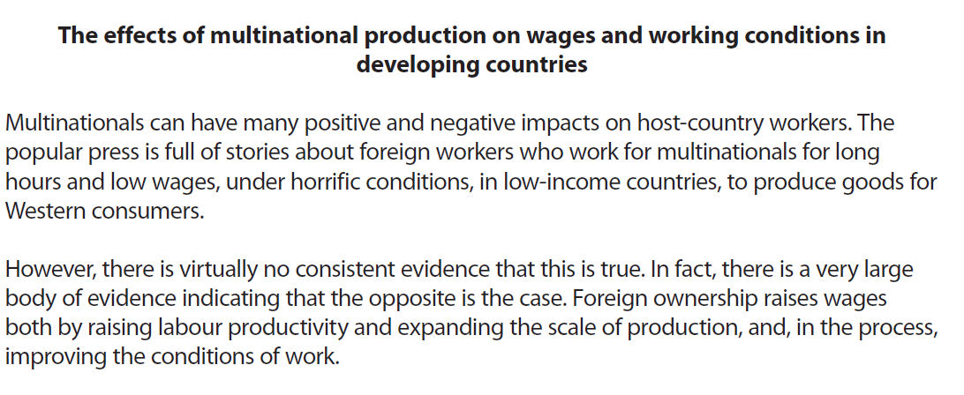

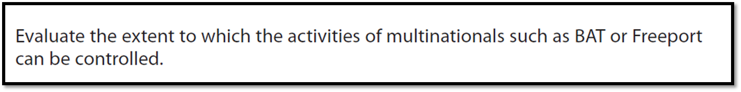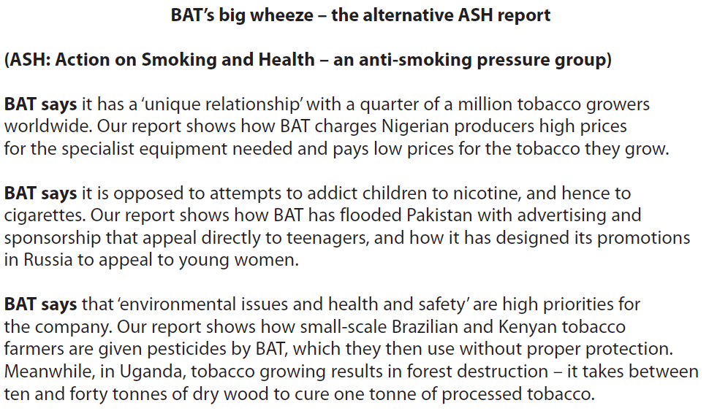

[10]

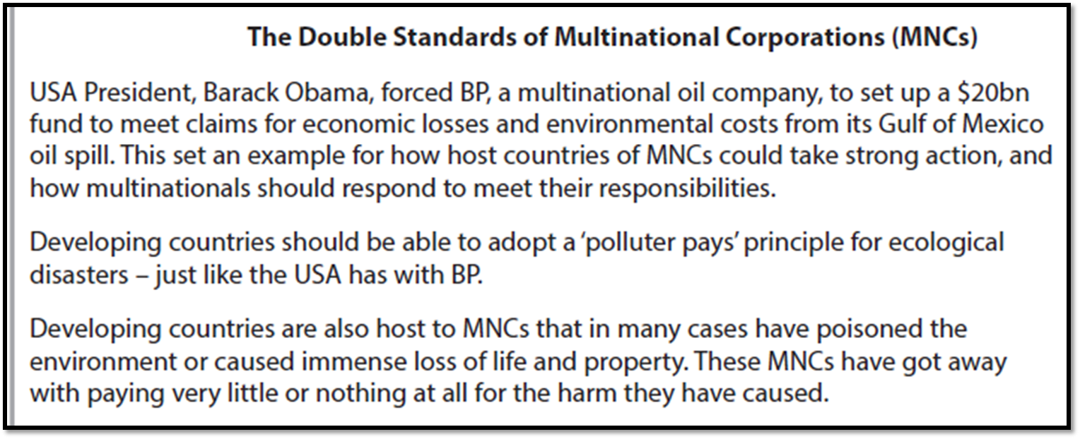

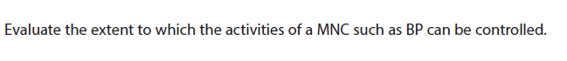

[10]

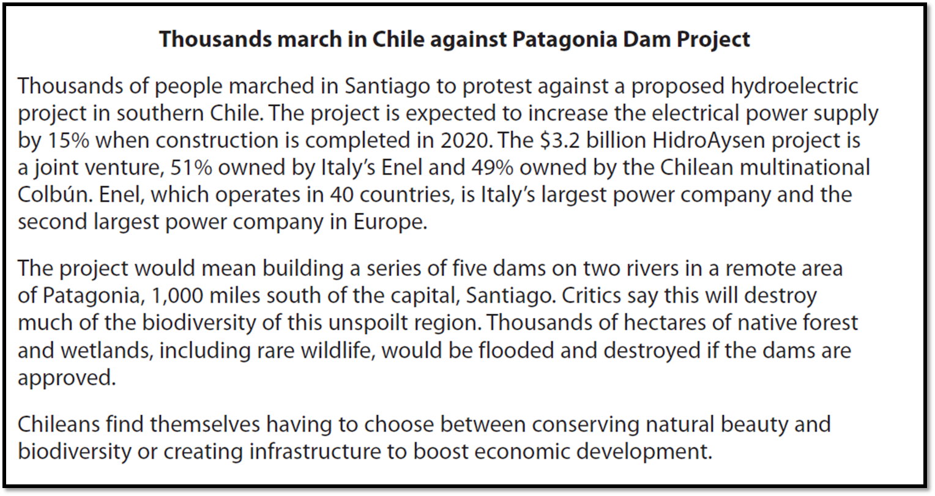

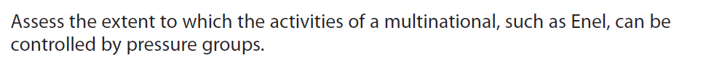

[9]