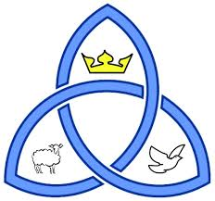**Christianity**

***Key beliefs***

• The nature of God - omnipotent, loving and just, and the

*Religious Studies GCSE*

*Study of*

*Christianity & Buddhism*

problem of evil and suffering the oneness of God and the Trinity:

• Different Christian beliefs about creation including the role of Word

and Spirit (John 1:1–3 and Genesis 1:1–3).

• Different Christian beliefs about the afterlife and their importance,

including: resurrection, judgement, heaven and hell.

***Beliefs and teachings about Jesus Christ and salvation***

• the incarnation and Jesus as the Son of God

• the crucifixion, resurrection and ascension

• sin, including original sin

Beverley High School

bd06662_• the means of salvation, including law, grace and Spirit

• the role of Christ in salvation including the idea of atonement.

***Worship and festivals***

RE Department

• liturgical, non-liturgical and informal, including the use of the Bible

• private prayer, prayer and its significance, including the Lord’s Prayer,

About the course.

You will be studying the AQA Full Course GCSE ‘A’ syllabus. The course includes a study of aspects of two religions and of four philosophical and ethical themes.

You will be invited to share your views and opinions on the issues raised.

You will sit two exams. The course outline covered in this booklet is for paper 1A - The study of two religions

set prayers and informal prayer.

• the meaning of sacrament: the sacrament of baptism and its

significance, the sacrament of eucharist (Holy Communion) and its

significance for Christians, including different ways in which it is

celebrated and different interpretations of its meaning.

• two contrasting examples of Christian pilgrimage: Lourdes and Iona

• the celebrations of Christmas and Easter, including their importance

for Christians in Great Britain today.

***The role of the church in the local and worldwide community***

• The place of mission, evangelism and Church growth.

• The importance of the worldwide Church including: food banks; working

For reconciliation; how Christian churches respond to persecution

• The work of one of the following: CAFOD, Christian Aid, or Tearfund.



***Worship and festivals***

• The nature, use and importance of Buddhist places of worship

including temples, shrines, monasteries (viharas), halls for

meditation or learning (gompas) and their key features including

Buddharupa, artefacts and offerings.

• Puja, the significance and role of puja/devotional ritual in the home

and in the temple, including chanting, both as a devotional practice

and as an aid to mental concentration, mantra recitation, use of

malas.

• Meditation, the different aims, significance and methods of

meditation: Samatha (concentration and tranquillity) including

mindfulness of breathing; Vipassana (insight) including zazen

• the visualisation of Buddhas and Bodhisattvas.

• The practice and significance of different ceremonies and rituals

associated with death and mourning in Theravada communities and

in Japan and Tibet.

• Festivals and retreats and their importance to Buddhists in Great

Britain today, including the celebrations, origins and

significance of Wesak & Parinirvana Day.

***Buddhist ethics***

• Ethical teaching: kamma (karma) and rebirth; compassion (karuna);

loving kindness (metta).

• The five moral precepts

• The six perfections in the Mahayanan tradition: generosity;

morality; patience; energy; meditation; wisdom, including how the

individual develops these perfections within themselves.

**Buddhism**

***Key beliefs***

• The concept of Dhamma (Dharma).

• The concept of dependent arising (paticcasamupada).

• The Three Marks of Existence: anicca (impermanence); anatta (no

fixed self/soul); dukkha (unsatisfactoriness of life, suffering).

• The human personality, in the Theravada and Mahayana traditions:

• Theravada: the Five Aggregates (skandhas) of form, sensation,

perception, mental formations, consciousness

• Mahayana: sunyata, the possibility of attaining Buddhahood and

Buddha-nature.

• Human destiny: different ideals in Theravada and Mahayana

traditions: Arhat (a ‘perfected person’) and Bodhisattva ideals

Buddhahood and the Pure Land.

***The Buddha and the Four Noble Truths***

• The Buddha’s life and its significance:

• the birth of the Buddha and his life of luxury

• the Four Sights: illness, old age, death, holy man

• the Buddha’s ascetic life

• the Buddha’s Enlightenment.

• The Four Noble Truths: 1 suffering (dukkha) including different

types of suffering; 2 the causes of suffering (samudaya), including

the Three Poisons, ignorance, greed and hate; 3 the end of craving

(tanha), interpretations of nibbana (nirvana) and Enlightenment;

4 the Eightfold Path (magga) to nibbana/nirvana; the path as the

Threefold Way: ethics (sila); meditation (samadhi) and wisdom

(panna). Dhammapada 190–191.

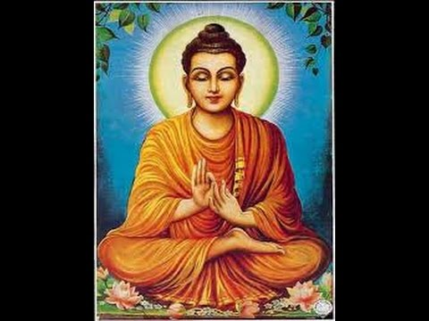



Marking and Assessment during the course.

There will be assessed pieces of work based on exam questions at appropriate times during each unit for which you will be awarded an equivalent GCSE grade. Marking will include comments and targets aimed to help you improve.

For example exam questions and mark schemes go to the following link;

<http://filestore.aqa.org.uk/resources/rs/AQA-80621A-ASQP.PDF>

