

2.1.4 Planning

Starter

Where do you want to be in 3 years’ time?_______________________________________________________________________________________________________________________________________________________________________________________________________________________________________________

In 13 years?______________________________________________________________________________________________________________________________________________________________________________________________________________________________________________

In 30 years?______________________________________________________________________________________________________________________________________________________________________________________________________________________________________________

How far does your plan go?____________________________________________________

Should businesses have a plan?____________________________________________________________________________

Write what you need to know for this unit here:

________________________________________________________________________________________________________________________________________________________________________________________________________________________________________________________________________________________________________________________________________

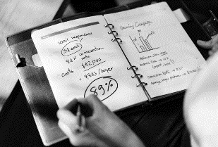Why does a business write a business plan?

________________________________________________________________________________________________________________________________________________________________________________________________________________________________________________________________________________________________________________________________________

Why does a business write a business plan? – continued

________________________________________________________________________________________________________________________________________________________________________________________________________________________________________________________________________________________________________________________________________

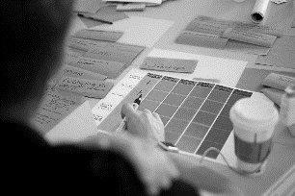What is a business plan?

________________________________________________________________________________________________________________________________________________________________________________________________________________________________________________________________________________________________________________________________________

What’s included on a business plan?

________________________________________________________________________________________________________________________________________________________________________________________________________________________________________________________________________________________________________________________________________

What else goes into a business plan?

|  |  |
| --- | --- |
| A |  |
| B |  |
| C |  |
| D |  |
| E |  |
| F |  |
| G |  |

Purpose of a business plan:

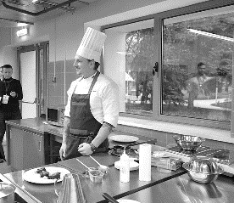#1 To help set up a new business

__________________________________________________________________________________________________________________________________________________________________________________________________________________________________________________________________________________________________________________________________________________________________________________________________________________________

#2 To help the business raise finance

__________________________________________________________________________________________________________________________________________________________________________________________________________________________________________________________________________________________________________________________________________________________________________________________________________________________

#2 To help the business raise finance continued

__________________________________________________________________________________________________________________________________________________________________________________________________________________________________________________________________________________________________________________________________________________________________________________________________________________________

[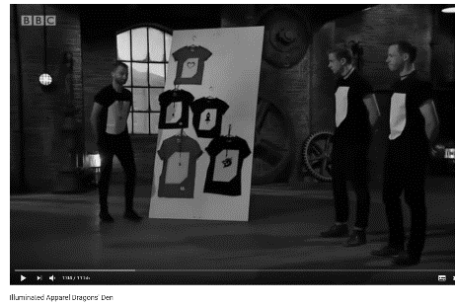](https://www.youtube.com/watch?v=k29hafxR1so)

#2 To help the business raise finance by negotiating

__________________________________________________________________________________________________________________________________________________________________________________________________________________________________________________________________________________________________________________________________________________________________________________________________________________________

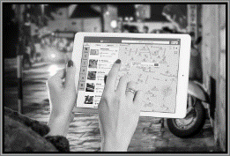#3 To help the business to set objectives

__________________________________________________________________________________________________________________________________________________________________________________________________________________________________________________________________________________________________________________________________________________________________________________________________________________________

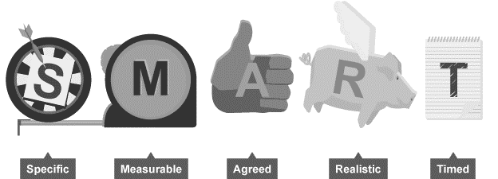#3 To help the business to set objectives - SMART

_________________________________________________________________________________________________________________________________________________________________________________________________________________________________________________________________________________________________________________________________________________________________________________________________________________________

#4 To outline how functions of the business will be organised

__________________________________________________________________________________________________________________________________________________________________________________________________________________________________________________________________________________________________________________________________________________________________________________________________________________________

What is a cash flow forecast

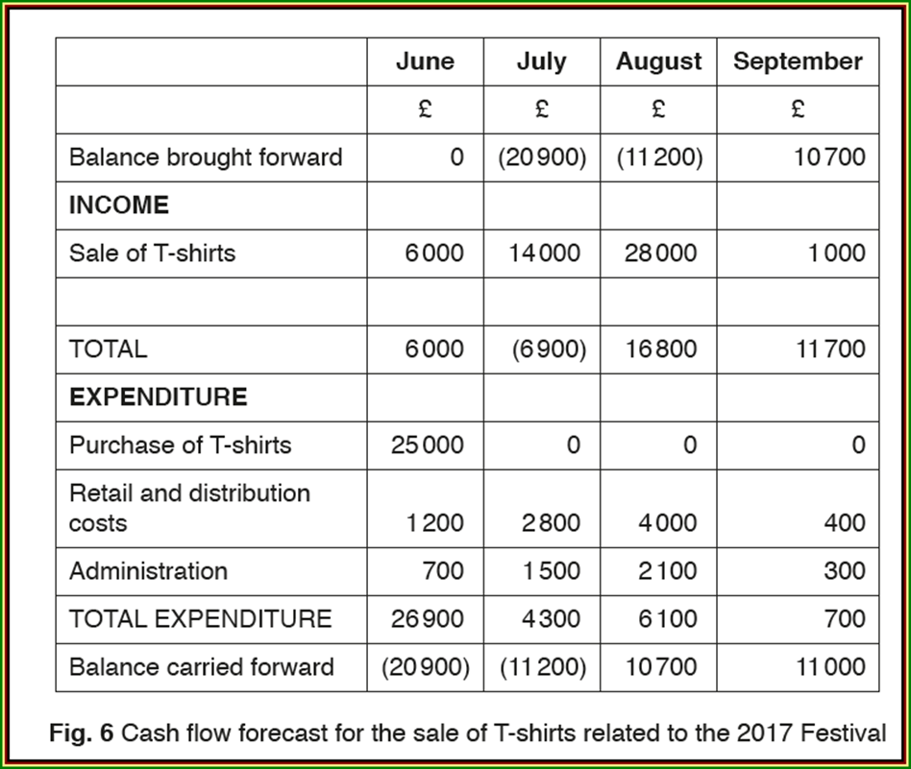

Cash inflow (income)

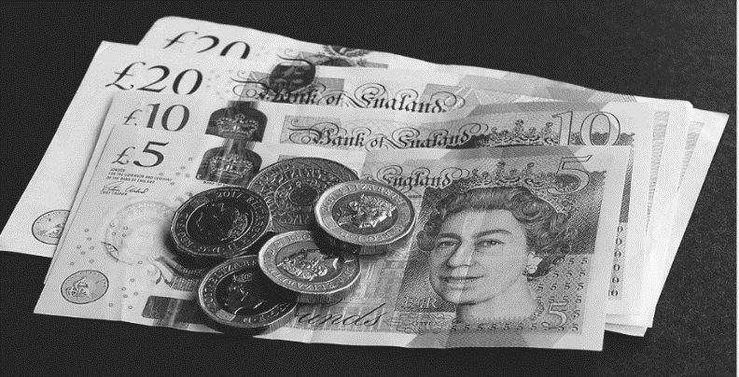

__________________________________________________________________________________________________________________________________________________________________________________________________________________________________________________________________________________________________________________________________________________________________________________________________________________________

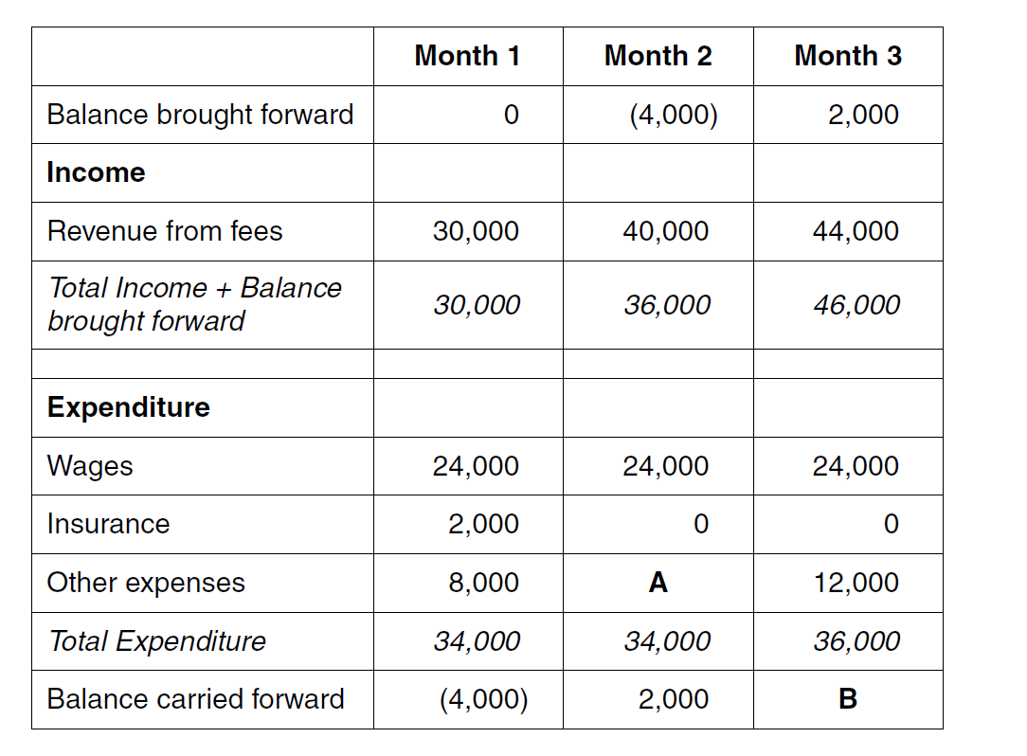

Highlight your diagram to show:

1. Income
2. Expenditure
3. Opening and closing balances

Now:

1. Calculate A and B

Example question:

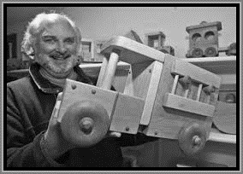About Bob:

__________________________________________________________________________________________________________________________________________________________________________________________________________________________________________________________________________________________________________________________________________________________________________________________________________________________

|  |  |  |  |  |  |  |
| --- | --- | --- | --- | --- | --- | --- |
| Cash Flow Forecast – Bob’s Wooden Toy Shop | | | | | | |
|  | **October**  **£** | **November**  **£** | **December**  **£** | **January**  **£** | **February**  **£** | **March**  **£** |
| **Total Receipts (cash inflow)** | 14,000 | 14,000 | 50,000 | 1,000 | 1,000 | 1,000 |
| **Total Payments**  **(Cash outflow)** | 20,000 | 20,000 | 20,000 | 20,000 | 20,000 | 20,000 |
| **Balance at start of month** | 1,000 |  |  |  |  |  |
| **Balance at end of month** |  |  |  |  |  |  |

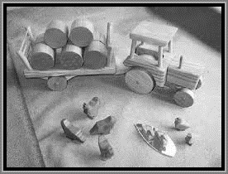Interpretation of Bob’s cash flow forecast

__________________________________________________________________________________________________________________________________________________________________________________________________________________________________________________________________________________________________________________________________________________________________________________________________________________________

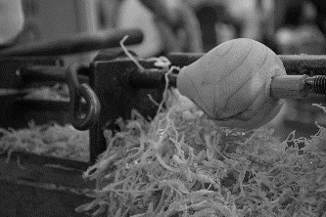More feedback for Bob

__________________________________________________________________________________________________________________________________________________________________________________________________________________________________________________________________________________________________________________________________________________________________________________________________________________________

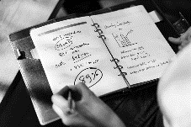Uses of cash flow forecasts

* A business will prepare a cash flow _________________ to help control and __________________ cash in and out of a business;
  + At years ________________ the business can make _______________________ between the predicted inflows and outflows and what actually ____________________________
  + Shows the business owner where likely cash ___________________ and _____________________ are so they can arrange suitable finance e.g. an overdraft with bank
* A good cash flow forecast may help the owner to secure a better _________________ on their finance e.g. lower rate __________________

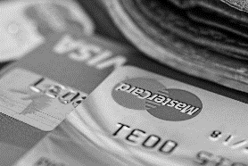Limitations of cash flow forecasts

* A cash flow forecast is only a 12-month __________________ which is very short term to make any ______________________ decisions about the business, they may need longer term finance
* This is only a forecast – an __________________ actual sales or expenses might be higher
* The owner may have overstated _____________________ or understated income

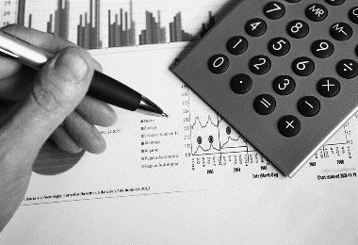Limitations of cash flow forecasts continued

* The cash flow forecast is not about ___________________ it is only about the cash in the business to meet the short-term _______________________.
* To get a full picture the business would need to show a statement of comprehensive income and a _________________________ of financial position
* It could be very risky for an _____________________ to make decisions about the business on just the cash flow forecast alone

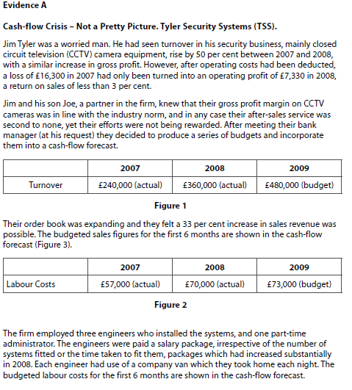



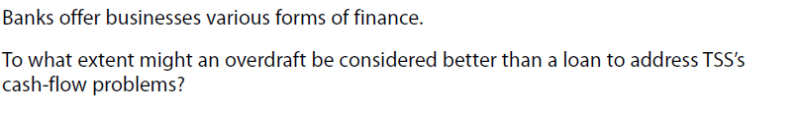

[8]

