

2.1.1 Internal Finance

Write a definition of finance here:

________________________________________________________________________________________________________________________________________________________________________________________________________________________________________________________________________________________________________________________________________

Reasons for raising finance:

|  |  |
| --- | --- |
| A |  |
| B |  |
| C |  |
| D |  |
| E |  |

**Owner’s capital: personal savings**

Owners capital





When is Owner’s Capital appropriate?

**Retained profit**

Retained profit

When is retained profit appropriate?



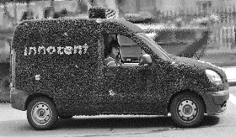Sale of assets

Sale of assets

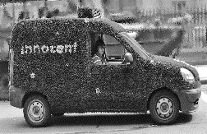

When is the sale of assets appropriate?



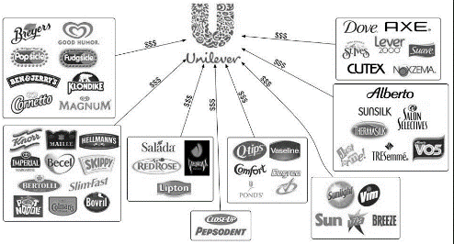Advantages of selling assets

____________________________________________________________________________________________________________________________________________________________________________________________________________________________________________________________________________________________________________________________________________________________________________________________________________________________________________________________________________________________________________

Disadvantages of selling assets

____________________________________________________________________________________________________________________________________________________________________________________________________________________________________________________________________________________________________________________________________________________________________________________________________________________________________________________________________________________________________________

|  |  |  |
| --- | --- | --- |
| Internal source of finance | Advantage | Disadvantage |
| Retained profit |  |  |
| Sale of assets |  |  |
| Owners equity |  |  |





