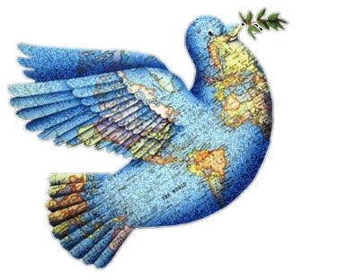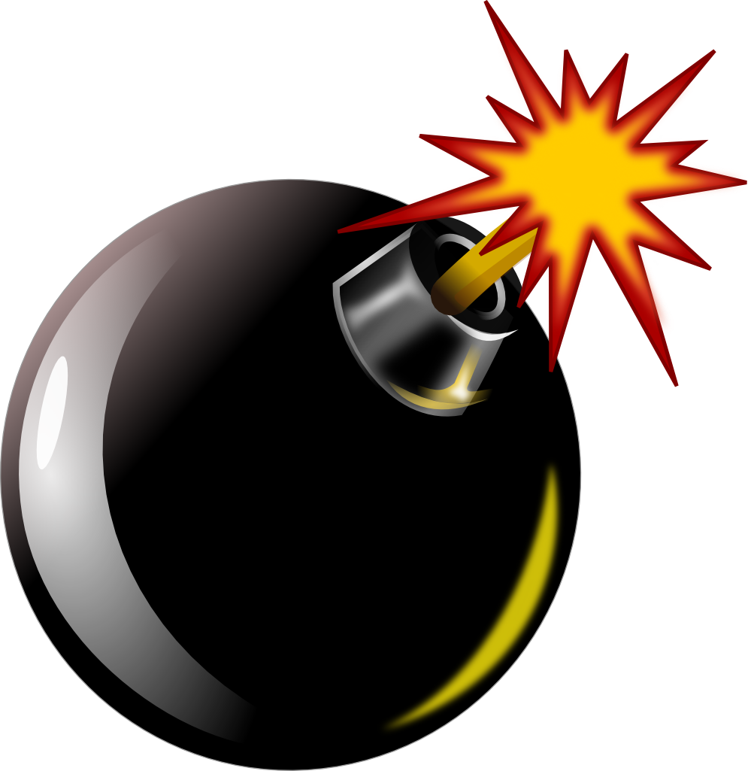

GCSE: Religion, Peace & Conflict – Key Terms.

|  |  |
| --- | --- |
| **Word/Term** | **Definition** |
| Peace |  |
| Justice |  |
| Forgiveness |  |
| Reconciliation |  |
| Pacifism |  |
| Conflict |  |
| Holy War |  |
| Just War |  |
| WMDs |  |
| Nuclear Weapons |  |
| Nuclear Deterrence |  |
| Quakers |  |
| Dalai Lama |  |
| Civil War |  |
| Conscientious Objector |  |
| Conventional Warfare |  |
| Retaliation |  |
| Terrorism |  |