

1.5.2 Entrepreneurial

motives and characteristics

Starter

* What skills do you have? Can you sew, sing, play an instrument, juggle, drive, grow plants, write songs etc?
* What motives do you have in life? Are you motivated by your family, your friends, money, status in life?
* Are **motives** and **characteristics** the same thing?

Write a definition of entrepreneur here:

________________________________________________________________________________________________________________________________________________________________________________________________________________________________________________________________________________________________________________________________________

Write a definition of entrepreneurial characteristics here:

________________________________________________________________________________________________________________________________________________________________________________________________________________________________________________________________________________________________________________________________________

Write a definition of entrepreneurial motives here:

________________________________________________________________________________________________________________________________________________________________________________________________________________________________________________________________________________________________________________________________________

Entrepreneurial characteristics

|  |  |  |
| --- | --- | --- |
| #1 Creativity |  |  |
| #2 Hard-work |  |  |
| #3 Resilience | Image result for karen jonga |  |
| #4 Initiative |  |  |
| #5 Self-confidence | Image result for levis roots |  |
| #6 Risk-taking |  |  |

Entrepreneurial skills

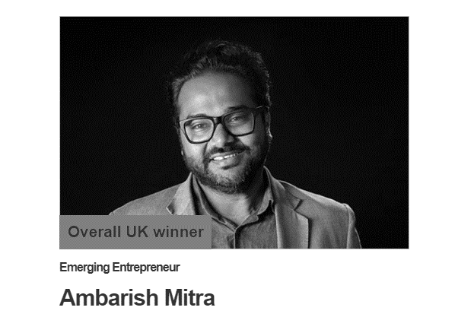

#1 communication

________________________________________________________________________________________________________________________________________________________________________________________________________________________________________________________________________________________________________________________________________

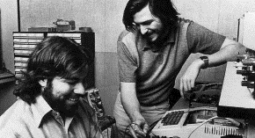#2 Team-working

________________________________________________________________________________________________________________________________________________________________________________________________________________________________________________________________________________________________________________________________________

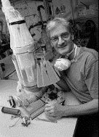#3 Problem solving

________________________________________________________________________________________________________________________________________________________________________________________________________________________________________________________________________________________________________________________________________

[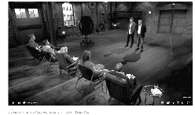](https://www.youtube.com/watch?v=Lodig6J0iMU)#4 Organisation

________________________________________________________________________________________________________________________________________________________________________________________________________________________________________________________________________________________________________________________________________

[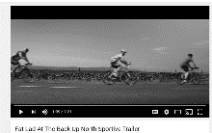](https://www.youtube.com/watch?v=yVGHRXFf5B0)#5 Numeracy

________________________________________________________________________________________________________________________________________________________________________________________________________________________________________________________________________________________________________________________________________

[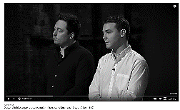](https://www.youtube.com/watch?v=nJ4qA-S-KmE)#6 IT

________________________________________________________________________________________________________________________________________________________________________________________________________________________________________________________________________________________________________________________________________

Profit maximisation

Profit satisficing

Non – financial motives

#1 Independence

#2 Flexibility

#3 Ethical Reasons

#4 Social Purpose

#5 Personal Challenge

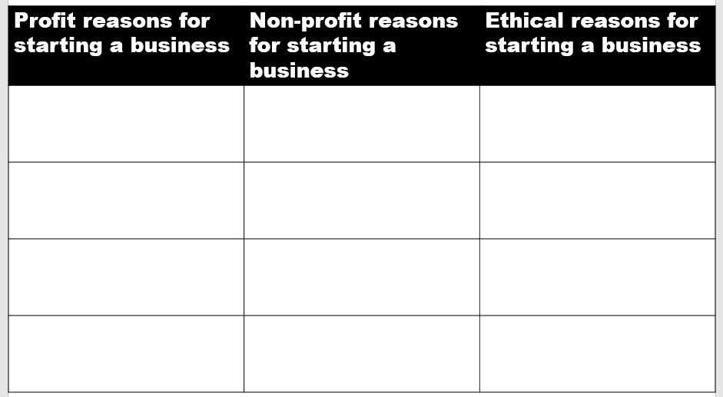

Motivations are NOT characteristics

|  |  |
| --- | --- |
| Characteristics | Motivations |
|  |  |

