

3.5.2 Ratio Analysis

Starter – how much did you remember?

|  |  |  |  |  |
| --- | --- | --- | --- | --- |
|  |  | |  | |
|  |  | |  | |
|  |  |  |  |  |
|  |
|  |  | |  | |
|  |  | |  | |
|  |  | |
|  |  | |  | |
|  |
|  |

Write a definition of ratios here:

________________________________________________________________________________________________________________________________________________________________________________________________________________________________________________________________________________________________________________________________________

Current ratio formula:

Notes:

________________________________________________________________________________________________________________________________________________________________________________________________________________________________________________________________________________________________________________________________________

Current ratio explained

________________________________________________________________________________________________________________________________________________________________________________________________________________________________________________________________________________________________________________________________________

Current ratio example calculation – use this data:

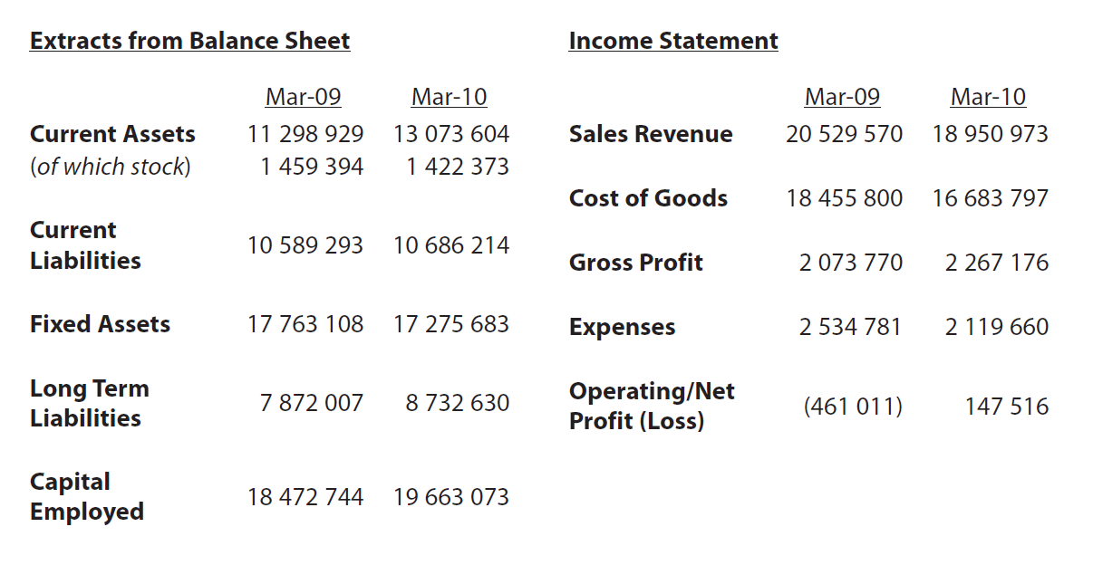

|  |  |  |
| --- | --- | --- |
|  | **2009** | **2010** |
| Current Assets |  |  |
| Current Liabilities |  |  |
| Current Ratio |  |  |

Acid test ratio formula:

Notes:

________________________________________________________________________________________________________________________________________________________________________________________________________________________________________________________________________________________________________________________________________

Acid test ratio explained

________________________________________________________________________________________________________________________________________________________________________________________________________________________________________________________________________________________________________________________________________

Acid test ratio example calculation – use this data:



|  |  |  |
| --- | --- | --- |
|  | **2009** | **2010** |
| Current Assets |  |  |
| Current Liabilities |  |  |
| Stock |  |  |
| Acid test Ratio |  |  |

Gearing ratio formula:

Notes:

________________________________________________________________________________________________________________________________________________________________________________________________________________________________________________________________________________________________________________________________________

Gearing ratio explained

________________________________________________________________________________________________________________________________________________________________________________________________________________________________________________________________________________________________________________________________________

Gearing test ratio example calculation – use this data:



|  |  |  |
| --- | --- | --- |
|  | **2009** | **2010** |
| Long Term Liabilities |  |  |
| Capital Employed |  |  |
| Gearing Ratio |  |  |

ROCE ratio formula:

Notes:

________________________________________________________________________________________________________________________________________________________________________________________________________________________________________________________________________________________________________________________________________

ROCE ratio explained

________________________________________________________________________________________________________________________________________________________________________________________________________________________________________________________________________________________________________________________________________

ROCE ratio example calculation – use this data:



|  |  |  |
| --- | --- | --- |
|  | **2009** | **2010** |
| Operating Profit or loss |  |  |
| Capital Employed |  |  |
| ROCE ratio |  |  |

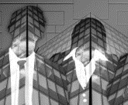Ratio limitations

________________________________________________________________________________________________________________________________________________________________________________________________________________________________________________________________________________________________________________________________________

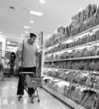Ratio limitations continued

________________________________________________________________________________________________________________________________________________________________________________________________________________________________________________________________________________________________________________________________________

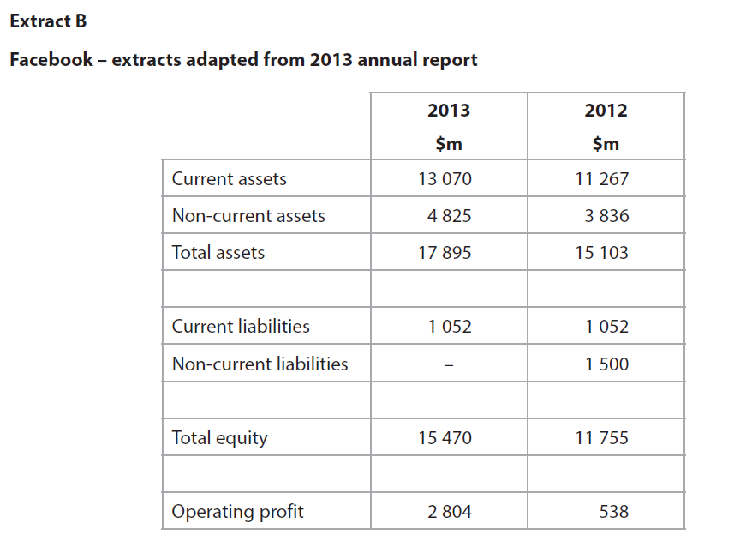

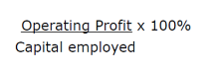

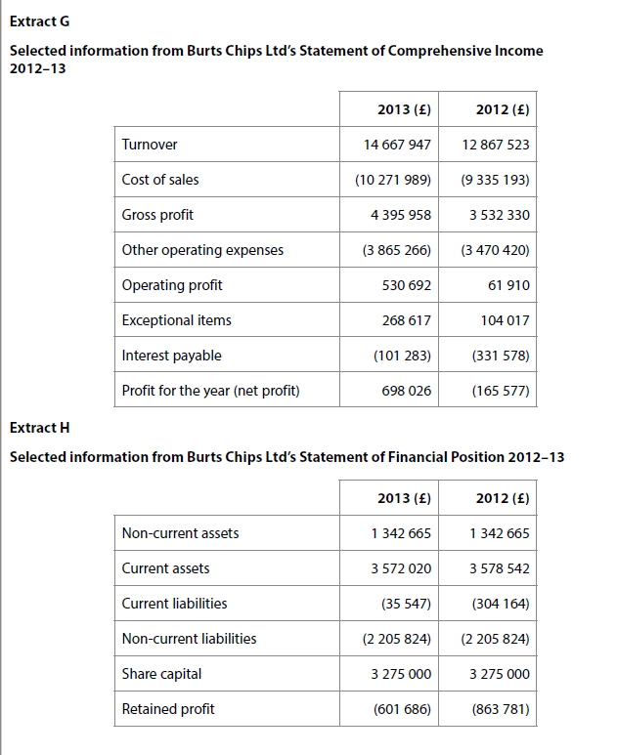

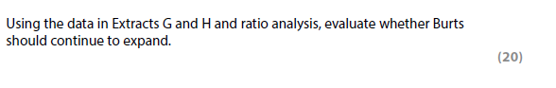

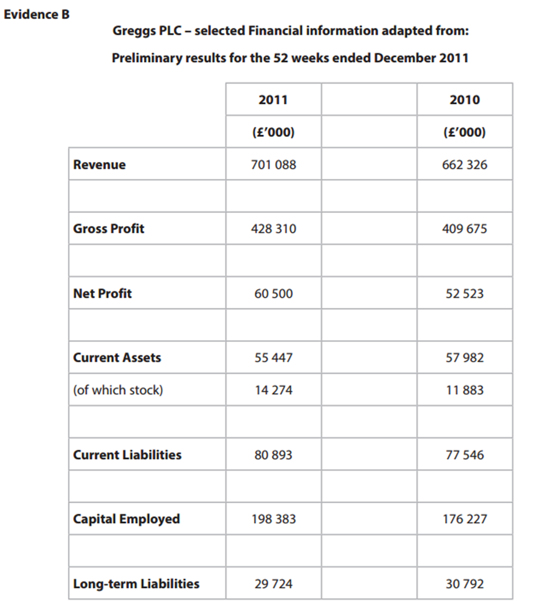



[4]



[4]



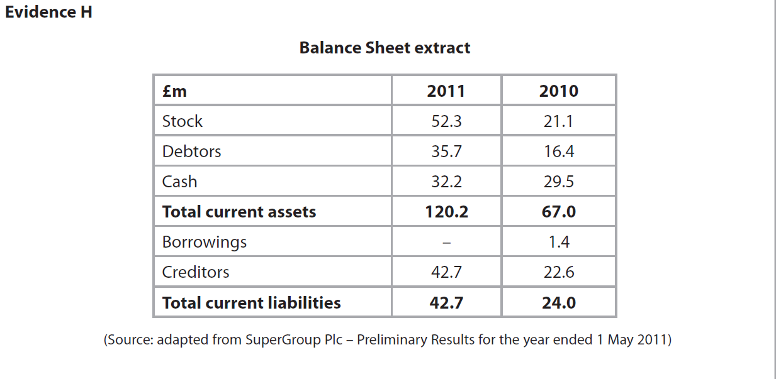

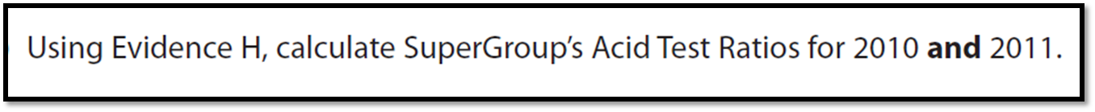

[4]

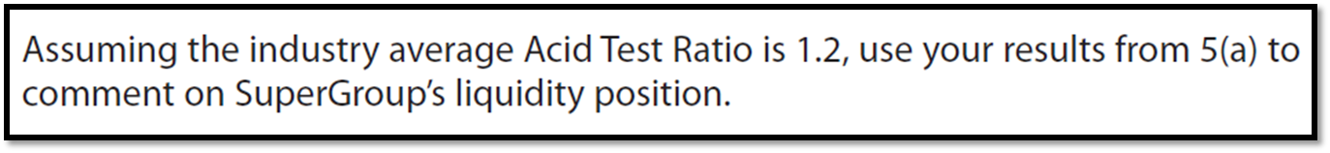

[4]