**Topic 9**

**The impacts of economic cycles and demographic changes**

**Learning outcomes**

After studying this topic, you will be able to:

* outline the short-term and long-term effects of economic cycles; and
* Understand the impact of demographic changes on personal finance.

**Introduction**

There are a number of economic and social factors that can affect personal finance.

Changes in the economy over time can be unforeseen and thus difficult to plan for. These movements in the economy are called ‘economic cycles’. It can very difficult to predict how an economy is going to perform in the future; events such as the financial crisis in 2008 and Brexit in 2012 can change the economic landscape overnight. This makes it very difficult to plan for the long term. Trying to plan for an uncertain future can make personal financial decisions more difficult in terms of investing, saving and borrowing, and makes ‘saving for a rainy day’ more important.

**Example** – Suppose you take out a loan with a variable interest rate during times of strong economic growth and low interest rates. An economic crisis arrives unexpectedly and interest rates are increased. Mortgage and loan repayment costs increase and you are now struggling to afford these repayments. At this point, you wish that you had an emergency fund put aside to cover this financial difficulty. **It is a fact that house repossessions will increase when interest rates rise suddenly.**

**First-time buyers**

The Office of National Statistics say that the average house price for first-time buyers was **£184,973** in December 2016, which is an annual increase of 7%.

According to the Council of Mortgage Lenders (CML), the typical first-time buyer deposit in January was 15.7% (around **£28,552**) – 108% of an average salary. **The average first-time buyer borrowed** 3.45 times their income and the average first-time buyer loan was an estimated **£132,400**.

[Interest rates over time](http://www.independent.co.uk/news/business/news/uk-interest-rates-hike-how-mortgage-savings-loans-how-change-effect-household-personal-finance-a8033716.html)

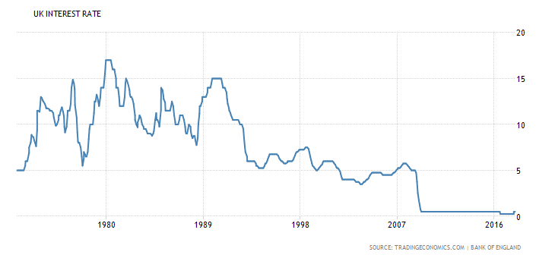

[Link to mortgage calculator](https://www.moneysavingexpert.com/mortgages/mortgage-rate-calculator)

**Calculations**

**Mortgage = £132,400**

**Duration = 25 year**

**Repayment type**

1. Calculate the monthly repayment when **IR’s are at 2.5%**

**Answer =**

1. Calculate the monthly repayment when IR’s are at levels seen in the 2000’s – 5%

**Answer =**

1. Calculate the monthly repayment when IR’s are at levels seen in the 1980’s – 10%

**Answer =**

1. Describe the effect on monthly mortgage repayments if IR’s increase from 2.5% to 10%. Please note that IR’s did reach 18% in the 1980’s.

**9.1 Economic cycles**

An ‘economic cycle’ is a repeating pattern of economic growth and decline. The pattern is predictable, although the timing of the peaks and troughs, and how large these peaks and troughs will be, are not. The economy tends to follow a general upward trend despite some dips along the way. The cycle tends to go up and down in a pattern, as illustrated in Figure 9.1.

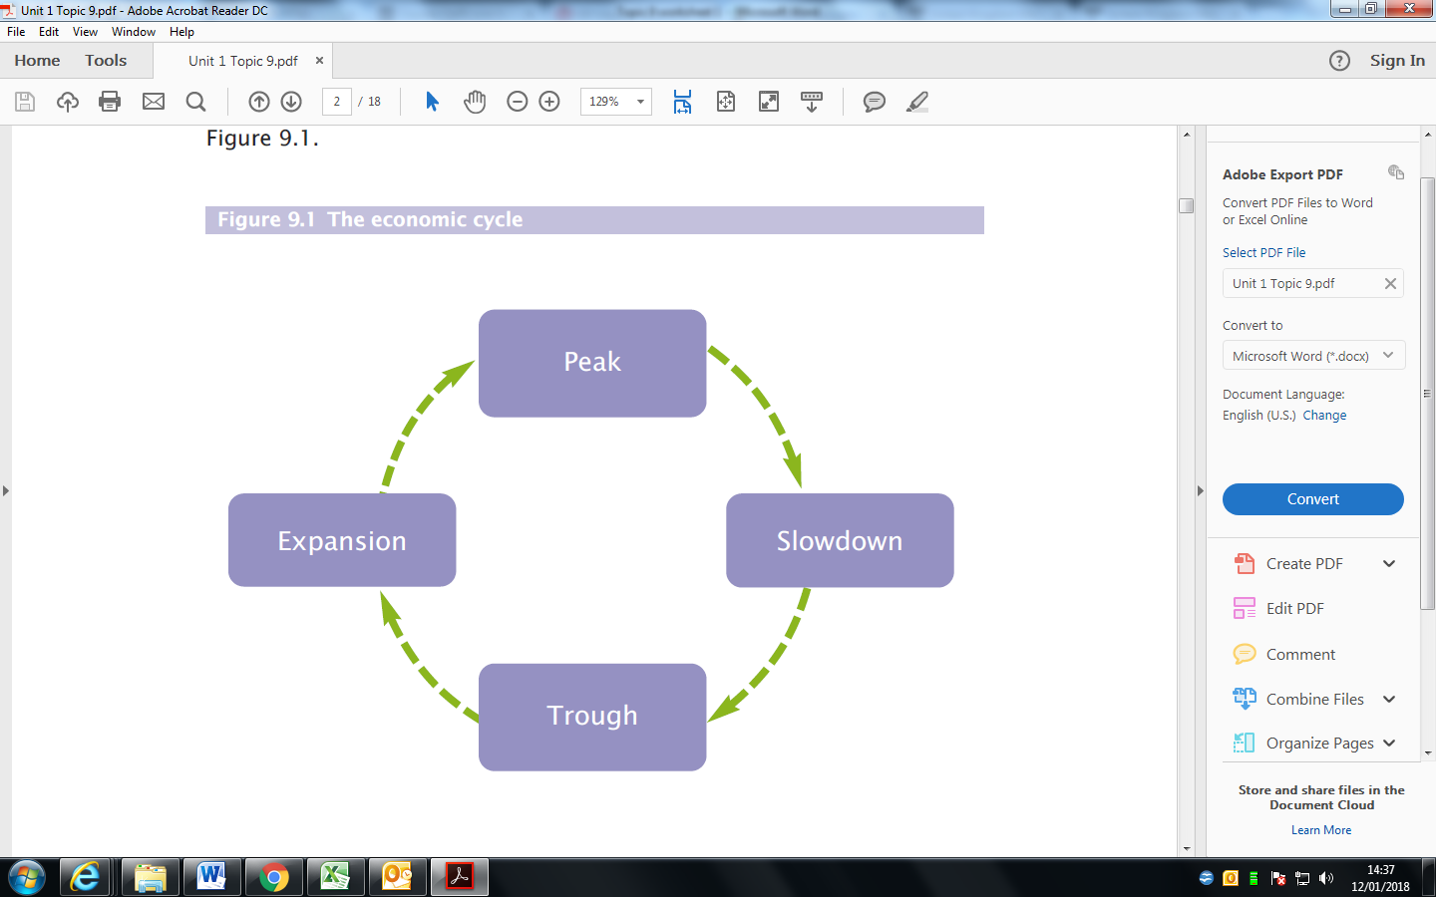

The factors that influence this cycle include:

* gross domestic product (GDP) – i.e. the total value of all of the goods and services that the UK produces, also known as ‘national income’;
* interest rates;
* employment rates; and
* Levels of spending.

One full economic cycle typically takes, on average, between five and ten years **(see Figure 9.2)**.

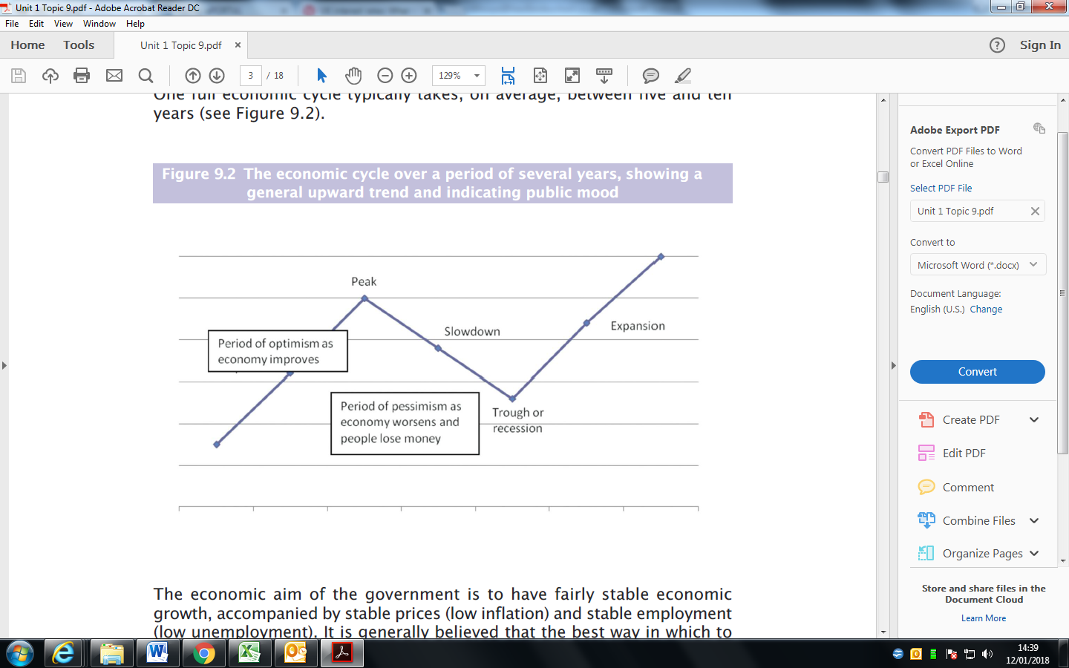



1. Describe what is likely to happen to each of the following indicators during the economic cycle:

* Unemployment -
* Wages -
* Inflation -
* GDP -
* Consumer spending –

**9.1.2 Financial planning and the economic cycle**

Economic cycles make short-term planning much easier than long-term planning. This is because the economy will not tend to change very dramatically over the short term.

Long-term financial planning, however, is much more difficult, because you cannot accurately predict things such as how much inflation or interest rates will increase, or whether you will continue to have the same job. If you want to buy a house, then you will have to make a longer-term financial plan, because home loans are typically for 25 years.

1. Describe what will happen to the purchase of `large ticket items` (houses, cars and kitchens) during a recession/slowdown.
2. What will happen to the demand for `fixed rate` mortgages during a period of uncertainty? Explain your answer.