Introduction to legislation

UK businesses are subject to laws (legislation) passed by both the UK parliament and the European parliament. Since both UK and EU law are passed by parliaments, laws are affected by party politics. Conservative governments suggest they interfere as little as possible with the workings of business. In other words, they claim to take a laissez-faire approach. This means trusting businesses to do their best for their customers and employees – in other words, let the market regulate business activities.

'The most enlightened judicial policy is to let people manage their own business in their own way.'
Oliver Wendell Holmes, nineteenth-century author

Labour governments are more suspicious that businesses may act in their shareholders' interests, not those of their customers. Therefore, there is a greater temptation to bring in laws to regulate business activity. Before the Labour government established the National Minimum Wage in 1999, employers could, and did, pay as little as £3 an hour. The 2014 rate of £6.50 per hour is not riches, but provides some protection for the lower paid.

There are five main areas in which the law affects businesses:

1 consumer protection
2 employee protection
3 environmental protection
4 competition policy
5 health and safety.
Consumer protection

Consumer protection law is designed to ensure that the companies from which they buy treat consumers fairly. This covers issues such as whether a product does what it claims to do, whether products are correctly labelled and measured out and the rights of the consumers to refunds or exchanges of faulty goods. Consumer protection legislation should ensure that no firm can gain an unfair competitive advantage by taking short-cuts in how their products are made. If all products and services must meet a minimum legal standard, companies cannot use unsafe/Cheaper materials to gain a competitive edge.

Two Acts of Parliament are especially important:

1 The Sale of Goods Act. First passed in 1893 and updated in 1979, this is the law that says 'goods must be fit for the purpose for which they are sold'. Before this law, nineteenth-century crooks sold 'cures' for 'bad blood' or cancer - and customers had no right to demand their money back. Today, if you buy shoes and holes appear in the soles within weeks, the Sale of Goods Act makes sure you can get your money back.

2 The Trade Descriptions Act. This was introduced in 1968 and updated in 2008. It forces companies to ensure that every claim and statement about a product is true. Before it, a beer producer could proclaim in advertising that 'Guinness is good for you'. In recent years, Danone has repeatedly been forced to back down on over-claims about the health virtues of products such as Activia.

The effect of consumer protection law on business has been to create more of a 'level playing field' in which competition has to be more based on real product benefits, not simply on imagination and willingness to deceive. At every stage, companies have argued against new laws, suggesting that they will undermine competition. There is little evidence for this.

Employee protection
Employment law sets out, and aims to protect, the rights of employees at work. These rights include the right to fair pay, sick leave, maternity and paternity leave, employment contracts being honoured, relationships with trade unions, the ability of employers to shed staff and the responsibilities of employers who make staff redundant. Of these, the easiest to remember (and to see the implications of) is the National Minimum Wage legislation that was introduced in 1999. Table 46.1 sets out the implications of employment legislation for businesses.

As a general rule, businesses like to have minimal constraints on their activities. A business craves flexibility in the way it deals with its staff; legislation tends to impose certain restriction on how staffs are dealt with. UK business leaders argue that more employment legislation makes them uncompetitive relative to their international rivals.
Yet UK employment legislation is not as tight as that in major rivals such as France and Germany. In its 2014-2015 report on global competitiveness, the World Economic Forum ranked the UK fifth in the world for 'labour market efficiency'. Yet there are still politicians who try to claim that Britain's labour market is over-regulated.

'Morality cannot be legislated, but behaviour can be regulated. Judicial decrees may not change the heart, but they can restrain the heartless.' Martin Luther King, civil rights leader

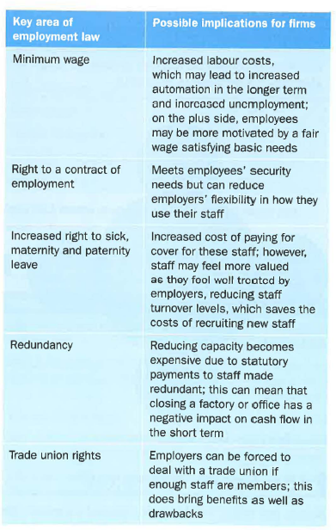

Environmental protection
Laws governing the impact of business on the environment are a key area today, given the increased acceptance of the need to legislate to protect the environment. A wide range of laws governs issues as diverse as the materials that firms must use for certain products, the processes firms are allowed to use in manufacturing and the extent to which firms must ensure their products are recyclable at the end of their lives. Environmental protection laws, perhaps more than any others, seem to most firms to be a source of additional cost without much of an upside.

Firms in the UK are also subject to EU laws; this is an area in which several EU directives have led to increased expectations of businesses. Of course, all these firms feel a sense of injustice that they are competing against non EU countries with less stringent environmental laws.

The reality is, though, that companies such as Dyson have succeeded in Japan and America precisely because consumers in those countries want well-designed, environmentally friendly products.

Hoover panic
Towards the end of August 2014, UK newspapers reported on panic buying of vacuum cleaners. New EU rules were to start on 1 September making it unlawful to sell vacuum cleaners with an engine with more than 1,600 watts of power. Although James Dyson made it clear that the power of the engine was barely related to its efficiency, media scare stories created a sales surge amounting to a 400 per cent increase. The EU's concern was to halt a 6 per cent annual rise in electricity usage on household electric goods – as part of Europe's promise to cut carbon emissions by 20 per cent by 2020. UK newspapers treated the story as another opportunity to bash the European Union; in fact, vacuums sold today are every bit as efficient as before - with better design compensating for smaller engines.

Among the various pieces of environmental legislation, especially important ones include the following:
- Landfill tax, which was introduced in the UK in 1996 following a European Union 'directive'. It forces businesses to pay £80 per tonne to deposit 'active waste' in landfill sites (council rubbish dumps). This adds to business costs and therefore can be said to damage international competitiveness. The other way to look at it is that it encourages businesses to minimise and then recycle waste instead of dumping it.

- The Environmental Protection Act 1990 (updated in 2008), which sets out the structure of waste management and emissions control for the UK. Perhaps its most notorious feature is the requirement for 'risk assessments' - that is, full analyses by companies of the possible environmental risks from different aspects of their business. This is time-consuming and bureaucratic, but has probably helped in the significant reduction of river pollution in the UK. In 1990, a swim in the Thames was a suicide mission. Today fish, at least, have returned to the river.

Competition policy

Even the strongest believers in laissez-faire see the value in government intervention to boost competition. The need becomes most obvious when one company tries to buy up a rival. If Cadbury (with about 33 per cent of the UK chocolate market) bought Mars UK (which has about 20 per cent), the resulting giant would surely find it easy to push prices up and consumer choice down.

In 2014, the new Competition and Markets Authority (CMA) took on the functions of the now-closed Competition Commission and Office of Fair Trading.

The government-funded CMA is responsible for:
• investigating takeovers and mergers
• investigating possible anti-competitive practices
• bringing criminal proceedings against individuals who commit cartel offences.

If the CMA is completely successful, UK consumers will benefit from real competition between companies doing their best to win market share. Sadly, price-fixing remains surprisingly common, as evidenced by the number of companies 'busted' for this illegal activity.

'If there were no bad people there would be no good lawyers.'
Charles Dickens, novelist

In October 2013, the UK's cement industry was forced to change its practices by the competition authorities. The industry (dominated by three multinational companies) would no longer be allowed to share sales and production data, and the largest producer was forced to sell off one of its biggest cement factories. The competition authorities suggested that over-charging had cost the struggling construction sector £180 million over the period 2009-2013.

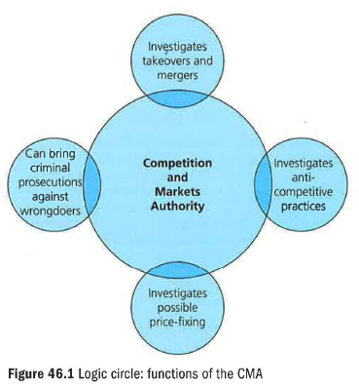

Health and safety

Health and safety legislation is designed to ensure the safety of employees and customers within the workplace.
The Health & Safety at Work Act 1974 places the major burden on employers. They have to provide a safe working environment for their staff the main areas covered by the legislation include the physical conditions in which staff are required to work, precautions that firms are required to take when planning their work and the way in which hazardous substances must be treated in the workplace.

The job of the Health and Safety Executive is to identify and prosecute any serious lapses by companies. In its 2014 annual report, the Executive prosecuted a scaffolding company that was found guilty and fined £300,000 (plus £124,000 in costs) after an employee was killed by an overturned skip lorry.

Despite the tight laws in Britain, there are still a worrying number of deaths at work. The annual toll is set out in Table 46.2. Even more striking is that there are as many as 230,000 workplace injuries a year. Health and safety cannot be taken for granted.

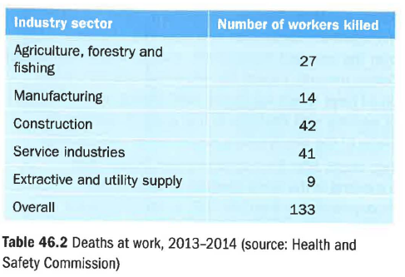

Legislation – evaluation

Legislation seeks to ensure that all firms compete on a 'level playing field'. This is a noble goal because one country's legislation can only create a level playing field in the home market. Super-tough laws, perhaps on the environment, add to costs and therefore may make it hard for UK firms to win contracts overseas. Although that could be a price worth paying, it may be better still for all developed trading countries to agree common standards. This is what happens within the European Union. For those who argue that laws are unnecessary because market forces will drive unscrupulous firms out of business, there is a disappointing lack of evidence to suggest that this argument is valid. Though plenty of businesses are convicted of breaking the law, it is a real challenge to find just one example of a firm that has been forced to close as a result of doing so. Is the incentive to avoid prosecution strong enough?

Key terms
Cartel: an agreement between producers to control supply and thereby control prices. This is illegal, but not unusual.

Laissez-faire: literally means 'let it be', implying leaving businesses free to choose their own policies and practices: trusting in the free market.

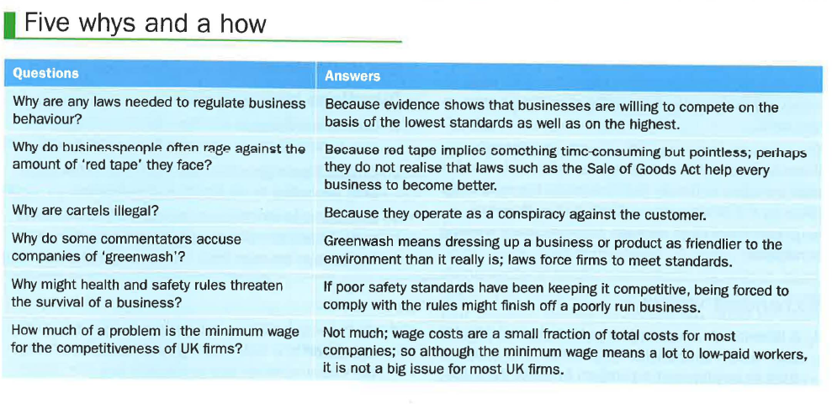

Revision questions (30 marks; 30 minutes)

1 a) Explain, in your own words, the meaning of the term 'laissez-faire'. (3)

b) Explain what a follower of laissez-faire might think about governments setting a National Minimum Wage. (4)

2 From the chapter, explain one advantage and one disadvantage to UK businesses of being based in the European Union. (6)

3 Briefly describe the main aims of the following legislation:

a) employment laws
b) consumer protection law
c) health and safety law. (6)

4 Explain two possible consequences of a tightening of environmental protection laws for one of the following:

a) a supermarket
b) a chemical manufacturer
c) a bank. (6)

5 Briefly explain why many UK firms would welcome a relaxation of environmental protection legislation. (5)

Data response

Forbes Bricks

Maintaining a legal factory is a lot harder than you might expect - just ask Dave Maisey, managing director of Forbes Bricks Ltd. Forbes is one of a handful of bespoke brick makers left in the UK. It can tailor-make any shape, size, colour or material of brick; this feature explains its lasting popularity among those looking for bricks to restore or maintain older properties. A medium-sized firm, Forbes owns a single factory in Kent, with a loyal workforce of skilled and semi-skilled staff. Dave, however, has the look of a tired man. Charged with managing most aspects of the business, he is also ultimately responsible for the firm's compliance with the legislation affecting the business. His biggest headache, he says, is health and safety: 'They just don't seem to understand that making bricks is a dusty business. You can't make bricks without dust, and the inspector we had round the other week was measuring dust levels all-round the shop floor, tutting as she went.'

The inspector from the HSE (Health and Safety Executive) was at the plant to measure the level of dust particles in the air and to assess the measures taken by the firm to ensure that staff suffered no long-term respiratory damage from the dusty working conditions.

Dave continued: 'I'd only just finished a full risk assessment on the new kiln we've bought, so luckily I managed to impress her with that. The inspector went over the accident record book, and our whole Health and Safety manual. I spent the whole day with her, time I could have spent out on the road finding new business, or working with the boys to find a better solution to some of the stockholding issues we've had recently.'

Two weeks after the inspector's visit, Dave called a meeting of the firm's directors to discuss the recommendation from the HSE: to spend an extra £105,000 on extractor units to reduce the dust levels in the air to standards acceptable under UK and EU law. Dave was also about to find out what purchasing director Andy Hemmings discovered when he visited a similar factory in China recently. Dave feared that Andy had found a factory with poor working conditions, paying well below Forbes' rates to staff and offering similar bricks at half the price.

1 Outline two reasons why Dave seems unhappy about the legislation affecting Forbes Bricks Ltd. (6)

2 Explain Dave's general responsibilities to his staff according to UK health and safety law. (4)

3 Evaluate whether the case study proves that different legal standards make it impossible to have fair competition between firms from different countries. (20)

Extended writing

1 A laissez-faire 'think-tank' has recommended that the government should allow small firms to be exempt from all employment legislation. Evaluate the value of that recommendation to UK businesses. (20)

2 An important objective of business-related legislation is a 'level playing field'. Evaluate the extent to which this is possible in a globalised world. (20)

