bd06662_

**GCSE Level Descriptors/Requirements**

|  |  |  |
| --- | --- | --- |
| Level | **Q5 – Twelve mark questions** | Marks |
| 4 | ***A well-argued response***, reasoned consideration of different points of view. Logical chains of reasoning ***leading to judgement***(s) supported by knowledge and understanding of relevant evidence and information.  ***References to religion applied to the issue.*** | 10-12 |
| 3 | Reasoned consideration of ***different points of view***. Logical chains of reasoning that draw on knowledge and understanding of relevant evidence and information. ***Clear reference to religion.*** | 7-9 |
| 2 | Reasoned consideration of a point of view. A ***logical chain of reasoning*** drawing on knowledge and understanding of ***relevant evidence*** and information. OR Recognition of ***different points of view***, each supported by relevant reasons / evidence. | 4-6 |
| 1 | Point of view with reason(s) stated in support. | 1-3 |

**Q4 – Five Mark questions**

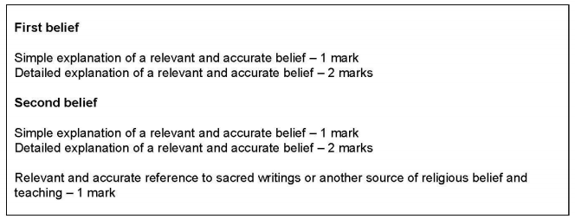

**Q3 – Four Mark questions**

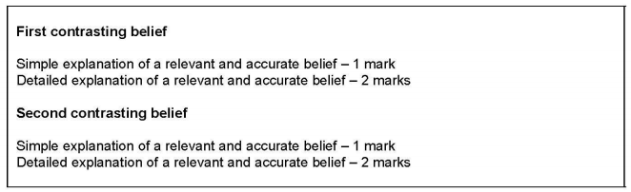



|  |  |  |
| --- | --- | --- |
| Grade | % | Old Grade  2019 |
| 9 | 89% | A\* |
| 8 | 82% | A\*/A |
| 7 | 76% | A |
| 6 | 69% | B |
| 5 | 62% | B/C |
| 4 | 54% | C |
| 3 | 40% | D/E |
| 2 | 26% | E/F |
| 1 | 12% | F/G |

|  |  |  |  |  |  |  |  |  |  |
| --- | --- | --- | --- | --- | --- | --- | --- | --- | --- |
| Max | 9 | 8 | 7 | 6 | 5 | 4 | 3 | 2 | 1 |
| 204 | 181 | 168 | 156 | 141 | 126 | 111 | 82 | 53 | 24 |
| 100% | 89% | 82% | 76% | 69% | 62% | 54% | 40% | 26% | 12% |

|  |  |
| --- | --- |
| /12 | Grade |
| 12 | 9 |
| 11 | 9 |
| 10 | 8 |
| 9 | 6 |
| 8 | 5 |
| 7 | 4 |
| 6 | 3 |
| 5 | 3 |
| 4 | 2 |
| 3 | 1 |
| 2 | 1 |
| 1 | U |

|  |  |  |
| --- | --- | --- |
| /24 | % | Grade |
| 24 | 100 | 9 |
| 23 | 96 | 9 |
| 22 | 92 | 9 |
| 21 | 88 | 8 |
| 20 | 83 | 8 |
| 19 | 79 | 7 |
| 18 | 75 | 6 |
| 17 | 71 | 6 |
| 16 | 67 | 5 |
| 15 | 63 | 5 |
| 14 | 58 | 4 |
| 13 | 54 | 4 |
| 12 | 50 | 3 |
| 11 | 46 | 3 |
| 10 | 42 | 3 |
| 9 | 38 | 2 |
| 8 | 33 | 2 |
| 7 | 29 | 2 |
| 6 | 25 | 1 |
| 5 | 21 | 1 |
| 4 | 16 | 1 |
| 3 | 13 | 1 |
| 2 | 8 | U |
| 1 | 4 | U |
| 0 | 0 | U |

|  |  |  |  |  |
| --- | --- | --- | --- | --- |
| Level |  | Marks | /12 | Grade |
| 4 | ***A well-argued response***, reasoned consideration of different points of view. Logical chains of reasoning ***leading to judgement***(s) supported by knowledge and understanding of relevant evidence and information.  ***References to religion applied to the issue.*** | 10-12 |  |  |
| 3 | Reasoned consideration of ***different points of view***. Logical chains of reasoning that draw on knowledge and understanding of relevant evidence and information. ***Clear reference to religion.*** | 7-9 |  |  |
| 2 | Reasoned consideration of a point of view. A ***logical chain of reasoning*** drawing on knowledge and understanding of ***relevant evidence*** and information. OR Recognition of ***different points of view***, each supported by relevant reasons / evidence. | 4-6 |  |  |
| 1 | Point of view with reason(s) stated in support. | 1-3 |  |  |

bd06662_

Comments:

Targets:

**GCSE – 12 Mark Evaluation Question results and feedback.**

Date: Signed:

|  |  |  |  |  |
| --- | --- | --- | --- | --- |
| Level |  | Marks | /12 | Grade |
| 4 | ***A well-argued response***, reasoned consideration of different points of view. Logical chains of reasoning ***leading to judgement***(s) supported by knowledge and understanding of relevant evidence and information.  ***References to religion applied to the issue.*** | 10-12 |  |  |
| 3 | Reasoned consideration of ***different points of view***. Logical chains of reasoning that draw on knowledge and understanding of relevant evidence and information. ***Clear reference to religion.*** | 7-9 |  |  |
| 2 | Reasoned consideration of a point of view. A ***logical chain of reasoning*** drawing on knowledge and understanding of ***relevant evidence*** and information. OR Recognition of ***different points of view***, each supported by relevant reasons / evidence. | 4-6 |  |  |
| 1 | Point of view with reason(s) stated in support. | 1-3 |  |  |

bd06662_

Comments:

Targets:

**GCSE – 12 Mark Evaluation Question results and feedback.**

Date: Signed: