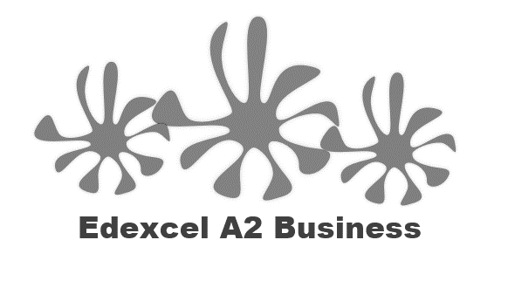

4.1.5 Trading blocs

Write a definition of trading blocs here:

________________________________________________________________________________________________________________________________________________________________________________________________________________________________________________________________________________________________________________________________________

EU trading bloc

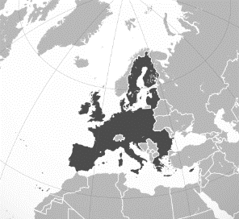

EU trading bloc brief details

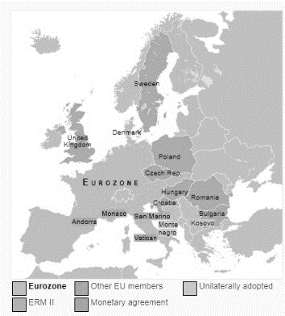

Brexit – impact on the UK

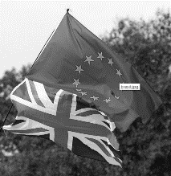________________________________________________________________________________________________________________________________________________________________________________________________________________________________________________________________________________________________________________________________________

Hard Brexit

________________________________________________________________________________________________________________________________________________________________________________________________________________________________________________________________________________________________________________________________________

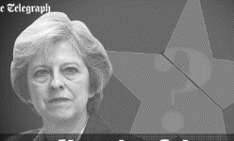Soft Brexit

________________________________________________________________________________________________________________________________________________________________________________________________________________________________________________________________________________________________________________________________________

ASEAN trading bloc

|  |  |  |  |
| --- | --- | --- | --- |
| T |  | B |  |
| P |  | L |  |
| M |  | C |  |
| V |  | B |  |

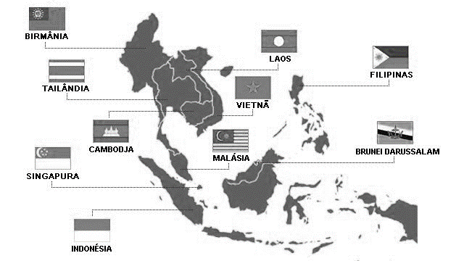

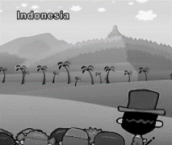

ASEAN trading

________________________________________________________________________________________________________________________________________________________________________________________________________________________________________________________________________________________________________________________________________

________________________________________________________________________________________________________________________________________________________________________________________________________________________________________________________________________________________________________________________________________

NAFTA Trading Bloc

|  |  |  |  |  |  |
| --- | --- | --- | --- | --- | --- |
| U |  | C |  | M |  |

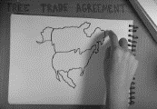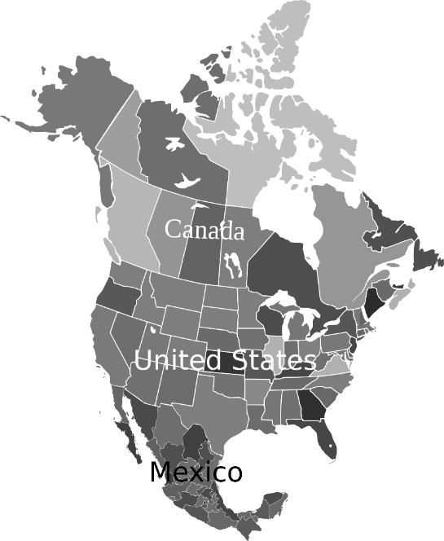

NAFTA Trading

________________________________________________________________________________________________________________________________________________________________________________________________________________________________________________________________________________________________________________________________________

________________________________________________________________________________________________________________________________________________________________________________________________________________________________________________________________________________________________________________________________________

Expansion of trading blocs

Write a definition of trade bloc expansion here:

________________________________________________________________________________________________________________________________________________________________________________________________________________________________________________________________________________________________________________________________________

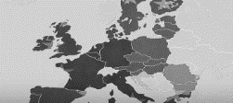Expansion of trading blocs

________________________________________________________________________________________________________________________________________________________________________________________________________________________________________________________________________________________________________________________________________

**Impact on business of trading blocs**

Opportunities of free trade

|  |  |
| --- | --- |
| #1 |  |
| #2 |  |
| #3 |  |
| #4 |  |

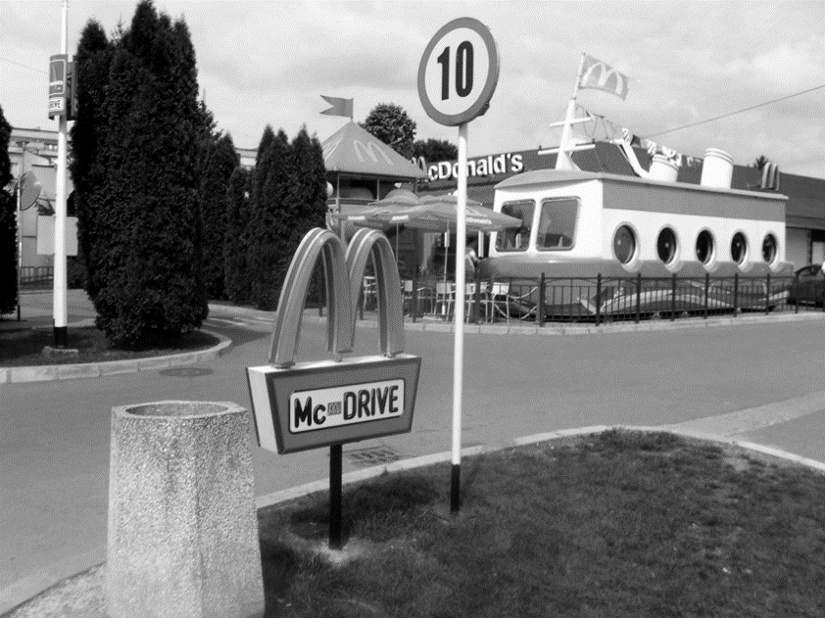Drawbacks of free trade

What country is this McD’s in? What clues to the country are in the picture?

________________________________________________________________________________________________________________________________________________________________________________________________________________________________________________________________________________________________________________________________________

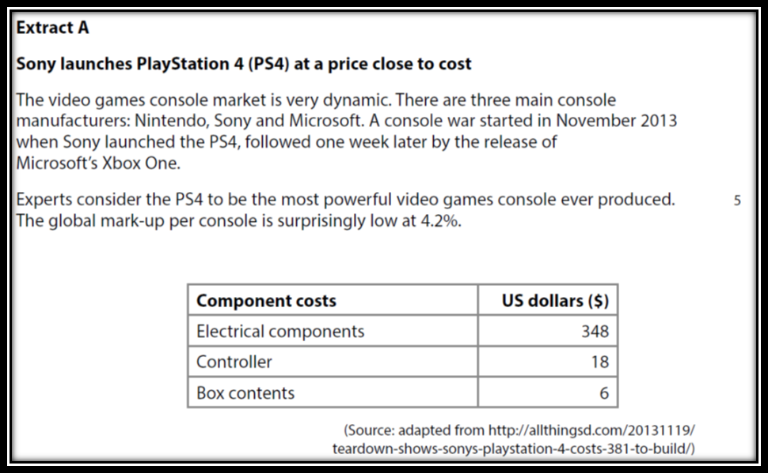



Case studies and question continue on page 8

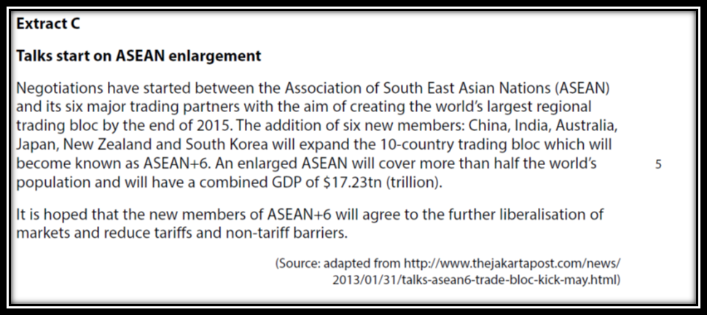

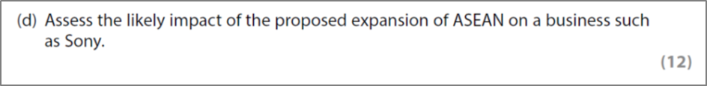

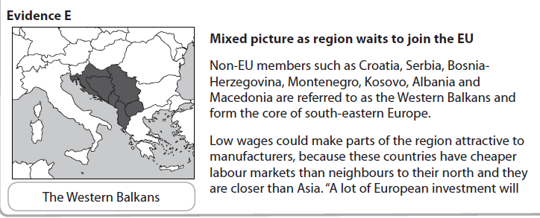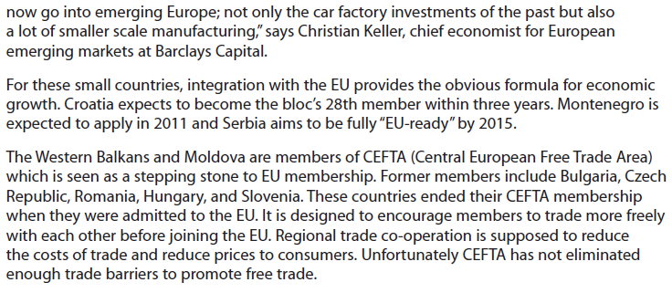

[15]

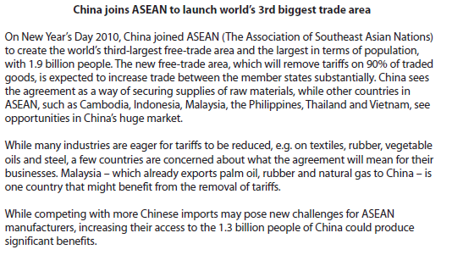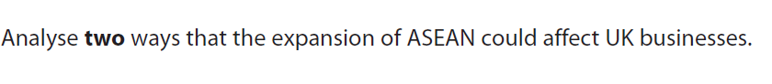

[8]

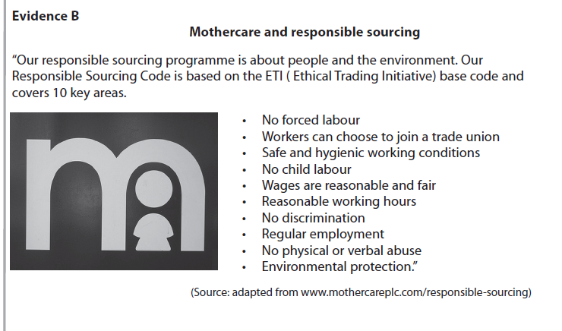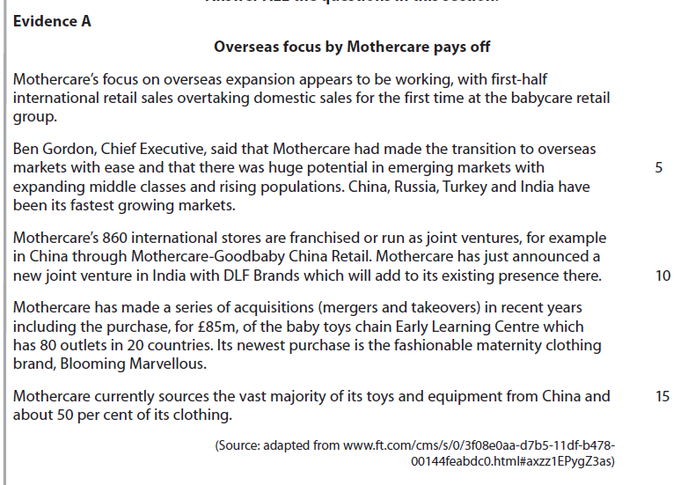

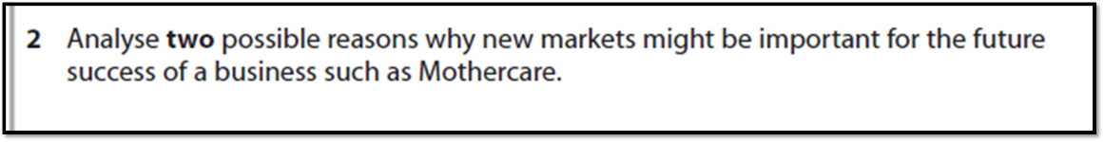

[8]