

3.1.1 Corporate objectives

Starter – mission statement:

* *To inspire and nurture the human spirit – one person, one cup and one neighbourhood at a time.*

Write your definition of mission statements here:

________________________________________________________________________________________________________________________________________________________________________________________________________________________________________________________________________________________________________________________________________

**Development of corporate objectives from mission statement/corporate aims**

Hierarchy of business objectives



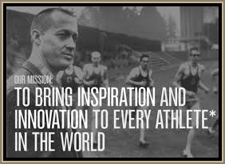Mission statements

________________________________________________________________________________________________________________________________________________________________________________________________________________________________________________________________________________________________________________________________________

Mission statement criticism

_______________________________________________________________________________________________________________________________________________________________________________________________________________________________________________________________________________________________________________________________________

Mission statement – coca cola

_______________________________________________________________________________________________________________________________________________________________________________________________________________________________________________________________________________________________________________________________________

Mission statement – Google

_______________________________________________________________________________________________________________________________________________________________________________________________________________________________________________________________________________________________________________________________________



Mission statement – Disney

_______________________________________________________________________________________________________________________________________________________________________________________________________________________________________________________________________________________________________________________________________

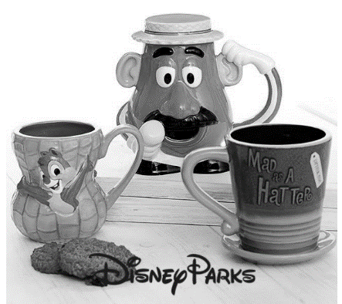Corporate objectives

_______________________________________________________________________________________________________________________________________________________________________________________________________________________________________________________________________________________________________________________________________

SMART objectives

S

M

A

R

T

[](https://us.bape.com/collections/men/products/1d80-110-051)

Department objectives

* In most businesses they divide up the work into departments or __________________________; sales, marketing, human resources, operations and ____________________________
* Each department will set their own objectives which should flow from the corporate ______________________________________
* For example, the _________________________________ department may aim to increase sales 3% each ___________________________, or increase sales revenue 2% each year
* This will help the business to achieve its corporate objectives of more ______________________________ for the shareholders

**Critical appraisal of mission statements/corporate aims**

What is the purpose of mission statements?

_______________________________________________________________________________________________________________________________________________________________________________________________________________________________________________________________________________________________________________________________________

Why did Facebook change its mission statement?



_______________________________________________________________________________________________________________________________________________________________________________________________________________________________________________________________________________________________________________________________________

Uses of mission

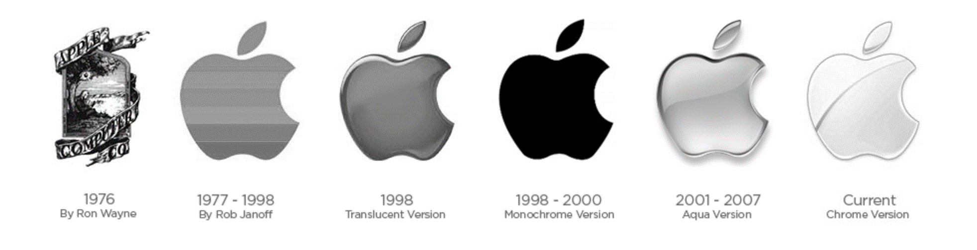

|  |
| --- |
| A |
| B |
| C |

Limitations of mission statements

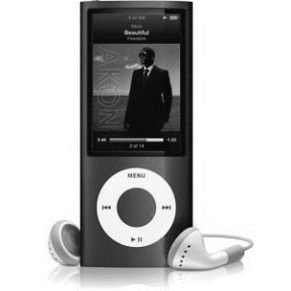

|  |
| --- |
| A |
| B |
| C |
| D |
| E |

Stakeholder perspectives on mission statements

|  |  |
| --- | --- |
| Owners |  |
| Managers |  |
| Employees |  |
| Pressure groups |  |
| Customers |  |
| Competitors |  |

