

4.2.1. Conditions that prompt trade



Define push factors here:

Push factor – saturated market



Push factor – high competition in home market



Define pull factors here:

#1 Opportunities in overseas markets

#2 Ability to spread risk – circle those you know

[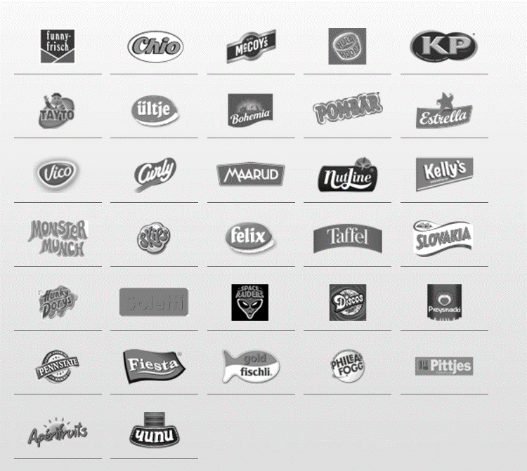](http://www.intersnack.com/our-brands-products/our-brands/)

____________________________________________________________________________________________________________________________________________________________________

[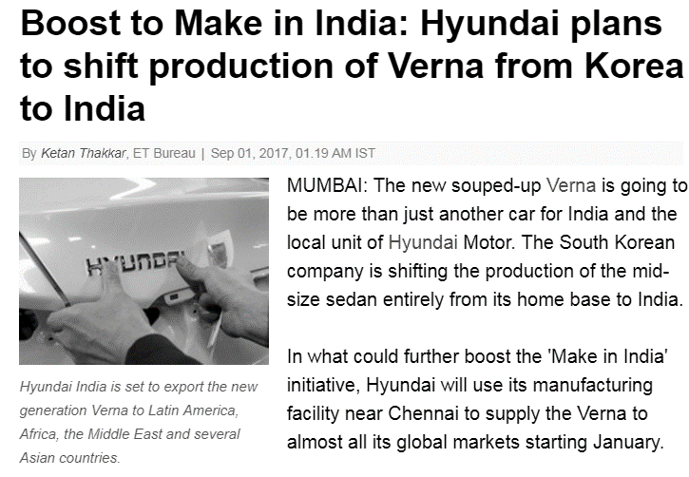](http://economictimes.indiatimes.com/industry/auto/news/boost-to-make-in-india-hyundai-plans-to-shift-production-of-verna-from-korea-to-india/articleshow/60316013.cms)#3 Ability to gain economies of scale

________________________________________________________________________________________________________________________________________________________________________________________________________________________________________________________________________________________________________________________________________

**Offshoring and outsourcing**

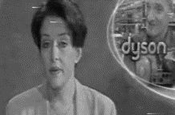

Offshoring - Dyson

________________________________________________________________________________________________________________________________________________________________________________________________________________________________________________________________________________________________________________________________________

Outsourcing

________________________________________________________________________________________________________________________________________________________________________________________________________________________________________________________________________________________________________________________________________

Outsourcing examples

|  |  |
| --- | --- |
| Production |  |
| Payroll |  |
| Purchasing |  |
| Delivery |  |

Business decision – keep call centre in UK or move it to India?

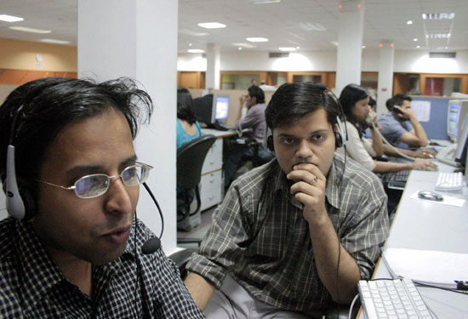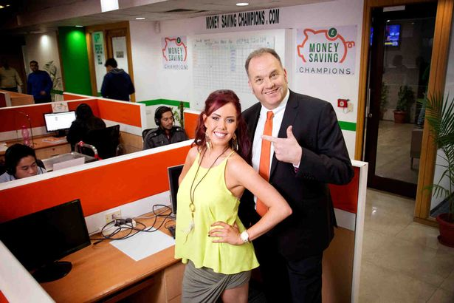

|  |  |
| --- | --- |
| Advantages | Disadvantages |
|  |  |

**Product lifecycle extension – draw the extension on (again this should be revision!)**

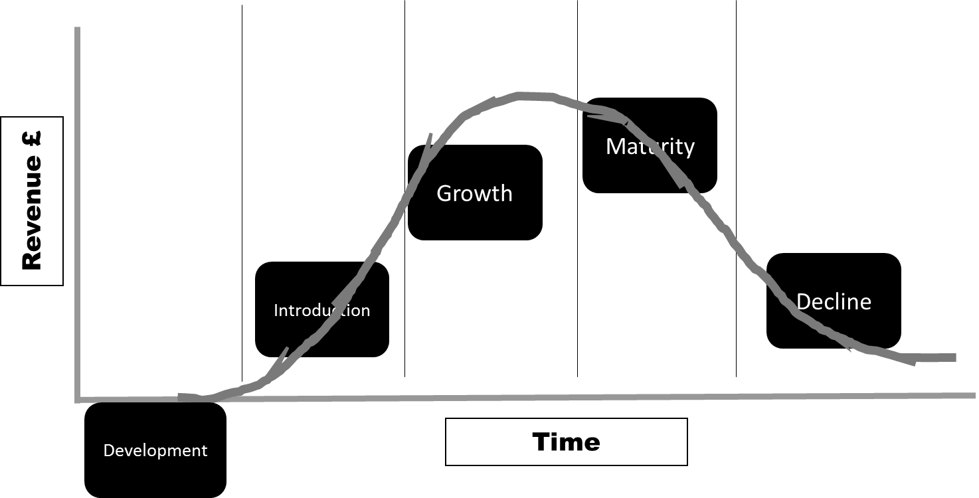

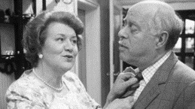Extension of product lifecycle

________________________________________________________________________________________________________________________________________________________________________________________________________________________________________________________________________________________________________________________________________

Extension of the product lifecycle – SPAM

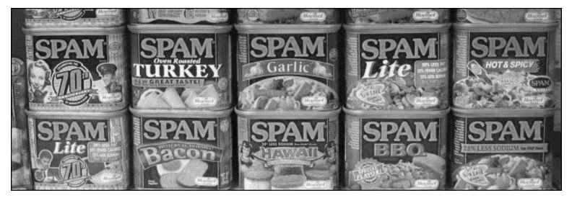

________________________________________________________________________________________________________________________________________________________________________________________________________________________________________________________________________________________________________________________________________

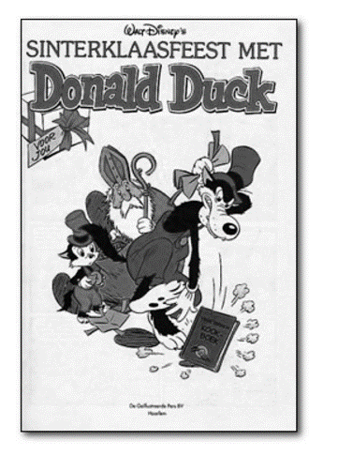Extension of the product lifecycle – Disney comics

________________________________________________________________________________________________________________________________________________________________________________________________________________________________________________________________________________________________________________________________________

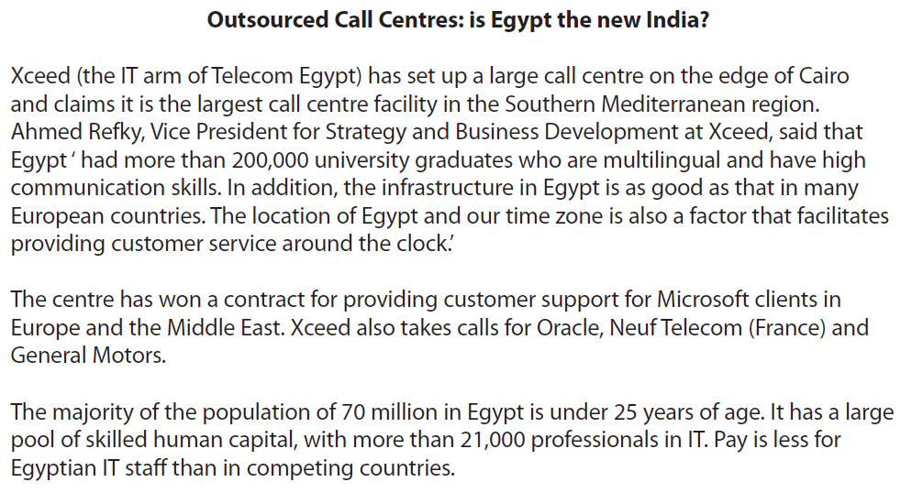



[8]

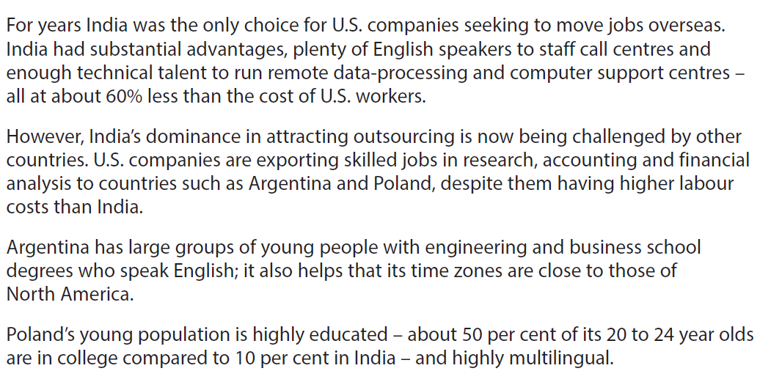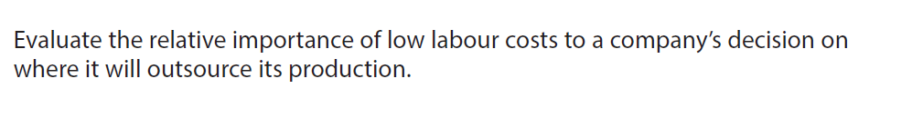

[10]

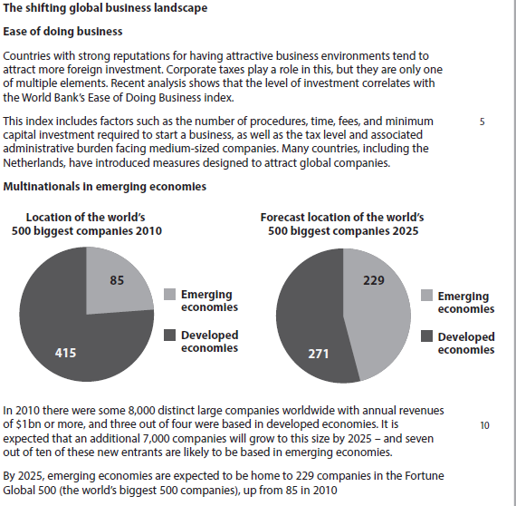

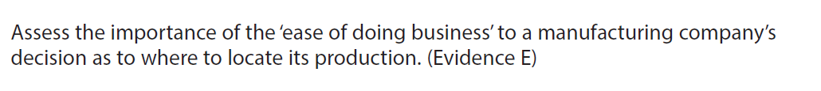

[10]