

1.3.2 Branding and Promotion

Starter

Tick the products that you would buy.

|  |  |  |  |  |  |
| --- | --- | --- | --- | --- | --- |
| [http://www.ricability.org.uk/assets/uploads/images/WWF_holding_on_2.jpg](http://www.google.co.uk/url?sa=i&rct=j&q=&esrc=s&frm=1&source=images&cd=&cad=rja&docid=HNrWiSCKsEVbnM&tbnid=Yw9_oGuiuZPPnM:&ved=0CAUQjRw&url=http://www.ricability.org.uk/consumer_reports/mobility_reports/stepping_out/choosing_a_walking_frame/&ei=B9-EUcS2HPTu0gXuwoDQDA&bvm=bv.45960087,d.d2k&psig=AFQjCNFwajOmyf1WrrkgH8DWzQXIE0Huag&ust=1367748732724955) | [http://upload.wikimedia.org/wikipedia/commons/6/69/Nissan_Micra_front_20081017.jpg](http://www.google.co.uk/url?sa=i&rct=j&q=&esrc=s&frm=1&source=images&cd=&cad=rja&docid=JErFDVAoh8U3qM&tbnid=VHP7-NuGRpQzmM:&ved=0CAUQjRw&url=http://commons.wikimedia.org/wiki/File:Nissan_Micra_front_20081017.jpg&ei=Jd-EUaWtOuTT0QXxwYH4Bg&bvm=bv.45960087,d.d2k&psig=AFQjCNEXdk6fjvQtf6XwDMBlKbGWaUFcmA&ust=1367748765678392) | http://ecx.images-amazon.com/images/I/411iFApcKVL._SL500_AA300_.jpg | [http://asset1.cbsistatic.com/cnwk.1d/i/tim/2012/09/17/06_archimedes_35438535_620x433.jpg](http://www.google.co.uk/url?sa=i&rct=j&q=&esrc=s&frm=1&source=images&cd=&cad=rja&docid=g10VYleEIxPjqM&tbnid=5nfD3gl6xufrNM:&ved=0CAUQjRw&url=http://www.cnet.com/iphone-5/&ei=eN-EUbNmzZnRBYWUgKgE&bvm=bv.45960087,d.d2k&psig=AFQjCNHEKy4A-uC8RmEc6_G0T7cKxtczhw&ust=1367748852495985) | [http://www.laverstokepark.co.uk/@@content/pub/image_3307/sausage%20roll%20on%20tray%20on%20white_17011.jpg](http://www.google.co.uk/url?sa=i&rct=j&q=&esrc=s&frm=1&source=images&cd=&cad=rja&docid=I0raieZDIDI-sM&tbnid=4sf5X7HvyUViMM:&ved=0CAUQjRw&url=http://www.laverstokepark.co.uk/pies-quiches-stocks/laverstoke-park-farm/buffet-sausage-rolls_ct483bd190pd1666.htm&ei=q9-EUfmoHciW0QXcyYCICA&bvm=bv.45960087,d.d2k&psig=AFQjCNEWn8r-4QtVj9Wt3W9uP4Gq9CA21Q&ust=1367748903344287) | https://encrypted-tbn3.gstatic.com/images?q=tbn:ANd9GcSh3uH5qOGUl4GRodqczvHN48LxubnvQSaLXyGUDYzqApiqSGGvcA |
|  |  |  |  |  |  |

* Do all products have the same customers?

__________________________________________________________________________________

* How many ways can you think to segment customers? e.g. Age

__________________________________________________________________________________

* Does the type of customer affect the way we “speak” to them through marketing?

__________________________________________________________________________________

Write your definition of promotion here:

________________________________________________________________________________________________________________________________________________________________________________________________________________________________________________________________________________________________________________________________________

Types of promotion

|  |  |  |
| --- | --- | --- |
| #1 Personal selling |  |  |
| #1 Personal selling - salesmen |  |  |
| #2 Direct marketing |  |  |
| #3 Above the line advertising (ATL) |  |  |
| #3 Above-the-line advantages and disadvantages | Advantages | Disadvantages |
| #4 Below the line Advertising |  |  |
| #4 Below-the-line advantages and disadvantages | Advantages | Disadvantages |
| #5 Public Relations |  |  |
| #5 Public relations long-term |  |  |
| #6 Sponsorship |  |  |

Sales promotions

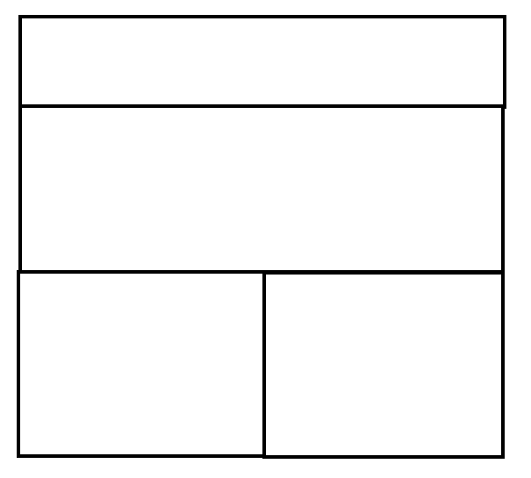







Digital communications







Write your definition of branding here:

________________________________________________________________________________________________________________________________________________________________________________________________________________________________________________________________________________________________________________________________________

Brands introduction

________________________________________________________________________________________________________________________________________________________________________________________________________________________________________________________________________________________________________________________________________

Manufacturer / corporate branding

________________________________________________________________________________________________________________________________________________________________________________________________________________________________________________________________________________________________________________________________________

|  |  |
| --- | --- |
| Image result for benefits |  |
|  |  |

Product branding

________________________________________________________________________________________________________________________________________________________________________________________________________________________________________________________________________________________________________________________________________

* Kitkat is __________
* Galaxy is ____________
* Dairy milk is ___________

|  |  |
| --- | --- |
| Image result for benefits |  |
|  |  |

Own brand products

________________________________________________________________________________________________________________________________________________________________________________________________________________________________________________________________________________________________________________________________________

|  |  |
| --- | --- |
| Image result for benefits |  |
|  |  |

Rebranding

________________________________________________________________________________________________________________________________________________________________________________________________________________________________________________________________________________________________________________________________________

Rebranding

________________________________________________________________________________________________________________________________________________________________________________________________________________________________________________________________________________________________________________________________________

Rebranding Example – old spice

________________________________________________________________________________________________________________________________________________________________________________________________________________________________________________________________________________________________________________________________________

The benefits of strong branding

Added value

________________________________________________________________________________________________________________________________________________________________________________________________________________________________________________________________________________________________________________________________________

Ability to charge premium prices

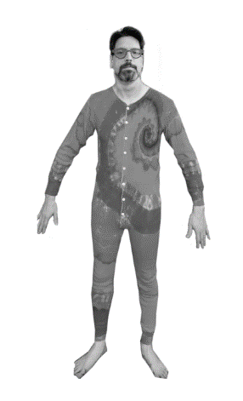How many of these are a brand name?

|  |  |
| --- | --- |
|  | Brand name yes or no |
| * Chapstick |  |
| * Sellotape |  |
| * Sharpie |  |
| * Jacuzzi |  |
| * Velcro |  |
| * Jet ski |  |
| * Bubble wrap |  |
| * Onesie |  |
| * Band-Aid |  |
| * Post-it |  |
| * Tarmac |  |

Reduced PED

________________________________________________________________________________________________________________________________________________________________________________________________________________________________________________________________________________________________________________________________________

Ways to build a brand:

Usp / Differentiation

Advertising

Sponsorship

Social Media

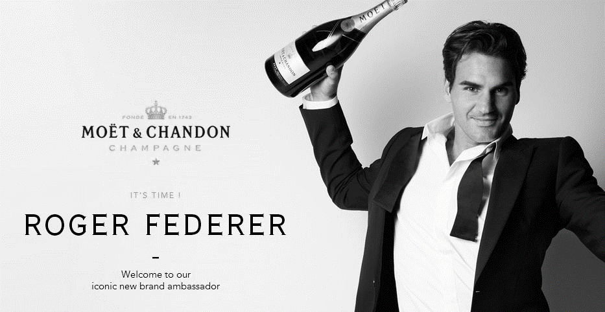

**Changes in branding and promotion to reflect social trends**

Viral Marketing

Social Media

Emotional Branding

