bd06662_[1]

Religious Beliefs, Values and Teachings

* The Three Poisons
* The Four Noble Truths
* The Eightfold Path
* The Five Precepts
* The Three Refuges (Buddha, Dharma & Sangha)
* The Five Khandas (Skhandas)

Sources of Wisdom and Authority

* The Buddha
* The Tipitaka

Practices that shape and express religious identity

* Theravada Buddhism
* Mahayana Buddhism
* Types and Purposes of Meditation



* The Nature and Purpose of Religious Art.
* Religion, art and popular culture. Including;
* Humour and Religion;
* Fiction and Religion;
* Cyber Religion and TV Religion.
* The Nature and Purpose of Religious Art.
* Religion, art and popular culture. Including;
* Humour and Religion;
* Fiction and Religion;
* Cyber Religion and TV Religion.

AQA Specification <http://web.aqa.org.uk/qual/gce/humanities/religious_studies_materials.php?tabid=2> .



Four topics are identified for study and there will be one question based on each topic. Candidates must answer two questions.

Understanding of any one topic may be informed by a study of the others, and, where relevant, candidates may draw on material from more than one topic in their answer to any question set. To study less than the full Specification content may disadvantage a candidate’s synoptic grasp of the material for study.

Where appropriate, answers should show awareness that there are differing views on the topics and issues studied, either within the religion or within the scholarship on that religion.

AO1 questions will be set on the content listed below.

AO2 questions will be focused on the issues surrounding the interpretation of the material studied or on the issues arising from that material identified in the boxes below.

Samsara and the three marks of existence

• The concept of samsara – the cycle of death and rebirth.

• The concepts of dukkha, anatta and anicca.

• The implications of these ideas for the Buddhist way of life and attitude to life.

Issues arising

• Is the Buddhist attitude to life negative and pessimistic?

• Are the truths of dukkha and anicca simply common sense?

• Can the concepts of samsara, dukkha, anicca and anatta be understood only through experience?

The Four Noble Truths

• The framework of the Four Noble Truths – the illness, the cause of the illness, the truth that there is an end to the illness, and the prescription.

• Tanha – the different types of craving and how they lead to suffering: craving for sense pleasures, craving to be rid of something and craving for re-becoming; the root of tanha in ignorance and the pointlessness of trying to fulfil tanha in samsara.

Nibbana – the truth of the end of craving and the end of dukkha arising from it; contrasts between samsara and nibbana; the experience of the arahant in this world and beyond death.

• The implications of these ideas for the Buddhist way of life and attitude to life.

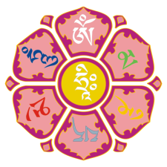Issues arising

• If the end of dukkha is achieved by the end of desire, should Buddhists desire to end desire?

• Can the goal of Buddhism be understood?

• Is it accurate to say that a Buddhist must be detached from, and disinterested in, life?

The Eightfold Path

• The nature and purpose of the Eightfold Path.

• In the context of the Eightfold Path:

– The nature of wisdom and its importance – right understanding and right thought.

– The nature of morality and its importance – right speech, right action and right livelihood.

– The nature of meditation and its importance – right effort, right mindfulness and right concentration.

– The relationship between wisdom, morality and meditation, and the ways in which they contribute to the path to enlightenment.

Issues arising

• Is any one of the three elements of the Eightfold Path – wisdom, morality and meditation – more important than the others?

• Do Buddhists follow the Eightfold Path for their own benefit rather than for the benefit of others?

• The significance of this teaching for Buddhists today.

The Sangha

• The Sangha as refuge

• The monastic community – its nature and discipline.

• The lay community – its life and discipline.

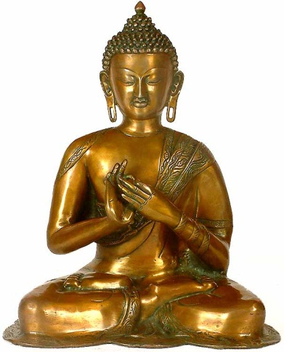• The relationship between the monastic and lay community, and the relative importance of each as a path to enlightenment.

Issues arising

• Is the way of the monk harder and better than the way of the lay Buddhist?

• Is Buddhism escapist?

• Which is more important for Buddhism today – the way of the monastic Sangha or the way of the lay Buddhist?