

3.4.2 Corporate culture

Write the definition of corporate culture here:

________________________________________________________________________________________________________________________________________________________________________________________________________________________________________________________________________________________________________________________________________

Features of a strong culture

________________________________________________________________________________________________________________________________________________________________________________________________________________________________________________________________________________________________________________________________________

Write about the culture at IKEA here:

Write about the culture at Google here:

Features of a weak culture

________________________________________________________________________________________________________________________________________________________________________________________________________________________________________________________________________________________________________________________________________

Write about the culture at Amazon here:

Write about the culture at Ryanair here:









How corporate culture is formed



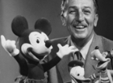







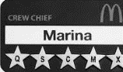





How corporate culture is formed

|  |  |
| --- | --- |
| A |  |
| B |  |
| C |  |
| D |  |
| E |  |
| F |  |
| G |  |

**Difficulties in changing an established culture**

|  |  |
| --- | --- |
| 1 |  |
| 2 |  |
| 3 |  |
| 4 |  |
| 5 |  |
| 6 |  |
| 7 |  |

Nokia – write about the problems in their culture here:



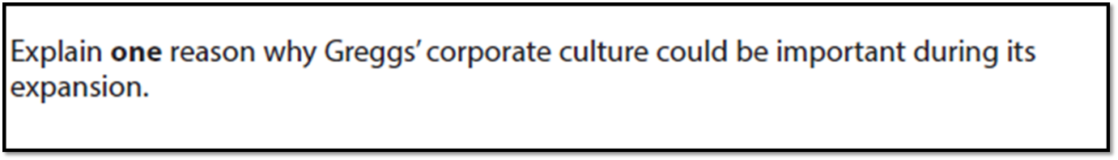

[4]





[10]