



Write the definition of corporate timescales here:

____________________________________________________________________________________________________________________________________________________________________

**Corporate timescales: short-termism versus long-termism**



Short-termism – quick financial reward

________________________________________________________________________________________________________________________________________________________________________________________________________________________________________________________________________________________________________________________________________

Short-termism – historical roots

________________________________________________________________________________________________________________________________________________________________________________________________________________________________________________________________________________________________________________________________________

Short-termism-lack of development

________________________________________________________________________________________________________________________________________________________________________________________________________________________________________________________________________________________________________________________________________

Long-termism

________________________________________________________________________________________________________________________________________________________________________________________________________________________________________________________________________________________________________________________________________

**Evidence-based versus subjective decision making**

Evidence based decision making

________________________________________________________________________________________________________________________________________________________________________________________________________________________________________________________________________________________________________________________________________

Evidence in evidence based decision making

________________________________________________________________________________________________________________________________________________________________________________________________________________________________________________________________________________________________________________________________________

5 steps of evidence based decision making



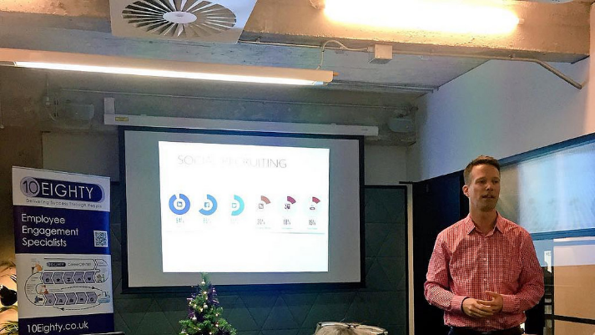



Subjective decision making

_______________________________________________________________________________________________________________________________________________________________________________________________________________________________________________________________________________________________________________________________________

BAFTAS

_______________________________________________________________________________________________________________________________________________________________________________________________________________________________________________________________________________________________________________________________________