

112 Market Research

Starter

* When you buy your first car – what colour will it be? ______________
* What if you could only have one colour, what if there was no choice?
* ___________________________________________________________________________

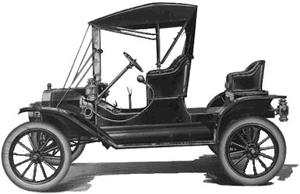 Write a definition of production orientation here:

________________________________________________________________________________________________________________________________________________________________________________________________________________________________________________________________________________________________________________________________________

[](https://www.apple.com/uk/ipad-pro/?afid=p238|s0w75KfkP-dc_mtid_187079nc38483_pcrid_342915389916_&cid=aos-uk-kwgo-ipad--slid--bran-apple+ipad+pro-e-product-)More product orientation examples:

________________________________________________________________________________________________________________________________________________________________________________________________________________________________________________________________________________________________________________________________________

Product orientation – Gillette

_______________________________________________________________________________________________________________________________________________________________________________________________________________________________________________________________________________________________________________________________________­­_

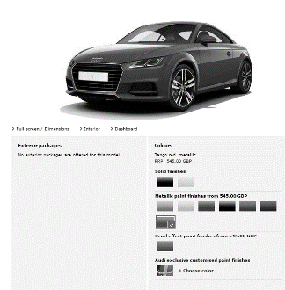Definition of market orientation:

________________________________________________________________________________________________________________________________________________________________________________________________________________________________________________________________________________________________________________________________________

Why is ASDA chosen by you an example of market orientation?



Market or product orientated:

|  |  |
| --- | --- |
|  |  |
|  |  |

Benefits to business of effective market research:

Benefits to a business of researching their market:

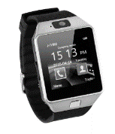







Write a definition of primary market research here:

________________________________________________________________________________________________________________________________________________________________________________________________________________________________________________________________________________________________________________________________________

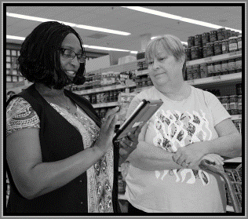What is primary research?

________________________________________________________________________________________________________________________________________________________________________________________________________________________________________________________________________________________________________________________________________

Primary Research methods:

|  |  |
| --- | --- |
| Questionnaires (surveys) |  |
| Observation |  |
| Customer interviews |  |
| Test Marketing |  |
| Focus groups |  |

Write a definition of secondary research here:

________________________________________________________________________________________________________________________________________________________________________________________________________________________________________________________________________________________________________________________________________

Secondary research methods:

|  |  |
| --- | --- |
| Government Sources |  |
| Trade Publications |  |
| Market reports |  |
| Internet sources |  |
| Newspapers / Magazines / TV / Radio |  |

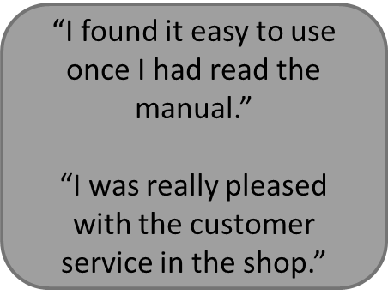 Qualitative research

________________________________________________________________________________________________________________________________________________________________________________________________________________________________________________________________________________________________________________________________________

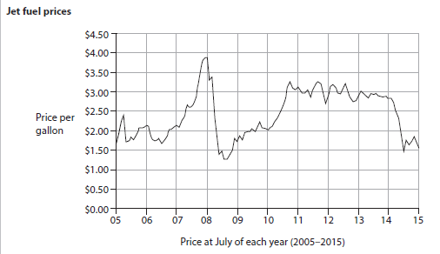Quantitative research

________________________________________________________________________________________________________________________________________________________________________________________________________________________________________________________________________________________________________________________________________

Sampling

* Sampling is the process of choosing the _____________________ people to be part of the research
* For example: ________________________ is a pet food manufacturer, they would only want to sample __________________ owners in their research

Sample size

* A sample size is the number of people who are ________________________ during the research
* The sample size needs to be _____________________ enough that the data has statistical ______________________ and can be useful to the business for _________________________ making

Bias

* Bias is when research __________________________ cannot be ______________________________ because of the way the research has been carried out. This can be through;
  + _________________________ bias
  + Biased _____________________________ e.g. “You really like shopping at the co-op don’t you?”
  + ________________________ bias e.g. They already use a different product or work for a marketing company

[](https://www.youtube.com/watch?v=B96LC_aFRFY)Websites

________________________________________________________________________________________________________________________________________________________________________________________________________________________________________________________________________________________________________________________________________

Social networks - twitter

________________________________________________________________________________________________________________________________________________________________________________________________________________________________________________________________________________________________________________________________________

[](https://my.morrisons.com/more/)Business databases

________________________________________________________________________________________________________________________________________________________________________________________________________________________________________________________________________________________________________________________________________

 Write a definition of market segments here:

________________________________________________________________________________________________________________________________________________________________________________________________________________________________________________________________________________________________________________________________________

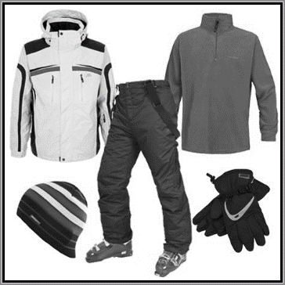Segmentation by location

________________________________________________________________________________________________________________________________________________________________________________________________________________________________________________________________________________________________________________________________________

Which location segments are these products aimed at?

|  |  |
| --- | --- |
|  |  |
| Image result for scottish products |  |
| Image result for welsh products |  |
|  |  |
|  |  |
| Image result for beach towel set |  |

Market segment demographics

________________________________________________________________________________________________________________________________________________________________________________________________________________________________________________________________________________________________________________________________________

Segmentation by lifestyle

________________________________________________________________________________________________________________________________________________________________________________________________________________________________________________________________________________________________________________________________________

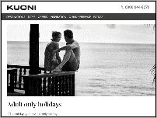Segmentation by lifestyle

________________________________________________________________________________________________________________________________________________________________________________________________________________________________________________________________________________________________________________________________________

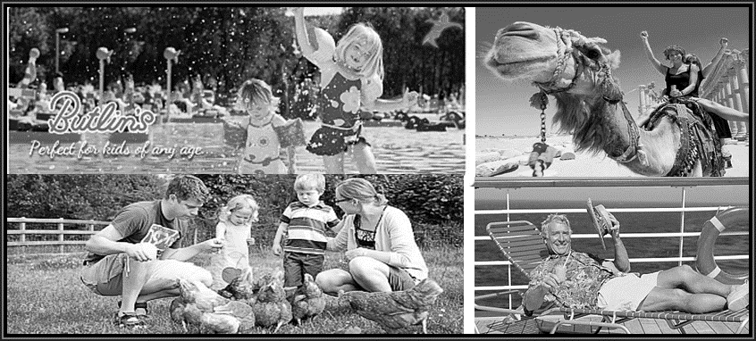

Segmentation by lifestyle – look at the 4 photos and describe the lifestyle segment that the holidays are aimed at. Try and say more than just the age of the segment, what kind of lifestyle do they enjoy?

Segmentation by income

________________________________________________________________________________________________________________________________________________________________________________________________________________________________________________________________________________________________________________________________________

What income groups are these products aimed at?



Segmentation by age

_______________________________________________________________________________________________________________________________________________________________________________________________________________________________________________________________________________________________________________________________________

What segmentation age do you think these products are aimed at?

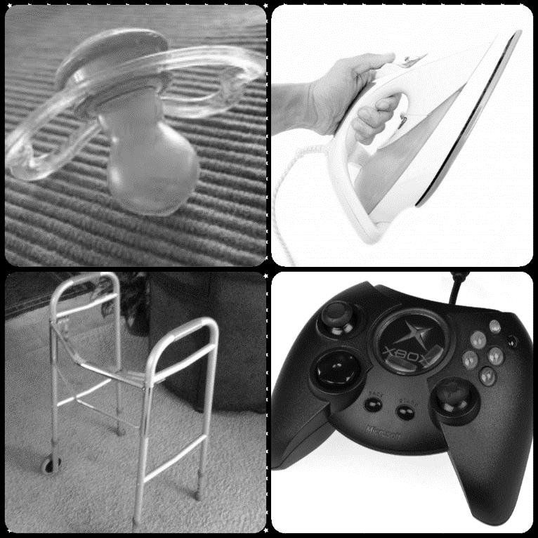

Discussion – can you explain why Kellog’s has so many different brands in its portfolio? Why don’t they just produce one cereal and we all have to eat it?

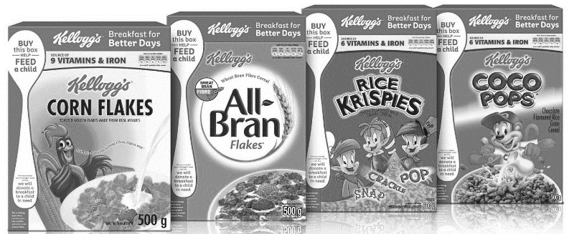

_______________________________________________________________________________________________________________________________________________________________________________________________________________________________________________________________________________________________________________________________________

Which age segmentation? Use the space to explain why.

|  |  |
| --- | --- |
| ($15, amazon.com) Get her a little something to help keep her first dorm room clean — just don't take it personally. |  |
|  |  |

Segmentation by gender

_______________________________________________________________________________________________________________________________________________________________________________________________________________________________________________________________________________________________________________________________________

Which gender segments are these products aimed at?

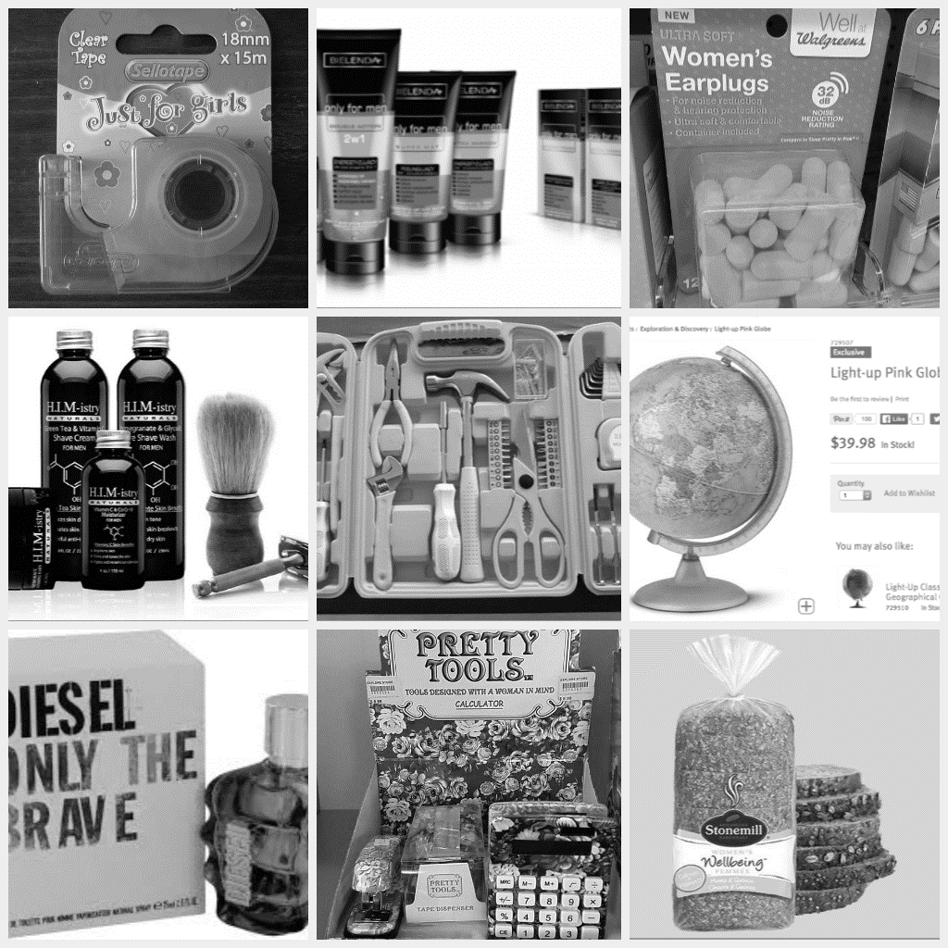

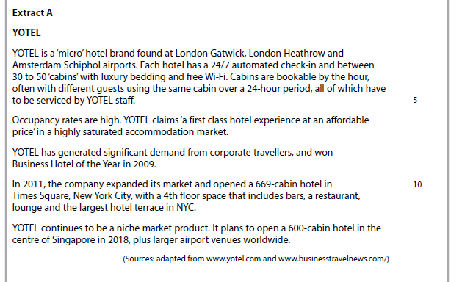



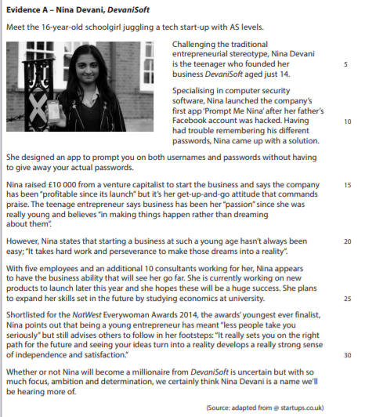

Evaluate the extent to which Devanisoft is a product orientated business [12]