Q1.Figure 1 shows how energy and biomass pass along a food chain.
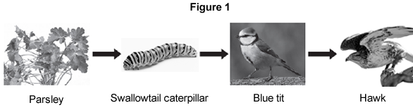
(a) The parsley shown in Figure 1 carries out photosynthesis.
.............................................................................................................................
.............................................................................................................................
.............................................................................................................................
.............................................................................................................................
(2)

(b) Which diagram shows the pyramid of biomass for the food chain in Figure 1?
Why is photosynthesis important in the food chain?
Tick (✔) one box.
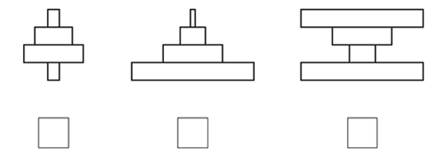
(1)

(c) Figure 2 shows the ways a swallowtail caterpillar transfers 20 J of energy from food.
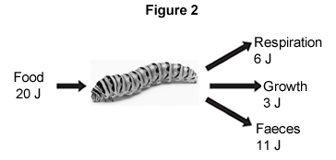
What percentage of the energy in the caterpillar’s food is used for growth?
.............................................................................................................................
.............................................................................................................................
Percentage = ...................................................
(2)
(d) The organisms in the food chain are adapted for survival.
(i) Figure 3 shows a swallowtail caterpillar seen from the back.
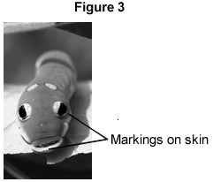
Suggest how the swallowtail caterpillar shown in Figure 3 is adapted to reduce the chance of being eaten by blue tits.
...................................................................................................................
...................................................................................................................
...................................................................................................................
...................................................................................................................
(2)

(ii) Figure 4 shows a hawk.
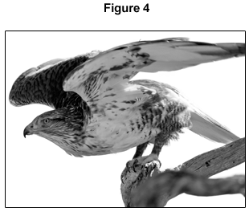
Suggest two ways that the hawk is adapted to catch and kill blue tits.
1 ................................................................................................................
...................................................................................................................
2 ................................................................................................................
...................................................................................................................
(2)
(Total 9 marks)
Blue tit: ©JensGade/iStock
Parsley: © Warren_Price/iStock
Caterpillar ©prettyzhizhi/iStock
Hawk: © kojihirano/iStock
Swallowtail caterpillar: © Anna_Po/iStock

Q2.The figure below shows the amount of forest cover on an island in Asia, in 1973 and in 2010.
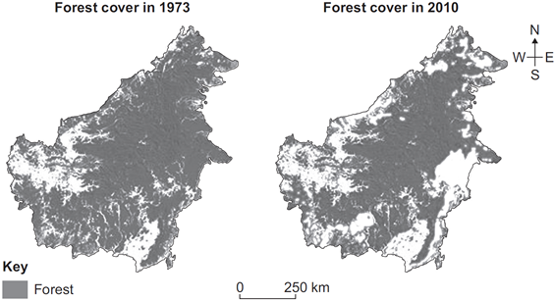
(a) (i) Deforestation has decreased the amount of forest cover on the island.
Describe the change in the pattern of forest cover on the island.
...................................................................................................................
...................................................................................................................
...................................................................................................................
...................................................................................................................
(2)

(ii) Give two possible reasons why the amount of forest has decreased between 1973 and 2010.
1 ................................................................................................................
...................................................................................................................
2 ................................................................................................................
...................................................................................................................
(2)

(b) Scientists are concerned about the effects of a decrease in forest cover on ecosystems.
Give two possible negative effects of the decrease in forest cover on ecosystems.
1 ..........................................................................................................................
.............................................................................................................................
2 ..........................................................................................................................
.............................................................................................................................
(2)
(Total 6 marks)

Q3.A grassy field on a farm measured 120 metres by 80 metres.
A student wanted to estimate the number of buttercup plants growing in the field.
The student found an area where buttercup plants were growing and placed a 1 m × 1 m quadrat in one position in that area.
Figure 1 shows the buttercup plants in the quadrat.
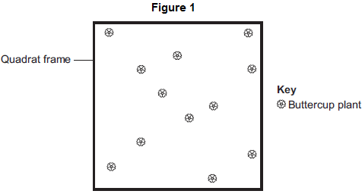
The student said, 'This result shows that there are 115 200 buttercup plants in the field.'
(a) (i) How did the student calculate that there were 115 200 buttercup plants in the field?
...............................................................................................................
...............................................................................................................
...............................................................................................................
...............................................................................................................
(2)

(ii) The student’s estimate of the number of buttercup plants in the field is probably not accurate. This is because the buttercup plants are not distributed evenly.
How would you improve the student’s method to give a more accurate estimate?
...............................................................................................................
...............................................................................................................
...............................................................................................................
...............................................................................................................
(2)

(b) Sunlight is one environmental factor that might affect the distribution of the buttercup plants.
(i) Give three other environmental factors that might affect the distribution of the buttercup plants.
1...............................................................................................................
2...............................................................................................................
3...............................................................................................................
(3)
(ii) Explain how the amount of sunlight could affect the distribution of the buttercup plants.
(3)

(c) Figure 2 is a map showing the position of the farm and a river which flows through it.
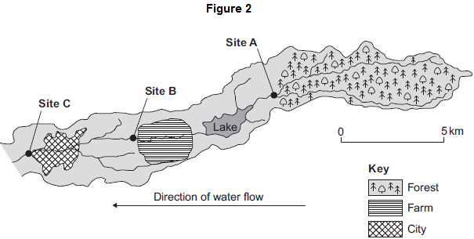
Every year, the farmer puts fertiliser containing mineral ions on some of his fields.When there is a lot of rain, some of the fertiliser is washed into the river.
(i) When fertiliser goes into the river, the concentration of oxygen dissolved in the water decreases.
Explain why the concentration of oxygen decreases.
...............................................................................................................
...............................................................................................................
...............................................................................................................
...............................................................................................................
...............................................................................................................
...............................................................................................................
...............................................................................................................
...............................................................................................................
...............................................................................................................
...............................................................................................................
(5)
(ii) There is a city 4 km downstream from the farm.
Apart from fertiliser, give one other form of pollution that might go into the river as it flows through the city.
...............................................................................................................
(1)

(d) Three sites, A, B and C, are shown in Figure 2.
Scientists took many samples of river water from these sites.
The scientists found larvae of three types of insect in the water: mayfly, stonefly and caddisfly. For each type of insect the scientists found several different species.
The scientists counted the number of different species of the larvae of each of the three types of insect.
Figure 3 shows the scientists’ results.
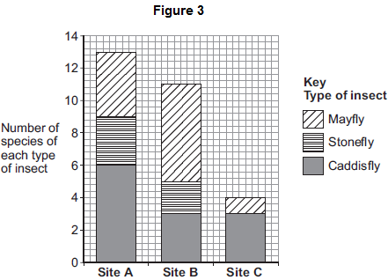
(i) How many more species of mayfly were there at Site B than at Site A?
........................................
(1)

(ii) Suggest what caused this increase in the number of species of mayfly.
...............................................................................................................
...............................................................................................................
(1)

(iii) The scientists stated that the number of species of stonefly was the best indicator of the amount of oxygen dissolved in the water.
Use information from Figure 3 to suggest why.
(1)
(Total 19 marks)

Q4. Animals in a habitat compete with each other.
(a) Give two factors for which animals may compete.
1 ......................................................................................................................
2 ......................................................................................................................
(2)

(b) The photographs show a mule deer and a white-tailed deer.
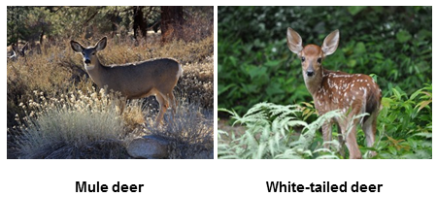
Mule deer by Dcrjsr (Own work) [CC-BY-3.0], via Wikimedia Commons. White-tailed deer by
Clay Heaton (Own work) [CC-BY-SA-3.0], via Wikimedia Commons
Mule deer and white-tailed deer live together in the same national park in the USA.
The graph shows changes in the populations of the two deer species between 1983 and 1999.
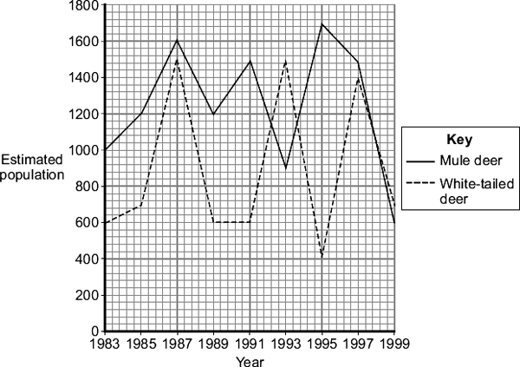
(i) Describe the changes in the population of white-tailed deer between 1991 and 1995.
...............................................................................................................
...............................................................................................................
...............................................................................................................
...............................................................................................................
(2)

(ii) Use information from the graph to suggest an explanation for changes in the population of white-tailed deer between 1991 and 1995.
...............................................................................................................
...............................................................................................................
...............................................................................................................
...............................................................................................................
(2)
(Total 6 marks)

Q5.Organisms compete with each other.
(a) Figure 1 shows two types of seaweed which live in similar seashore habitats.
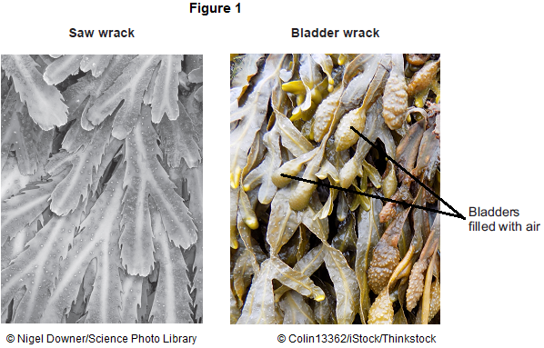
Most of the time the two seaweeds are covered with water.
Bladder wrack has bladders filled with air.
Bladder wrack grows more quickly than saw wrack.
Suggest an explanation why.
........................................................................................................................
........................................................................................................................
........................................................................................................................
........................................................................................................................
........................................................................................................................
........................................................................................................................
........................................................................................................................
(3)

(b) Figure 2 shows an angler fish.
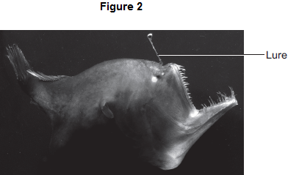
© Dante Fenolio/Science Photo Library
Angler fish live at depths of over 1000 m.
In clear water, sunlight does not usually reach more than 100 m deep.
Many angler fish have a transparent ‘lure’ containing a high concentration of bioluminescent bacteria.
Bioluminescent bacteria produce light.
Suggest an advantage to the angler fish of having a lure containing bioluminescent bacteria.
........................................................................................................................
........................................................................................................................
........................................................................................................................
........................................................................................................................
........................................................................................................................
(2)
(Total 5 marks)

Q6. Desert plants are adapted for survival in a dry climate.
(a) Joshua trees live in deserts.
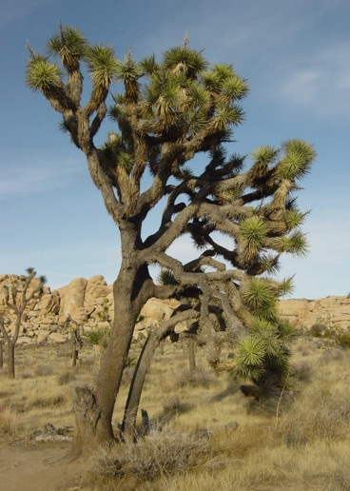
By nyenyec [CC BY-SA 3.0], via Wikimedia Commons
Joshua trees have two different types of root:
• a system of shallow roots spread out over a large area• roots about 1 m in diameter, shaped like bulbs, deep in the soil.
Explain the advantage to the Joshua tree of having:
(i) shallow roots spread out over a large area
...............................................................................................................
...............................................................................................................
...............................................................................................................
...............................................................................................................
(2)

(ii) large, bulb-like roots deep in the soil.
...............................................................................................................
...............................................................................................................
(1)

(b) Creosote bushes also live in deserts.
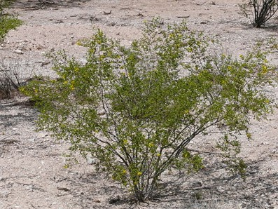
By Sue in az (Own work) [Public domain], via Wikimedia Commons
The leaves of creosote bushes:• are covered with a layer of wax
• fold together during the day.
Explain how the leaves of the Creosote bush help it to survive in deserts.
........................................................................................................................
........................................................................................................................
........................................................................................................................
........................................................................................................................
........................................................................................................................
........................................................................................................................
(3)
(Total 6 marks)

Q7.On a rocky shore, when the tide goes in and out, organisms are exposed to the air for
different amounts of time.
(a) On hot, windy days when the tide is out the concentration of the salt solution in rock pools may become very high.
What term is used to describe organisms that can survive in severe conditions such as very high concentrations of salt solution?
.................................................................................................................................
(1)

(b) Periwinkles are types of snail.
Students surveyed the different types of periwinkle living on a rocky shore.
The diagram shows the results of the students’ survey.
The highest position that the sea water reaches on the shore is called the high tide level.
Each bar represents the range of habitats for each type of periwinkle.
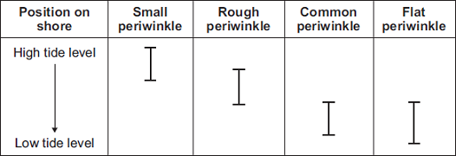
(i) Which two types of periwinkle are likely to compete with each other to the greatest extent?
...............................................................................................................
(1)

(ii) Explain your answer to part (b)(i).
...............................................................................................................
...............................................................................................................
(1)

(iii) The small periwinkle can survive much nearer to the high tide level than the flat periwinkle.
Suggest two reasons why the flat periwinkle cannot survive near to the high tide level.
1.............................................................................................................
...............................................................................................................
...............................................................................................................
2.............................................................................................................
...............................................................................................................
...............................................................................................................
(2)
(Total 5 marks)

Q8. The photograph shows a lionfish. Lionfish are normally found in the Pacific Ocean.
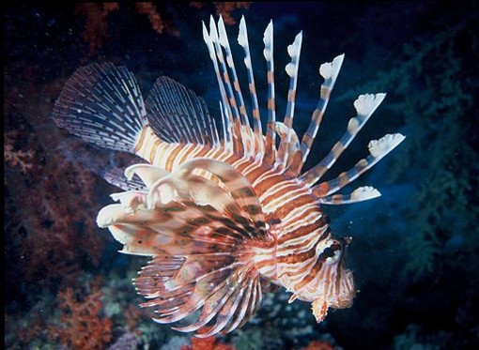
By Albert Kok at nl.wikipedia [Public domain], from Wikimedia Commons
In 1992 six lionfish escaped from an aquarium into the Atlantic Ocean.
Now there are thousands of lionfish in the Atlantic Ocean. Numbers of the native Atlantic fish have gone down because the lionfish have eaten many native Atlantic fish.
Suggest explanations for the large increase in the number of lionfish in the Atlantic Ocean.
.................................................................................................................................
.................................................................................................................................
.................................................................................................................................
.................................................................................................................................
.................................................................................................................................
.................................................................................................................................
.................................................................................................................................
.................................................................................................................................
(3)
(Total 3 marks)

M1.(a) any two from:
• idea of absorption of light / energy
• transfer to chemical energy
allow produce sugars / glucose / starch / carbohydrate / food / biomass
• provides food / energy for animals / caterpillar
• releases oxygen
2

(b) 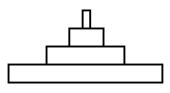
1

(c) 15(%)
allow 1 mark for 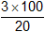 with no answer or incorrect answer
or
allow 1 mark for 0.15
2

(d) (i) any two from:
• markings look like eyes / face / mouth of much larger animal
• looks fierce / scary / dangerous
allow it looks like a snake
• to frighten blue tit / bird
max 1 if reference to camouflage
2

(ii) any two from:
• sharp / long / big claws
ignore strong
• sharp / hooked beak
ignore strong / big
• large wings or flies quickly
allow streamlined / aerodynamic
ignore powerful wings
• good eyesight
2
[9]

M2.(a) (i) forest at the edges (of the island) has been removed
allow centrally the forest remains
1

an appropriate area on the island is identified eg south east or bottom right
1

(ii) any two from:
• (to provide land) for farming / agriculture
• (to provide land) for quarrying
• (to provide land / wood) for building
allow to provide timber
• to provide fuel
• to produce paper
allow forest fires
2

(b) any two from:
• decreased biodiversity
• loss of habitats
• increased carbon dioxide (concentration)
• global warming
allow effects of global warming eg flooding / rise in sea level
allow soil erosion
2
[6]

M3.(a) (i) counts / 12
1
× 120 × 80 / × 9600
or
× area of field
1
(ii) (more) quadrats / repeats
1
placed randomly
ignore method of achieving randomness
1

(b) (i) any three from:
• temperature / warmth / heat
• water / rain
• minerals / ions / salts (in soil)
allow nutrients / fertiliser / soil fertility
ignore food
• pH (of soil)
• trampling
• herbivores
ignore predators
• competition (with other species)
• pollution qualified e.g. SO₂ / herbicide
• wind (related to seed dispersal).
ignore space / oxygen / CO₂ / soil unqualified
3

(ii) light needed for photosynthesis
1
for making food / sugar / etc.
1
effect on buttercup distribution eg more plants in sunny areas / fewer plants in shady areas
1
(c) (i) fertiliser / ions / salts cause growth of algae / plants
1
(algae / plants) block light
1
(low light) causes algae / plants to die
1
microorganisms / bacteria feed on / break down / cause decay of organic matter / of dead plants
do not allow germs / viruses
1
(aerobic) respiration (by microbes) uses O₂
do not allow anaerobic
1

(ii) sewage / toxic chemicals / correct named example eg metals / bleach / disinfectant / detergent etc
allow suitable named examples eg metals such as Pb / Zn / Cr / oil / SO₂ / acid rain / pesticides / litter
ignore chemicals unqualified
ignore waste unqualified
ignore human waste / domestic waste / industrial waste unqualified
1

(d) (i) 2
1
(ii) more food
allow other sensible suggestion eg more species colonise from tributary streams after forest
1
(iii) number of stonefly species decreases (from A to B / B to C / A to C) as more pollution enters river / less oxygen
allow fewer species in more polluted water
ignore none are found at site C
1
[19]

M4. (a) any two from:
• food / feeding
ignore water
• mates / mating
• territory / space / land / shelter / nesting sites
ignore homes / place to live / habitat / resources
• status (within group)
2

(b) (i) rises to 1480 to 1500
or rises by 880 to 900
or rises until 1993
ignore incorrect figures if 1993 given
1

falls to 400 to 440 or falls by 1040 to 1100
if neither mark gained then allow 1 mark for rise followed by fall or fell by 160 to 200
1

(ii) rises because: -
less competition from mule deer
or mule deer population falling
or fewer mule deer
ignore reference to food / breeding
ignore reference to predation / disease
1

falls because: -
more competition from mule deer
or mule deer population rising
or more mule deer
ignore more / less suited to environment
if neither mark gained then correct reference to competition gains 1 mark
1
[6]

M5.(a) gets more light (near surface)
allow warmer (near surface)
allow bladders contain (more) carbon dioxide
1

(so) photosynthesises more
1

(because) bladders aid floating (when tide is in)
or
(so) more biomass / glucose / starch produced
ref to ‘more’ needed only once, eg gets more light for photosynthesis gains two marks
if ‘more’ not given do not award mark on the first occasion
1

(b) lets angler fish see / attract its prey / mates or see predators as it is dark (at 1000m)
or
lets angler fish see / attract prey to get food
or
lets angler fish see / attract mates to reproduce
or
lets angler fish see predators to avoid being eaten
must be in a correct pair to gain two marks
2
[5]

M6. (a) (i) increased water uptake
ignore nutrients / food
allow quicker water uptake
allow collects water over larger area
1

(after) rain
accept ideas in terms of more successful competitor
1

(ii) water storage or stability or safety from predators
ignore absorption of water from soil
1

(b) reduces water loss / evaporation
accept reduces transpiration
allow stops water loss
1

wax protects plant or reflects heat or keeps plant cool or unpalatable
ignore reflects light
1

folding reduces surface area or folding reduces warming
accept enclosed stomata or less exposure of stomata or increased humidity or less water concentration gradient
allow prevents burning
ignore less likely to be damaged
1
[6]

M7.(a) extremophile(s)
1

(b) (i) common (periwinkle) and flat (periwinkle)
either order, both required
1

(ii) (common and flat) both live in the same habitat / area / named area
allow habitats overlap the most
1

(iii) any two from:
• would have wrong food
• would otherwise be exposed to (specific) predators
• cannot tolerate extended exposure to air or reduced submersion in seawater
allow cannot tolerate temperature / dehydration
• cannot tolerate high salt concentration (in rock pools)
allow low salt concentration (in rock pools)
• cannot compete with small periwinkle
2
[5]

M8. there are no / few predators of the lionfish
or spines protect lionfish from predation
allow warning colouration / poisonous
or no / fewer disease organisms
1

predators / prey in Atlantic do not recognise lionfish
or not fished by humans
allow high reproduction
1

also there is abundant food in Atlantic
or there is no / less competition in Atlantic
ignore adaptation to new environment
1
[3]

