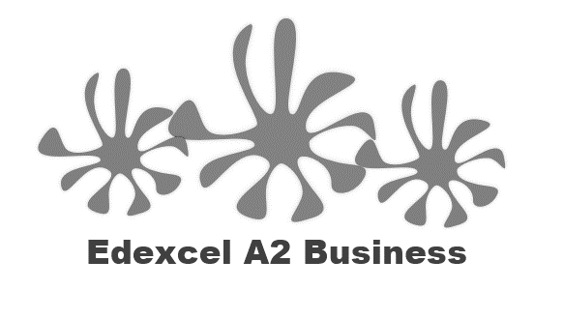



Spot the odd one out – which one is NOT a stakeholder of a business?

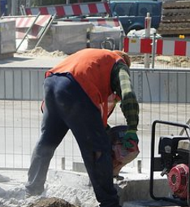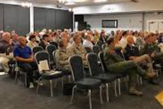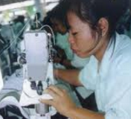

Write the definitions here:

|  |  |
| --- | --- |
|  |  |
|  |  |

Internal stakeholders:

|  |  |  |
| --- | --- | --- |
|  | Who? | Interest in the business |
|  |  |  |
|  |  |  |
|  |  |  |

External stakeholders:

|  |  |  |
| --- | --- | --- |
|  | Who? | Interest in the business |
|  |  |  |
|  |  |  |
|  |  |  |
|  |  |  |
|  |  |  |

Tesco PLC

Analysis of stakeholders - suppliers

**Who are they?**

|  |
| --- |
|  |

**Are they internal or external to the business?**

|  |
| --- |
|  |

**What power do they have?**

|  |
| --- |
|  |

**What interest do they have in the business?**

|  |
| --- |
|  |

**What influence do they have?**

|  |
| --- |
|  |

**Is the influence positive or negative?**

|  |
| --- |
|  |

**Do their objectives conflict with those of the Directors / Owners?**

|  |
| --- |
|  |

**Step 1**

**__________________________________________________________________________________**

**Step 2**

**__________________________________________________________________________________**

**Step 3**

**__________________________________________________________________________________**

**Step 4**

**__________________________________________________________________________________**

**Step 5**

|  |  |  |
| --- | --- | --- |
|  |  |  |
|  |  |  |
|  |  |  |
|  |  |  |
|  |  |  |
|  |  |  |

**Step 6 and 7**

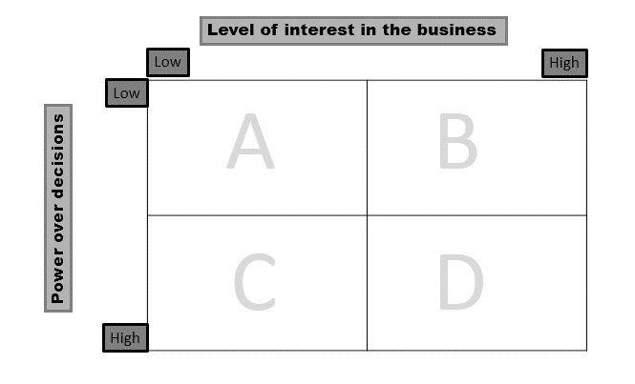

Stakeholder mapping – step 8

_____________________________________________________________________________________________________________________________

|  |  |
| --- | --- |
| A |  |
| B |  |
| C |  |
| D |  |

Stakeholder objectives – possible conflict

|  |  |  |
| --- | --- | --- |
| Customers | Low prices |  |
| Suppliers | High prices for their supplies |  |
| Government | Tax, CMA |  |
| Unions | Working conditions and pay |  |
| Employees | Pay and job security |  |
| Managers | Budgets, promotion |  |
| Competitors | Small local independents see Tesco’s as a threat |  |

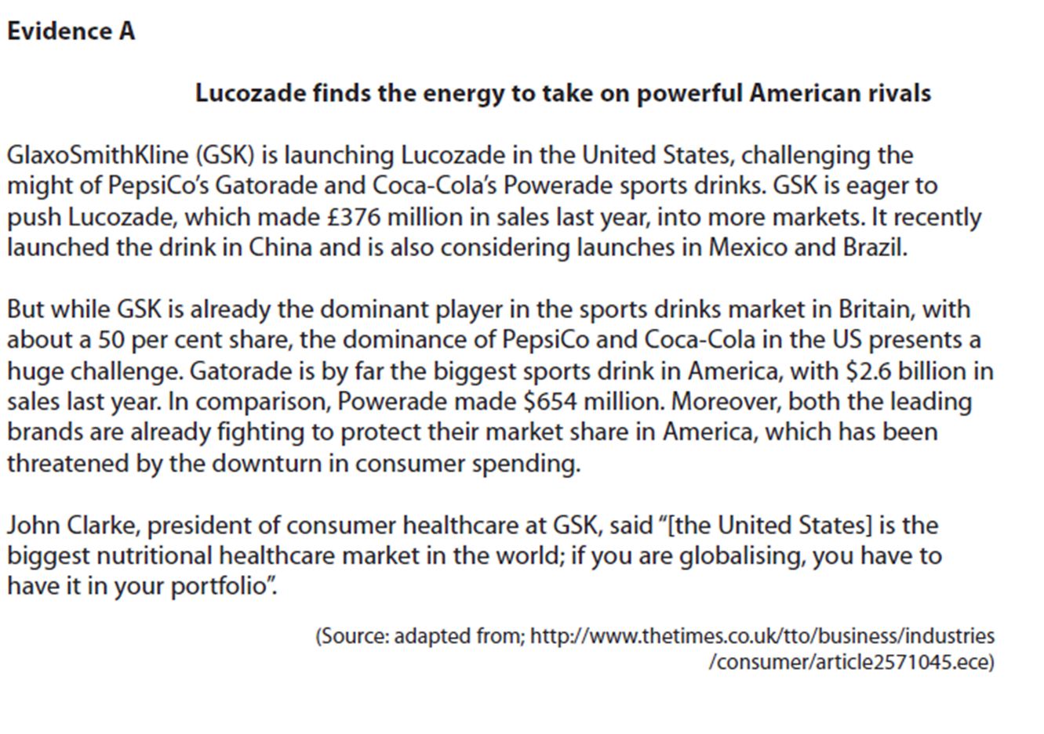



[9]

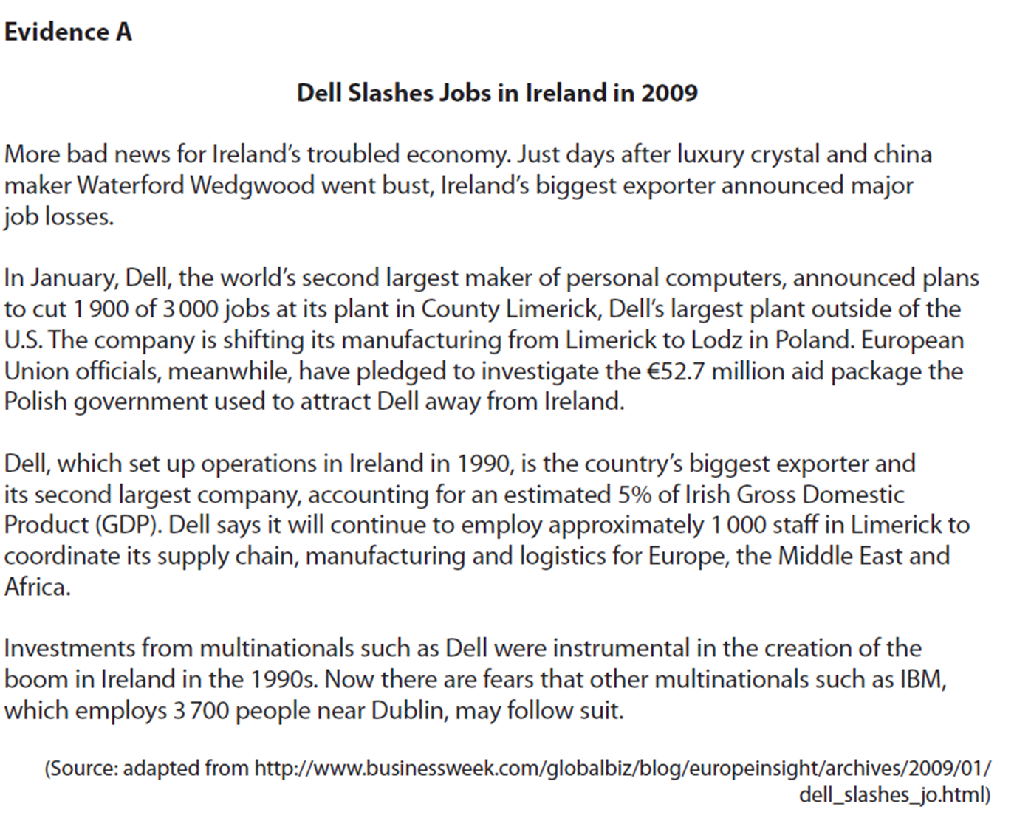

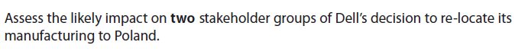

[9]