



[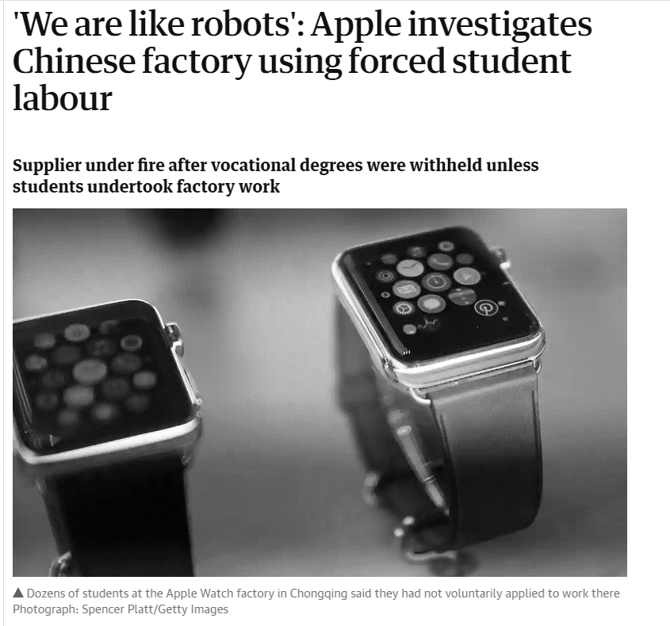](https://www.theguardian.com/technology/2018/oct/30/we-are-like-robots-apple-investigates-chinese-factory-using-forced-student-labour?CMP=share_btn_tw)

|  |  |
| --- | --- |
| 1. Where is the factory that Apple is investigating? |  |
| 2. Who carried out the research according to the article? |  |
| 3. What is an Apple Internship a disguise for? |  |
| 4. How long is a working day for the students? |  |
| 5. Do you consider this kind of business practice to be ethical? |  |

Stakeholder conflict map

MNC objectives vs stakeholders

________________________________________________________________________________________________________________________________________________________________________________________________________________________________________________________________________________________________________________________________________

Shareholder objectives vs ethical objectives

|  |  |
| --- | --- |
| **Shareholder objectives** | **Ethical corporate objectives** |
|  |  |

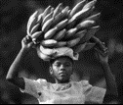Stakeholders – labour exploitation

________________________________________________________________________________________________________________________________________________________________________________________________________________________________________________________________________________________________________________________________________

**Pay and working conditions**

Pay

________________________________________________________________________________________________________________________________________________________________________________________________________________________________________________________________________________________________________________________________________

____________________________________________________________________________________________________________________________________________________________________

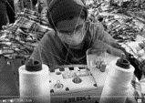Working conditions

________________________________________________________________________________________________________________________________________________________________________________________________________________________________________________________________________________________________________________________________________

**Environmental considerations**

________________________________________________________________________________________________________________________________________________________________________________________________________________________________________________________________________________________________________________________________________

MNCs and emissions

________________________________________________________________________________________________________________________________________________________________________________________________________________________________________________________________________________________________________________________________________

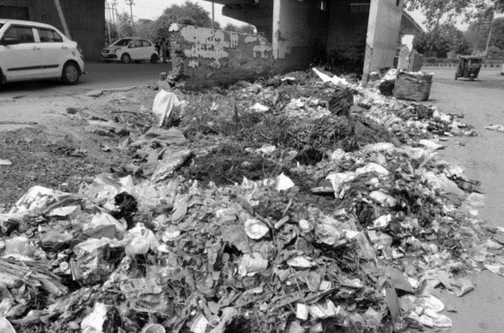

MNC and waste disposal

________________________________________________________________________________________________________________________________________________________________________________________________________________________________________________________________________________________________________________________________________

**Supply chain considerations**

Supply chain problems

* Having part of a -------------------- chain in a developing nation can be a problem for the MNCs
* Many garment factories or labour ----------------------------------------- production processes outsource to slums, refugee camps and unlicensed back street businesses with poor working ---------------------------
* This can mean that labour is intentionally or unessentially -------------------------------- by the MNCs

Forced labour

To better understand what forced labour constitutes in practice, the ILO initially developed a list of six forced labour indicators:

• ---------------------------------- or actual physical harm to the worker

• restriction of ---------------------------------------------- or confinement to the workplace

• ------------------------ bondages

• withholding of --------------------------------- or excessive wage reductions

• retention of -------------------------------- documents

• threat of denunciations to the ---------------------------------

Child labour

* Some children are trapped in forms of _______________________ in armed conflicts, forced labour and debt ________________________ (to pay off debts incurred by parents and grandparents), drug trafficking and organised ____________________ and in many other forms of labour.
* For some work, children receive no payment, only __________________ and a place to ___________________
* ______________________ is the most common reason why children work
* Poor ________________________________ spend the bulk of their income on food and the income provided by working children is often critical to their __________________________

Marketing considerations

Ethics and misleading marketing

|  |  |
| --- | --- |
|  |  |
|  |  |

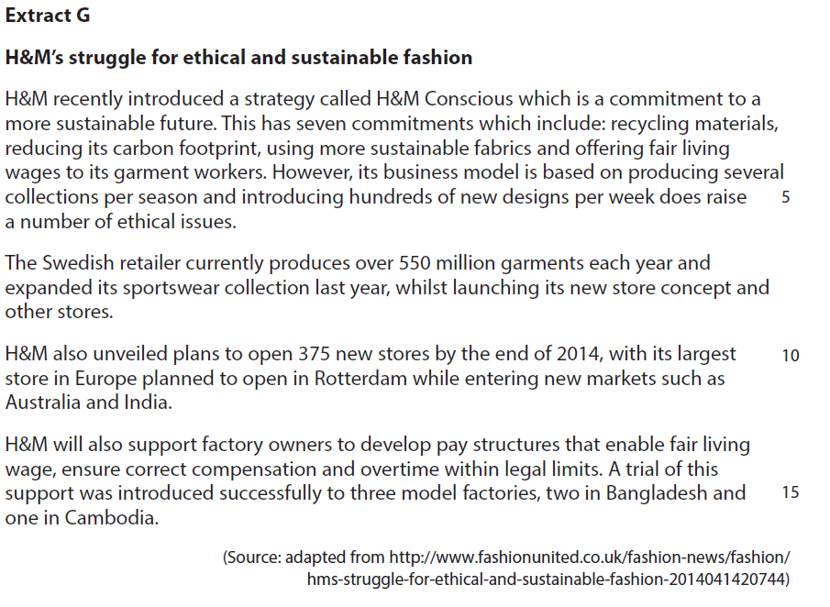

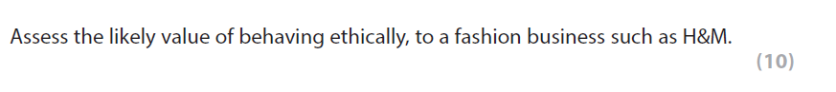

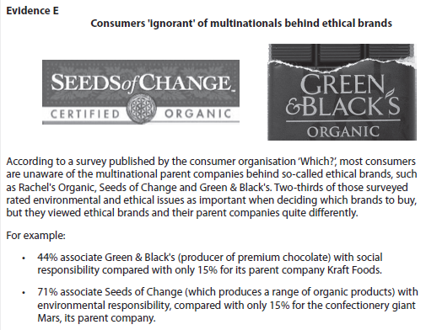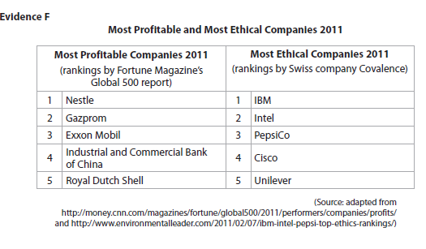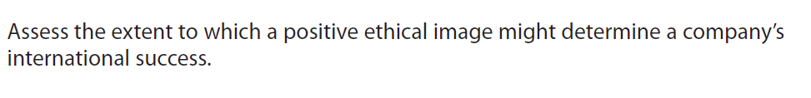

[10]

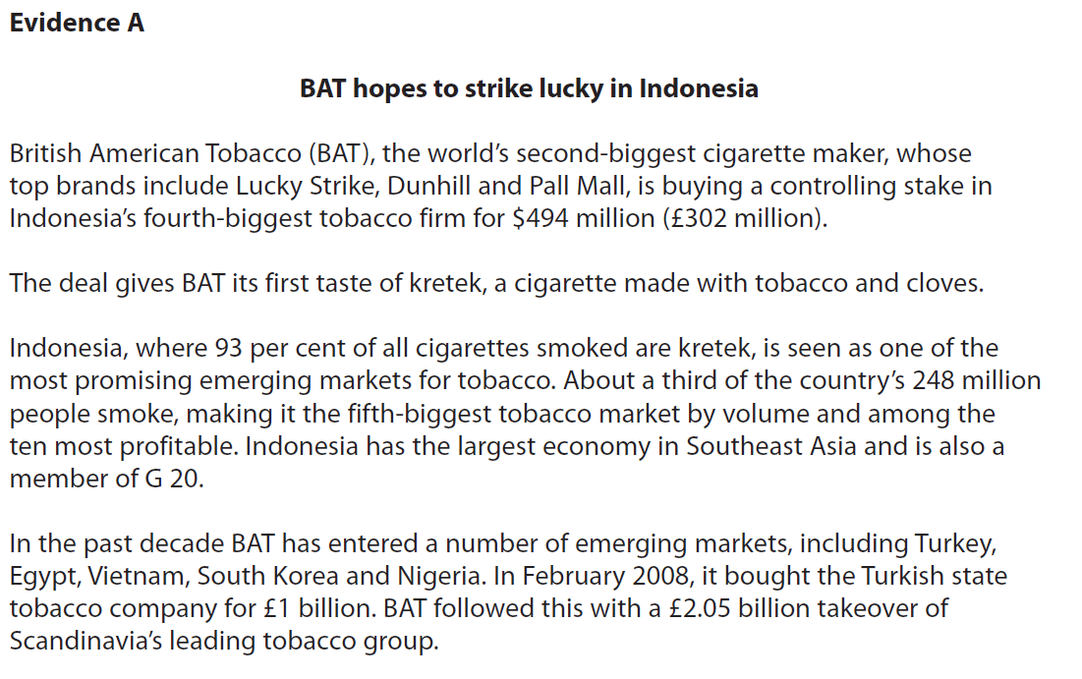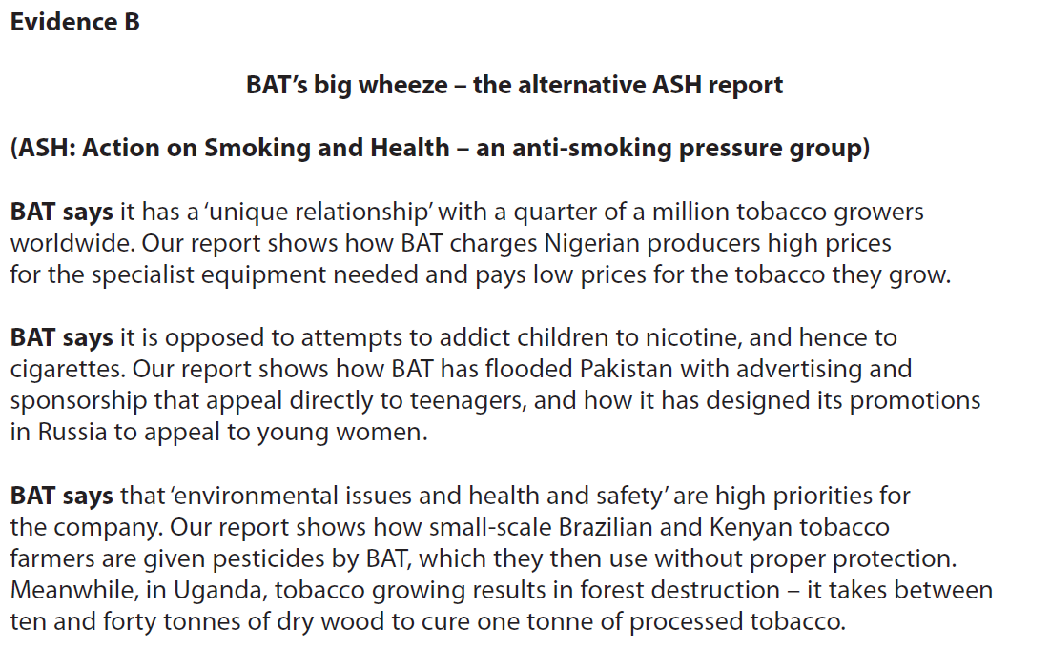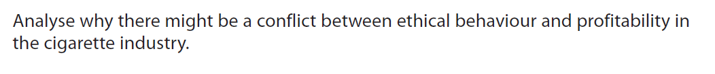

[6]