

2.1.2 External finance

Starter – write a list of words you can use instead of “money” here:

Write a definition of external finance here:

________________________________________________________________________________________________________________________________________________________________________________________________________________________________________________________________________________________________________________________________________



Sources of finance

#1 Family and friends

Sources of finance

________________________________________________________________________________________________________________________________________________________________________________________________________________________________________________________________________________________________________________________________________

|  |  |
| --- | --- |
| Advantages | Disadvantages |
|  |  |

#2 Banks

Sources of finance

________________________________________________________________________________________________________________________________________________________________________________________________________________________________________________________________________________________________________________________________________

|  |  |
| --- | --- |
| Advantages | Disadvantages |
|  |  |

#3 Peer to peer funding

Sources of finance

________________________________________________________________________________________________________________________________________________________________________________________________________________________________________________________________________________________________________________________________________

|  |  |
| --- | --- |
| Advantages | Disadvantages |
|  |  |

#4 Business angels

Sources of finance

________________________________________________________________________________________________________________________________________________________________________________________________________________________________________________________________________________________________________________________________________

|  |  |
| --- | --- |
| Advantages | Disadvantages |
|  |  |

#5 crowd funding

Sources of finance

________________________________________________________________________________________________________________________________________________________________________________________________________________________________________________________________________________________________________________________________________

|  |  |
| --- | --- |
| Advantages | Disadvantages |
|  |  |

#6 Other business

Sources of finance

__________________________________________________________________________________________________________________________________________________________________________________________________________________________________________________________________________________________________________________________________________________________________________________________________________________________

Methods of finance

**Methods of finance**

#1 Loans

Methods of finance

________________________________________________________________________________________________________________________________________________________________________________________________________________________________________________________________________________________________________________________________________

|  |  |
| --- | --- |
| Advantages | Disadvantages |
|  |  |

#2 Share capital

Methods of finance

________________________________________________________________________________________________________________________________________________________________________________________________________________________________________________________________________________________________________________________________________

|  |  |
| --- | --- |
| Advantages | Disadvantages |
|  |  |

 #3 Venture Capital

Methods of finance

________________________________________________________________________________________________________________________________________________________________________________________________________________________________________________________________________________________________________________________________________

|  |  |
| --- | --- |
| Advantages | Disadvantages |
|  |  |

[](https://www.business.natwest.com/business/business-lending-at-natwest/business-overdrafts.html)#4 Overdrafts

Methods of finance

________________________________________________________________________________________________________________________________________________________________________________________________________________________________________________________________________________________________________________________________________

|  |  |
| --- | --- |
| Advantages | Disadvantages |
|  |  |

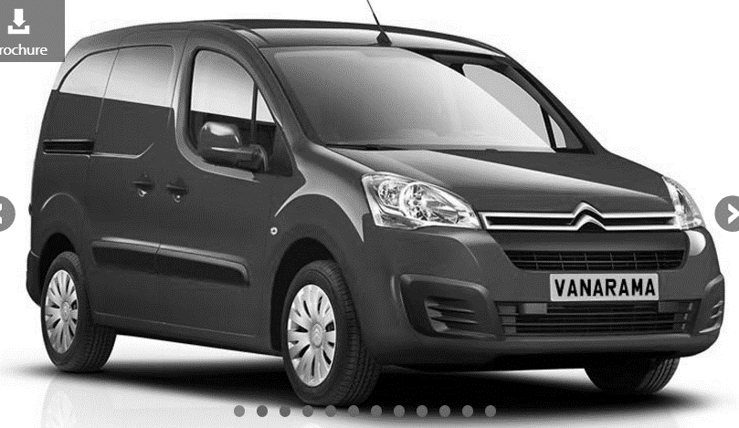#5 Leasing

Methods of finance

________________________________________________________________________________________________________________________________________________________________________________________________________________________________________________________________________________________________________________________________________

|  |  |
| --- | --- |
| Advantages | Disadvantages |
|  |  |

#6 Trade credit

Methods of finance

________________________________________________________________________________________________________________________________________________________________________________________________________________________________________________________________________________________________________________________________________

|  |  |
| --- | --- |
| Advantages | Disadvantages |
|  |  |

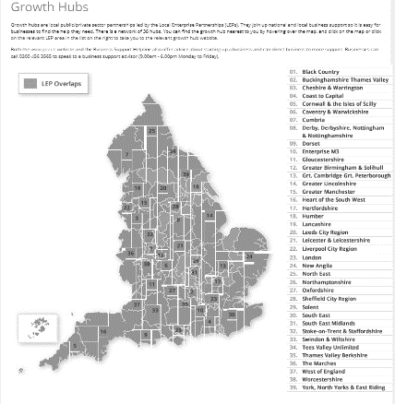#7 Grants

Methods of finance

________________________________________________________________________________________________________________________________________________________________________________________________________________________________________________________________________________________________________________________________________

|  |  |
| --- | --- |
| Advantages | Disadvantages |
|  |  |

