

2.3.1 Profit

Write a definition of profit here:

________________________________________________________________________________________________________________________________________________________________________________________________________________________________________________________________________________________________________________________________________

[](https://www.supergroup.co.uk/media/docs/SuperGroup-2016-Annual-Report-Accounts.pdf)Statement of comprehensive income

________________________________________________________________________________________________________________________________________________________________________________________________________________________________________________________________________________________________________________________________________

________________________________________________________________________________________________________________________________________________________________________________________________________________________________________________________________________________________________________________________________________

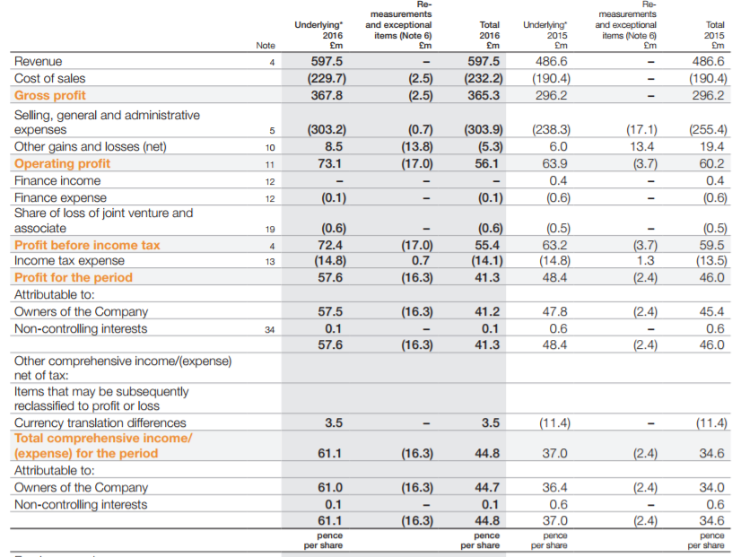

Gross profit formula – write that here:

What is the GP for SuperGroup Plc?

Read it on the statement of comprehensive income



|  |  |
| --- | --- |
| **2015** |  |
| 2016 |  |

Conclusions

________________________________________________________________________________________________________________________________________________________________________________________________________________________________________________________________________________________________________________________________________

Operating profit formula – write that here:



|  |  |
| --- | --- |
| **2015** |  |
| 2016 |  |

Conclusions:

________________________________________________________________________________________________________________________________________________________________________________________________________________________________________________________________________________________________________________________________________

Net profit formula – write that here:



|  |  |
| --- | --- |
| **2015** |  |
| 2016 |  |

Conclusions:

________________________________________________________________________________________________________________________________________________________________________________________________________________________________________________________________________________________________________________________________________

How the statement of comprehensive income helps to measure profitability:

____________________________________________________________________________________________________________________________________________________________________________________________________________________________________________________________________________________________________________________________________________________________________________________________________________________________________________________________________________________________________________

Gross profit margin % – write the formula here:



|  |  |
| --- | --- |
| **2015** |  |
| 2016 |  |

Conclusions:

______________________________________________________________________________________________________________________________________________________________________________________________________________________________________________________

__________________________________________________________________________________

Operating profit margin % – write the formula here:



|  |  |
| --- | --- |
| **2015** |  |
| 2016 |  |

Conclusions:

______________________________________________________________________________________________________________________________________________________________________________________________________________________________________________________

__________________________________________________________________________________

Net profit margin % – write the formula here:



|  |  |
| --- | --- |
| **2015** |  |
| 2016 |  |

Conclusions:

______________________________________________________________________________________________________________________________________________________________________________________________________________________________________________________

__________________________________________________________________________________

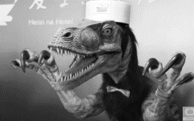Ways to improve profitability:

**Increase revenue**



**Reduce costs**

Profit vs cash

|  |  |
| --- | --- |
| Profit | Cash |
|  |  |

