Product Life Cycle
The product life cycle is an important concept in marketing. It describes the stages a product goes through from when it was first thought of until it finally is removed from the market. Not all products reach this final stage. Some continue to grow and others rise and fall.
What are the main stages of the product life cycle?
The main stages of the product life cycle are:
- Introduction – researching, developing and then launching the product
- Growth – when sales are increasing at their fastest rate
- Maturity – sales are near their highest, but the rate of growth is slowing down, e.g. new competitors in market or saturation
- Decline – final stage of the cycle, when sales begin to fall
This can be illustrated by looking at the sales during the time period of the product.

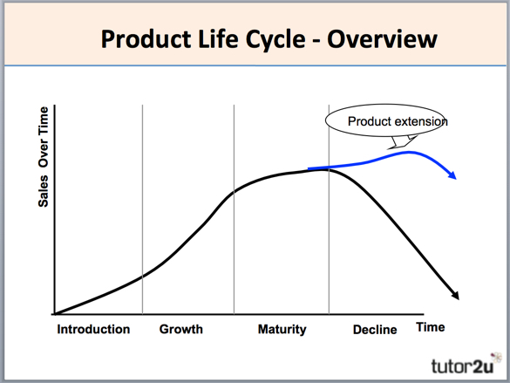
Extending the Product Life Cycle
What can businesses do to extend the product life cycle?
- Extension strategies extend the life of the product before it goes into decline. Again businesses use marketing techniques to improve sales. Examples of the techniques are:
- Advertising – try to gain a new audience or remind the current audience
- Price reduction – more attractive to customers
- Adding value – add new features to the current product, e.g. improving the specifications on a smartphone
- Explore new markets – selling the product into new geographical areas or creating a version targeted at different segments
- New packaging – brightening up old packaging or subtle changes

