3.6.2 Key factors in change

Write a definition of change management here:

________________________________________________________________________________________________________________________________________________________________________________________________________________________________________________________________________________________________________________________________________
Two types of change:

Planned change | Emergent change

Organisational culture – factor in change
________________________________________________________________________________________________________________________________________________________________________________________________________________________________________________________________________________________________________________________________________
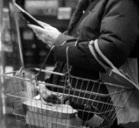
Size of organisation – factor in change

________________________________________________________________________________________________________________________________________________________________________________________________________________________________________________________________________________________________________________________________________
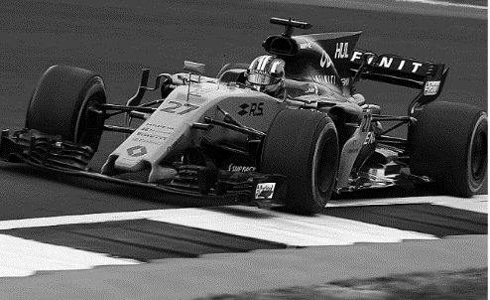
Time / speed of change – factor in change
________________________________________________________________________________________________________________________________________________________________________________________________________________________________________________________________________________________________________________________________________

Change – continuous improvement

________________________________________________________________________________________________________________________________________________________________________________________________________________________________________________________________________________________________________________________________________

Traditional | Kaizen

Dr Kotter’s 8 steps:

Change - Cadbury

________________________________________________________________________________________________________________________________________________________________________________________________________________________________________________________________________________________________________________________________________
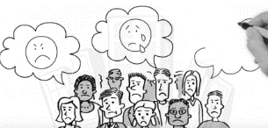
Resistance to change defined

________________________________________________________________________________________________________________________________________________________________________________________________________________________________________________________________________________________________________________________________________
Resistance to change – the employee perspective

________________________________________________________________________________________________________________________________________________________________________________________________________________________________________________________________________________________________________________________________________
Managing resistance to change

Ways to reduce resistance to change

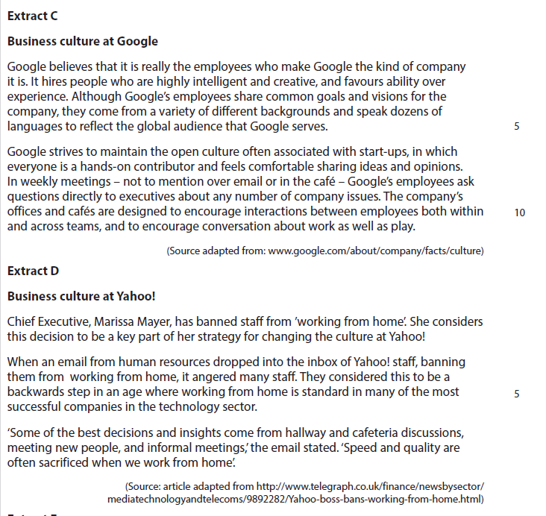
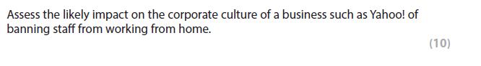

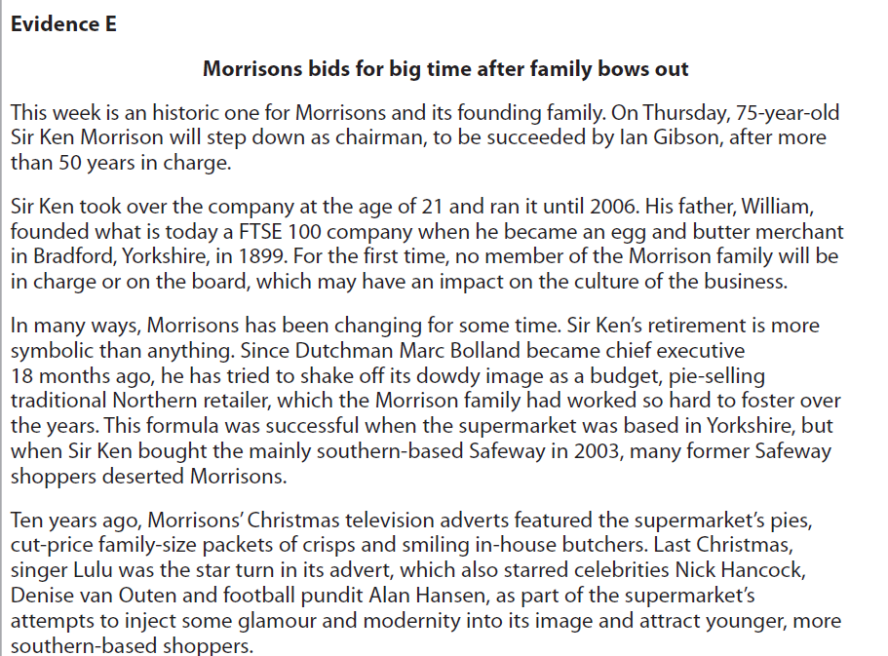

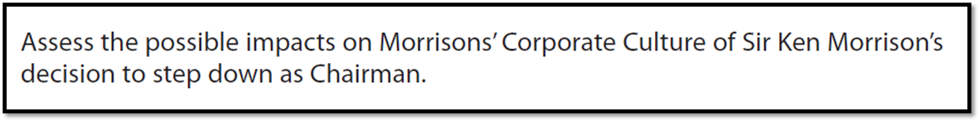
[8]

