1.3.4 Distribution

Starter
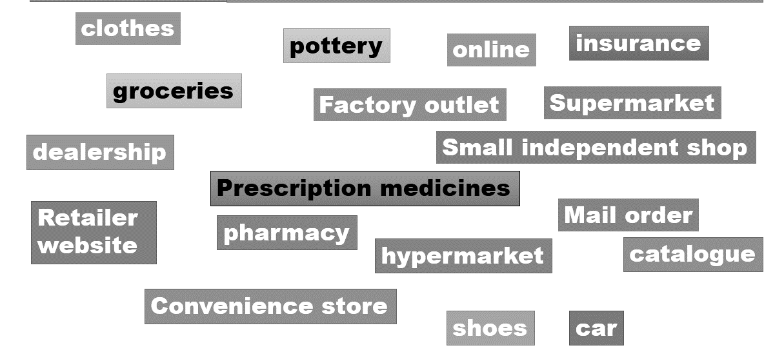

Write your definition of distribution here:
________________________________________________________________________________________________________________________________________________________________________________________________________________________________________________________________________________________________________________________________________

4 stage distribution

4 stage example
________________________________________________________________________________________________________________________________________________________________________________________________________________________________________________________________________________________________________________________________________
4 Stage distribution channels
________________________________________________________________________________________________________________________________________________________________________________________________________________________________________________________________________________________________________________________________________
3 stage distribution

3 stage example

_______________________________________________________________________________________________________________________________________________________________________________________________________________________________________________________________________________________________________________________________________
3 stage distribution channels
________________________________________________________________________________________________________________________________________________________________________________________________________________________________________________________________________________________________________________________________________

2 stage distribution

2 stage distribution example

________________________________________________________________________________________________________________________________________________________________________________________________________________________________________________________________________________________________________________________________________
2 stage distribution channels
_______________________________________________________________________________________________________________________________________________________________________________________________________________________________________________________________________________________________________________________________________

Online distribution
________________________________________________________________________________________________________________________________________________________________________________________________________________________________________________________________________________________________________________________________________
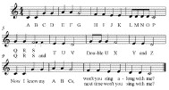Changing from product to service
________________________________________________________________________________________________________________________________________________________________________________________________________________________________________________________________________________________________________________________________________
Choice of distribution channel
______________________________________________________________________________________________________________________________________________________________________________________________________________________________________________________
A
B
C
D

