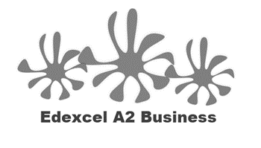
1.5.4 Forms of Business

Starter
- Have you ever been to the dentist?
- Have you ever needed to send a pet to the vet?
- Have your family ever used a solicitor (maybe to help them buy a house)?
- What do these 3 types of business have in common?

____________________________________________________________________________________________________________________________________________________________________

Write a definition of business forms here:
____________________________________________________________________________________________________________________________________________________________________
Write a definition of limited liability here:
____________________________________________________________________________________________________________________________________________________________________

Unlimited liability

________________________________________________________________________________________________________________________________________________________________________________________________________________________________________________________________________________________________________________________________________

Growth of a business

Sole trader
________________________________________________________________________________________________________________________________________________________________________________________________________________________________________________________________________________________________________________________________________
Advantages | Disadvantages

Partnership

________________________________________________________________________________________________________________________________________________________________________________________________________________________________________________________________________________________________________________________________________
Advantages | Disadvantages

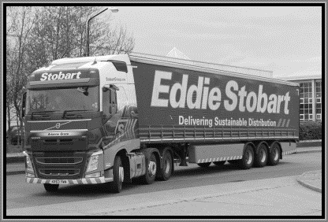
Private Limited Company (Ltd)

________________________________________________________________________________________________________________________________________________________________________________________________________________________________________________________________________________________________________________________________________
Advantages | Disadvantages

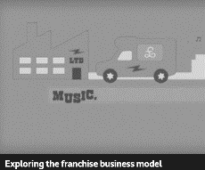
Franchising introduction
________________________________________________________________________________________________________________________________________________________________________________________________________________________________________________________________________________________________________________________________________
What is a franchise?

________________________________________________________________________________________________________________________________________________________________________________________________________________________________________________________________________________________________________________________________________
Franchising vocab
Franchisee_____________________________________________________________________
Franchisor______________________________________________________________________
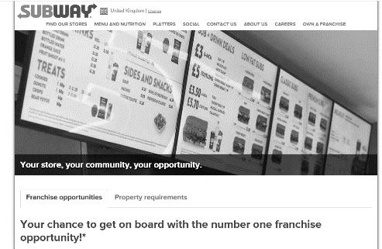

Cost of a franchise

________________________________________________________________________________________________________________________________________________________________________________________________________________________________________________________________________________________________________________________________________
Franchising pros and cons
Advantages | Disadvantages

Social enterprise
________________________________________________________________________________________________________________________________________________________________________________________________________________________________________________________________________________________________________________________________________
Lifestyle Business
________________________________________________________________________________________________________________________________________________________________________________________________________________________________________________________________________________________________________________________________________
Online business
________________________________________________________________________________________________________________________________________________________________________________________________________________________________________________________________________________________________________________________________________
Growth to PLC and stock market flotation
Growth to PLC

- Once a limited ______________________ has grown in size and needs further ___________________________ which it cannot get from its current pool of owners it may consider becoming a ___________________________
- If it intends to ____________________________ shares on the stock market, so they can be bought by anyone, it will need to first issue a prospectus where ______________________ investors are invited to purchase share before _______________________
- Going public is expensive
  - Lawyers to draw up _______________ paperwork
  - Publications
  - Advertising and _________________
  - Company must have ___________________________ in share capital

