3.1.2 Theories of corporate strategy

Write a definition of corporate strategy here:
________________________________________________________________________________________________________________________________________________________________________________________________________________________________________________________________________________________________________________________________________
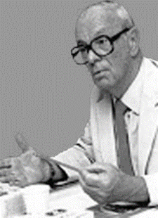
Ansoff’s Matrix
Write about Igor Ansoff here:
________________________________________________________________________________________________________________________________________________________________________________________________________________________________________________________________________________________________________________________________________
________________________________________________________________________________________________________________________________________________________________________________________________________________________________________________________________________________________________________________________________________

 | Existing Product or Service | New Product or Service
Existing market
New Market

Uses and limitations of Ansoff’s matrix:
Uses
Limitations

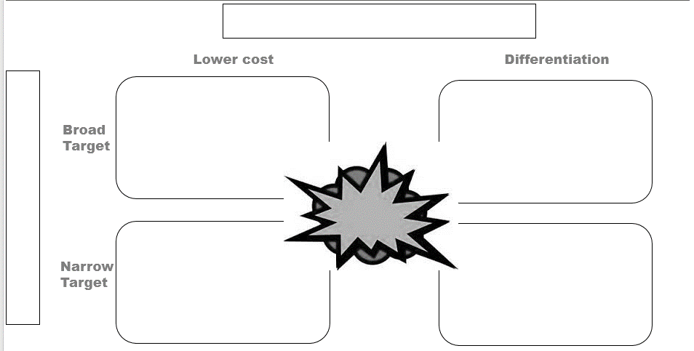

Porters Strategic Matrix

- 1979 Michael ________________ suggested that there were _________ generic business strategies that would get competitive ________________________. These were:
  - Cost _____________________________; making products at the lowest cost, may include outsourcing, lean management, standard no _____________________ low cost products
  - __________________________________________; the product or service is unique and the ________________________ adds value to the product
  - __________________________________; the product or service will serve a very small specific _____________________________, high costs are passed on to customers, no close substitutes (Divided into cost focus and differentiation focus)
- He also said that if a business failed to select one of these strategies that they would be in danger and _____________________________________________________________________
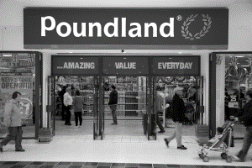
Cost leadership
________________________________________________________________________________________________________________________________________________________________________________________________________________________________________________________________________________________________________________________________________
Differentiation
________________________________________________________________________________________________________________________________________________________________________________________________________________________________________________________________________________________________________________________________________
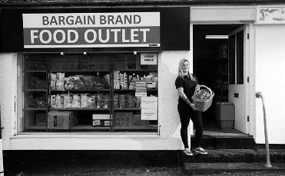
Cost focus
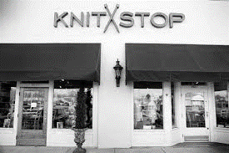
________________________________________________________________________________________________________________________________________________________________________________________________________________________________________________________________________________________________________________________________________
Differentiation focus
________________________________________________________________________________________________________________________________________________________________________________________________________________________________________________________________________________________________________________________________________

Uses and limitations of Porter’s strategic matrix:

Limitations
Uses

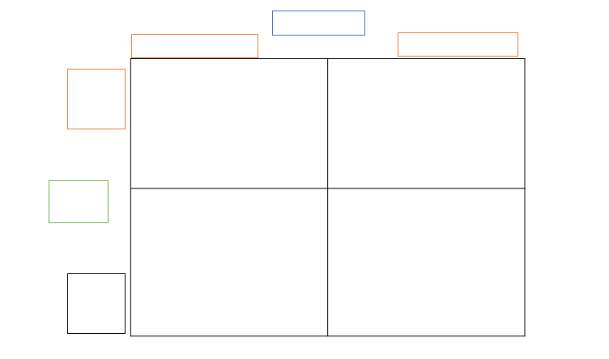

BCG Matrix

- The BCG is a _______________ with a marketing planning __________________ which helps managers to plan for a balanced product ____________________________________
- It looks at two dimensions, market _______________________________ and market _____________________, in order to assess new and existing products in terms of their market ______________________________________
- A business would place each individual product in its product portfolio (or product _______________________) onto one of the ______________________________________ of the Boston Matrix based on the product's relative market share and the product's market _____________________ in the industry
- There are four possible results from using the Boston matrix; cash ________________, star, dog and problem child (also known as _______________________________ mark)

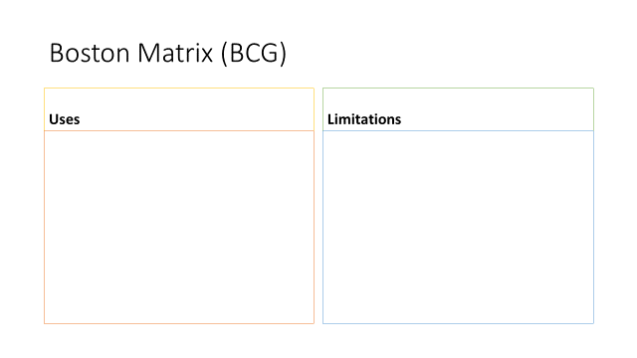

Kay’s Distinctive Capabilities

________________________________________________________________________________________________________________________________________________________________________________________________________________________________________________________________________________________________________________________________________
Examples of Kay’s in business
________________________________________________________________________________________________________________________________________________________________________________________________________________________________________________________________________________________________________________________________________

Strategic vs tactical decisions
Strategic | Tactical

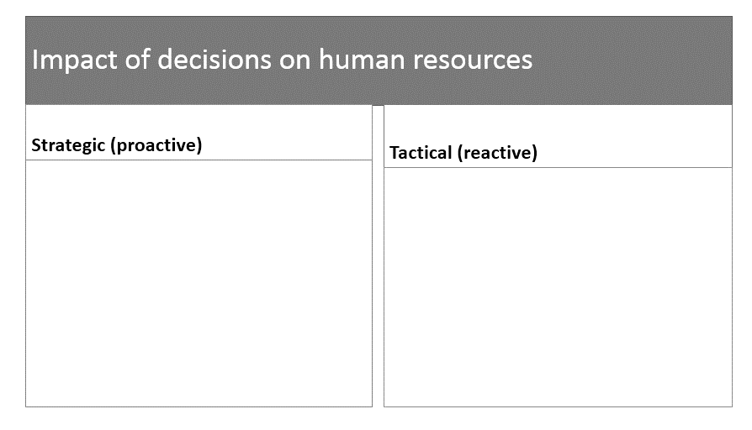

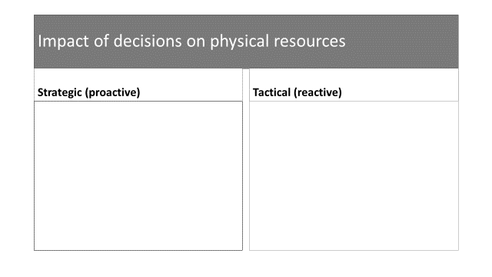

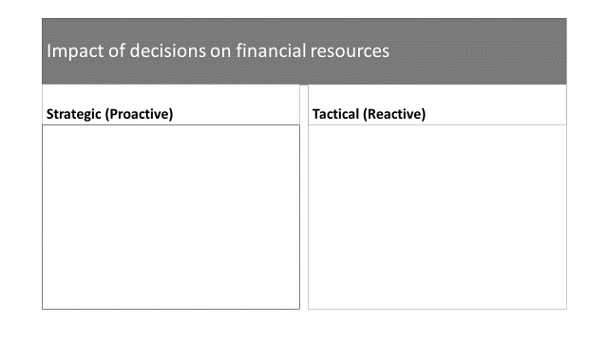

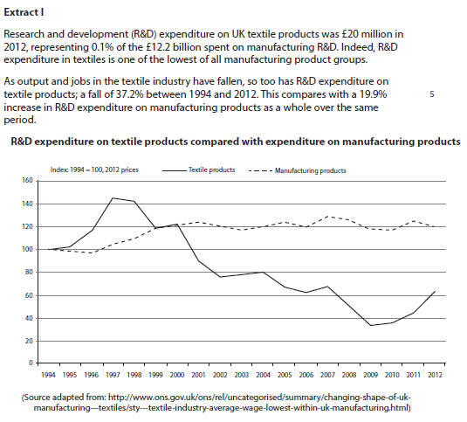

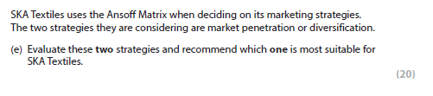

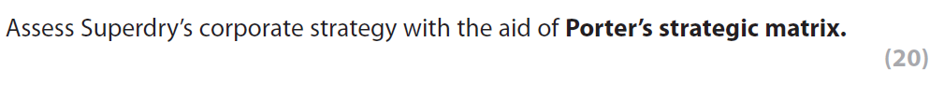
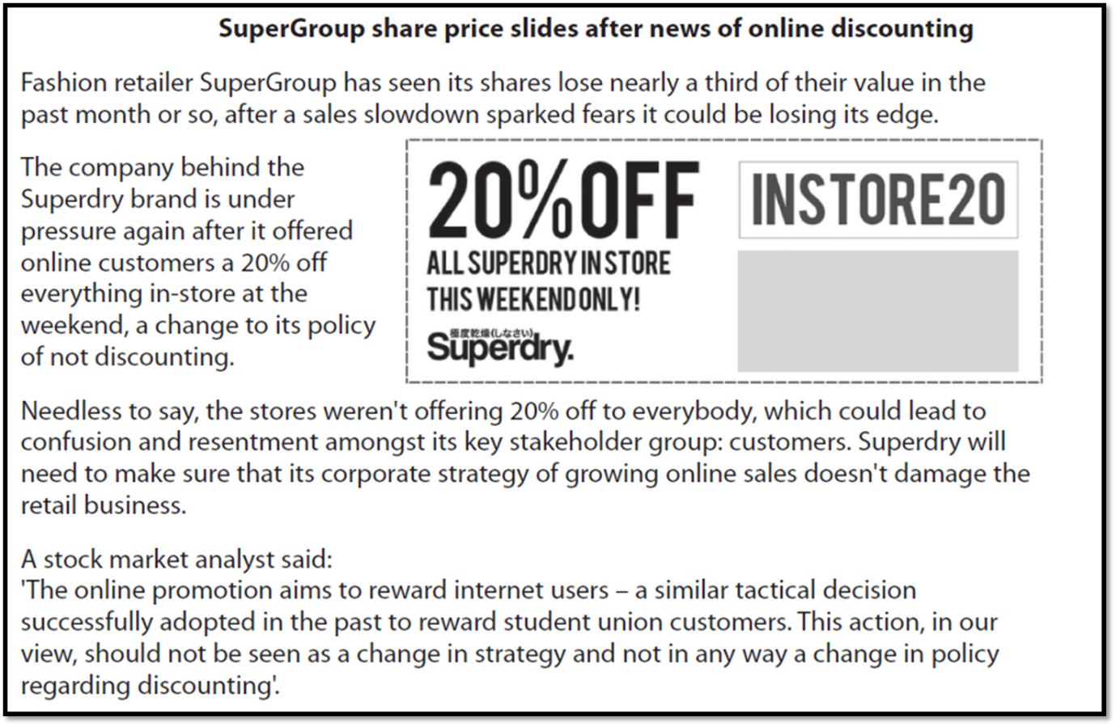

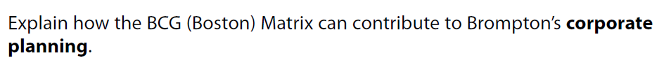
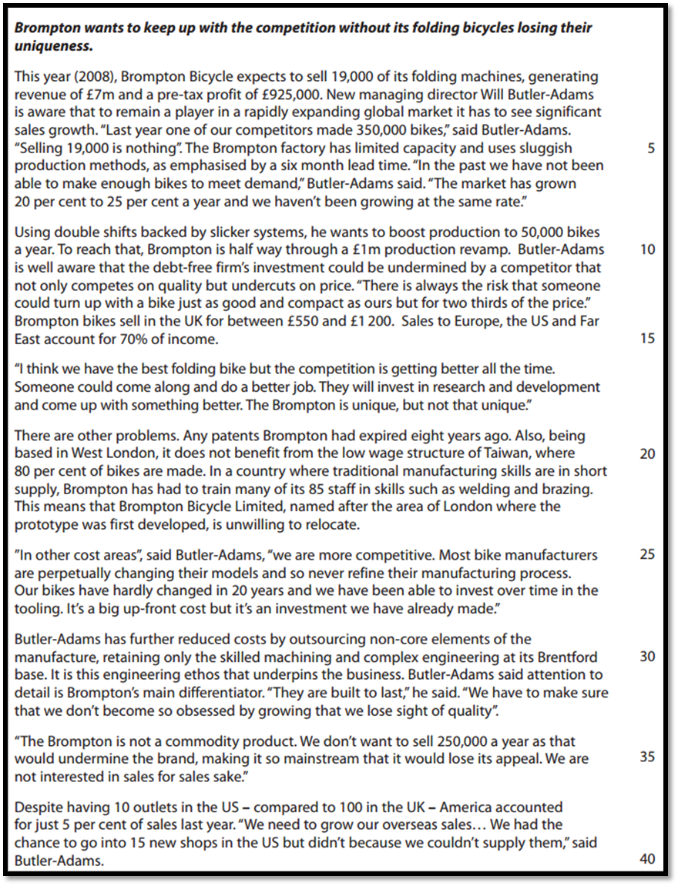

[5]

