Q1.Figure 1 shows a human cheek cell viewed under a light microscope.
Figure 1
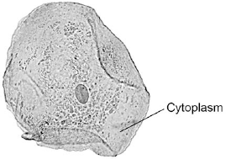
© Ed Reschke/Photolibrary/Getty Images
(a) Label the nucleus and cell membrane on Figure 1.
(2)

(b) Cheek cells are a type of body cell.
Body cells grow through cell division.
What is the name of this type of cell division?
Tick one box.
Differentiation
Mitosis
Specialisation

(1)

(c) Ribosomes and mitochondria are not shown in Figure 1.
What type of microscope is needed to see ribosomes and mitochondria?
.............................................................................................................................
(1)

(d) What is the advantage of using the type of microscope you named in part (c)?

Tick one box.
Cheaper
Higher magnification
Lower resolution

(1)

(e) The cheek cell in Figure 2 is magnified 250 times.
The width of the cell is shown by the line D to E.
Figure 2
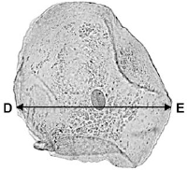
Calculate the width of the cheek cell in micrometres (µm).
Complete the following steps.
Measure the width of the cell using a ruler .......................................... mm
Use the equation to work out the real width of the cell in mm:
real size = 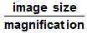 ............................................ mm
Convert mm to µm ............................................. µm
(3)

(f) A red blood cell is 8 µin diameter.
A bacterial cell is 40 times smaller.
Calculate the diameter of the bacterial cell.

Tick one box.
0.02 µm
0.2 µm
2.0 µm
20.0 µm

(1)
(Total 9 marks)

Q2.Living organisms are made of cells.
(a) Animal and plant cells have several parts. Each part has a different function.
Draw one line from each cell part to the correct function of that part.
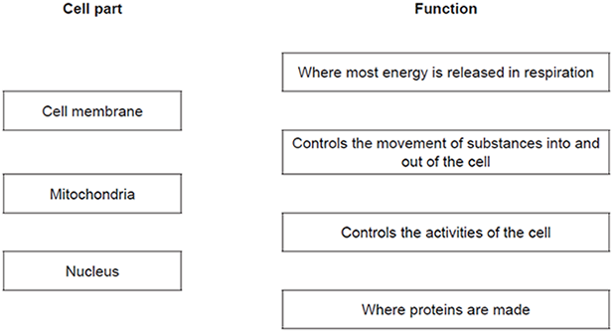
(3)

(b) The diagram below shows a cell from a plant leaf.
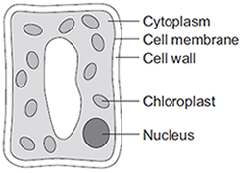
Which two parts in the diagram above are not found in an animal cell?
1 ....................................................................................................................
2 ....................................................................................................................
(2)
(Total 5 marks)

Q3.The image below shows an epithelial cell from the lining of the small intestine.
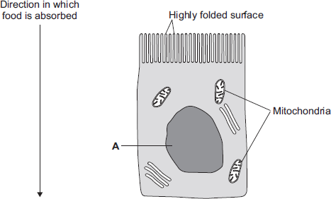
(a) (i) In the image above, the part of the cell labelled A contains chromosomes.
What is the name of part A?
...............................................................................................................
(1)

(ii) How are most soluble food molecules absorbed into the epithelial cells of the small intestine?
Draw a ring around the correct answer.

 | diffusion | osmosis | respiration

(1)

(b) Suggest how the highly folded cell surface helps the epithelial cell to absorb soluble food.
........................................................................................................................
........................................................................................................................
(1)

(c) Epithelial cells also carry out active transport.
(i) Name one food molecule absorbed into epithelial cells by active transport.
...............................................................................................................
(1)

(ii) Why is it necessary to absorb some food molecules by active transport?
...............................................................................................................
...............................................................................................................
(1)

(ii) Suggest why epithelial cells have many mitochondria.
...............................................................................................................
...............................................................................................................
...............................................................................................................
...............................................................................................................
(2)

(d) Some plants also carry out active transport.
Give one substance that plants absorb by active transport.
........................................................................................................................
(1)
(Total 8 marks)

Q4.The diagram shows a cell.
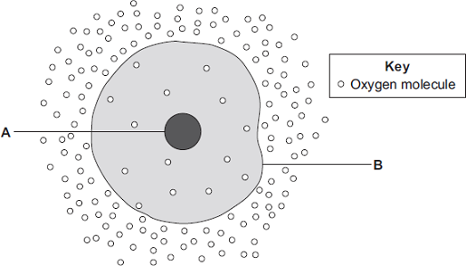
(a) (i) Use words from the box to name the structures labelled A and B .

 | cell membrane | chloroplast | cytoplasm | nucleus

A .......................................................
B .......................................................
(2)

(ii) The cell in the diagram is an animal cell.
How can you tell it is an animal cell and not a plant cell?
Give two reasons.
1 ............................................................................................................
...............................................................................................................
2 ............................................................................................................
...............................................................................................................
(2)

(b) Oxygen will diffuse into the cell in the diagram.
Why?
Use information from the diagram.
........................................................................................................................
........................................................................................................................
(1)

(c) The cell shown in the diagram is usually found with similar cells.
Draw a ring around the correct answer to complete the sentence.

 |  | an organ.
 | Scientists call a group of similar cells | a system.
 |  | a tissue.

(1)
(Total 6 marks)

Q5. Cells contain a solution of salts and sugars.
A student is investigating how cells change when they are put into water.
(a) The student:
• looks at a plant cell using a microscope
• adds water to the cell.
The plant cell swells up.
Explain why, as fully as you can.
........................................................................................................................
........................................................................................................................
........................................................................................................................
........................................................................................................................
........................................................................................................................
........................................................................................................................
(3)

(b) When animal cells are put in water, they swell up, and then burst.
When plant cells are put in water, they swell up, but do not burst.
How does the structure of plant cells prevent them from bursting?
........................................................................................................................
........................................................................................................................
(1)
(Total 4 marks)

Q6. (a) The diagrams show what happens to the shape of a plant cell placed in distilled water.
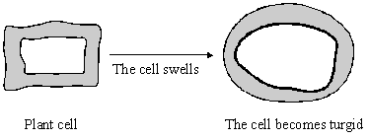

(i) Explain why the cell swells and becomes turgid. Name the process involved.
..........................................................................................................................
..........................................................................................................................
..........................................................................................................................
(2)

(ii) Give one feature of the cell wall which allows the cell to become turgid.
..........................................................................................................................
(1)

(b) Describe the change which will occur if a piece of peeled potato is placed in a concentrated sugar solution and explain why this change occurs.
.....................................................................................................................................
.....................................................................................................................................
.....................................................................................................................................
.....................................................................................................................................
.....................................................................................................................................
.....................................................................................................................................
(3)
(Total 6 marks)

Q7. The diagram shows a cell from a plant leaf.
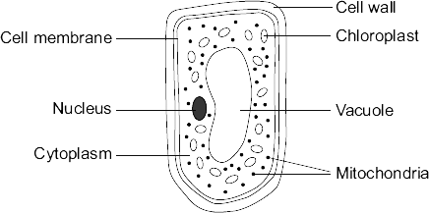
(a) Name the part of this cell that:
(i) controls the passage of substances in and out of the cell
...............................................................................................................
(1)

(ii) is filled with cell sap.
...............................................................................................................
(1)

(b) Give the names of two parts of the leaf cell that would not be found in a human liver cell.
.................................................. and ..................................................
(2)

(c) The chloroplasts produce oxygen.
Draw a ring around the correct answer to complete the sentence.

 | diffusion.
The oxygen produced by the chloroplasts passes out of the cell by | digestion.
 | respiration.

(1)
(Total 5 marks)

Q8. The table shows the concentrations of three mineral ions in the roots of a plant and in the water in the surrounding soil.
Mineral ion | Concentration in millimoles per kilogram
 | Plant root | Soil
Calcium | 120 | 2.0
Magnesium | 80 | 3.1
Potassium | 250 | 1.2

(a) (i) The plant roots could not have absorbed these mineral ions by diffusion.
Explain why.
...............................................................................................................
...............................................................................................................
...............................................................................................................
...............................................................................................................
(2)

(ii) Name the process by which the plant roots absorb mineral ions.
...............................................................................................................
(1)

(b) How do the following features of plant roots help the plant to absorb mineral ions from the soil?
(i) A plant root has thousands of root hairs.
...............................................................................................................
...............................................................................................................
(1)

(ii) A root hair cell contains many mitochondria.
...............................................................................................................
...............................................................................................................
...............................................................................................................
...............................................................................................................
(2)

(iii) Many of the cells in the root store starch.
...............................................................................................................
...............................................................................................................
(1)
(Total 7 marks)

M1.(a) nucleus labelled correctly
1

cell membrane labelled correctly
1

(b) mitosis
1

(c) electron (microscope)
1

(d) higher magnification
1

(e) 45 (mm)
1

45 / 250 or 0.18 (mm)
allow ecf
1

180 (µm)
1

allow 180 (µm) with no working shown for 3 marks
(f) 0.2 µm
1
[9]

M2.(a) 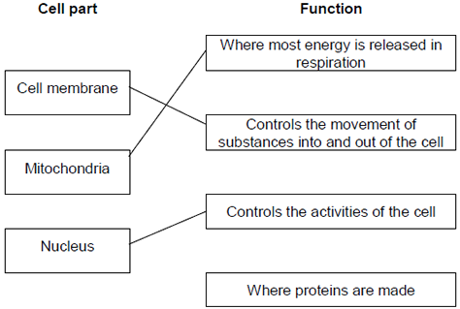
extra lines cancel
3

(b) Cell wall
in either order
1
Chloroplast
allow (permanent) vacuole
1
[5]

M3.(a) (i) nucleus
1
(ii) diffusion
1

(b) increases / larger surface area (for diffusion)
ignore large surface area to volume ratio
1

(c) (i) sugar / glucose
accept amino acids / other named monosaccharides
1
(ii) against a concentration gradient
or
from low to high concentration
1
(iii) (active transport requires) energy
1
(from) respiration
1

(d) minerals / ions
accept named ion ignore nutrients
do not accept water
1
[8]

M4.(a) (i) A = nucleus
1

B = (cell) membrane
1

(ii) any two from:
ignore shape
• no (cell) wall
• no (large / permanent) vacuole
• no chloroplasts / chlorophyll
2

(b) because high to low oxygen / concentration or down gradient
allow ‘more / a lot of oxygen molecules outside’
ignore along / across gradient
1

(c) a tissue
1
[6]

M5. (a) because water enters (the cell / it / named cell)
do not accept salt / sugar / solution entering
1

by osmosis / diffusion
if osmosis / diffusion not given accept concentration inside cell greater than outside cell
assume concentration refers to solute concentration unless answer indicates otherwise
allow water goes up the concentration gradient
allow water goes down its concentration gradient
do not accept if diffusion of salt / sugar
1

through a partially permeable membrane
allow semi / selectively permeable membrane or description
1

(b) (plant cells) have (cell) wall
accept animal cells have no (cell) wall
ignore reference to cell membrane
do not accept reference to other organelles or any implication that animal cells have a cell wall eg plant cells have a thicker cell wall
1
[4]

M6. (a) (i) water (molecules) enter(s) (the cell)
or water (molecules) pass(es) through the (semi-permeable) cell membrane
1
by osmosis
or because the concentration of water is
greater outside (the cell than inside it
the vacuole)
accept because of the concentration
gradient provided there is no contradiction
1

(ii) any one from
(it is) elastic
(it is) strong
(it is fully) permeable (to water)
or water can pass through it
do not credit semi-permeable
do not credit cell membrane is semi-permeable
1

(b) (the piece of) potato shrinks
or loses its turgor
or becomes flabby
or becomes flaccid
or plasmolysis occur
or cytoplasm pulls away from the cell wall
(because) concentration of sugar
or because concentration of water
1
(solution) is greater than concentration inside the cell / vacuole
inside the cell / vacuole is greater than concentration (of water) outside
1
water is drawn out of the cell
1
[6]

M7. (a) (i) (cell) membrane
1

(ii) vacuole
1

(b) any two from:
• (cell) wall
• chloroplast(s)
ignore chlorophyll
• vacuole
ignore cell sap
2

(c) diffusion
1
[5]

M8. (a) (i) diffusion is down the concentration gradient
for a description of diffusion
ignore along / across gradients
1

to enter must go up / against the concentration gradient
accept by diffusion ions would leave the root
or
concentration higher in the root / plant
or
concentration lower in the soil
1

(ii) active transport
allow active uptake
1

(b) (i) (root hairs →) large surface / area
1

(ii) (aerobic) respiration
do not allow anaerobic
1

releases / supplies / provides / gives energy
accept make ATP (for active transport)
do not allow ‘makes / produces / creates’ energy
1

(iii) starch is energy source / store (for active transport)
allow starch can be used in respiration
do not allow ‘makes / produces / creates’ energy
1
[7]

