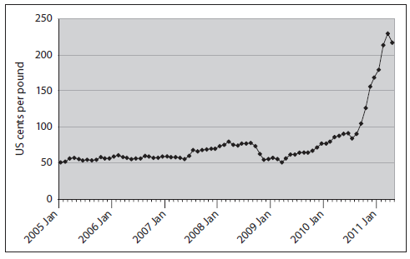

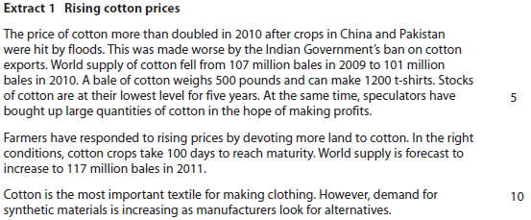
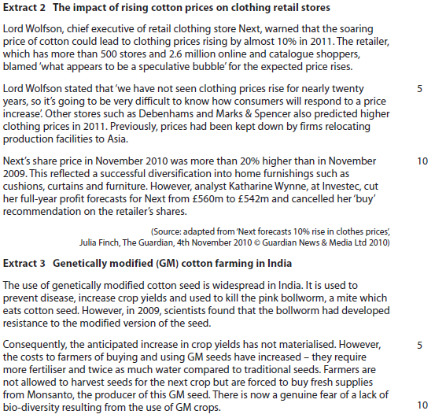
Question:
- With reference to the information provided and your own knowledge, discuss whether the price elasticity of supply for cotton is likely to be inelastic or elastic. (10)

Originally: How is the price elasticity of supply for cotton likely to change over time? Discuss the impacting factors. (10)

10c June 2012
http://qualifications.pearson.com/content/dam/pdf/A%20Level/Economics/2013/Exam%20materials/6EC01_01_rms_20120816.pdf
p23-24

