1.2.4 Price Elasticity of Demand

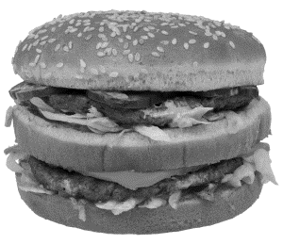
Starter
If the price of a Big Mac goes up to £10 would you still buy one?

The link between demand and price
____________________________________________________________________________________________________________________________________________________________________________________________________________________________________________________________________________________________________________________________________________________________________________________________________________________________________________________________________________________________________________
Write your definition of PED here:
________________________________________________________________________________________________________________________________________________________________________________________________________________________________________________________________________________________________________________________________________

PED formula:

% change in price formula:

Example calculations % change
 | Product A | Product B | Product C | Product D
Old Price | £300 | £55 | £70 | £60
New price | £290 | £29 | £77 | £65
% Change

Example PED calculation

Example PED calculation Steps

What does a PED value mean?

Interpretation of numerical values of price elasticity of demand
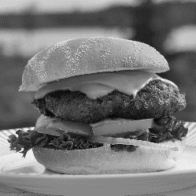
Elastic demand

________________________________________________________________________________________________________________________________________________________________________________________________________________________________________________________________________________________________________________________________________
Elastic demand and calculations

________________________________________________________________________________________________________________________________________________________________________________________________________________________________________________________________________________________________________________________________________
Inelastic demand

________________________________________________________________________________________________________________________________________________________________________________________________________________________________________________________________________________________________________________________________________

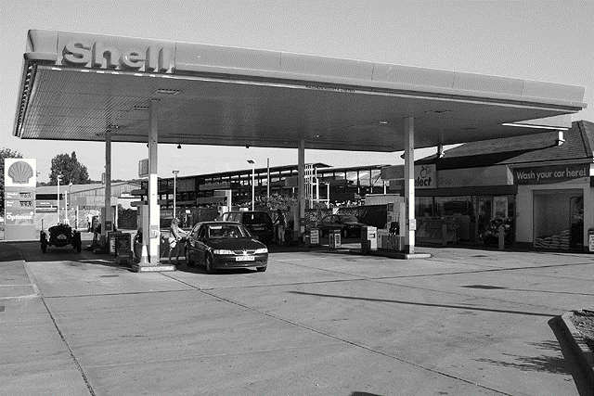
Inelastic demand explained
________________________________________________________________________________________________________________________________________________________________________________________________________________________________________________________________________________________________________________________________________
Inelastic demand and calculations

________________________________________________________________________________________________________________________________________________________________________________________________________________________________________________________________________________________________________________________________________

Examples
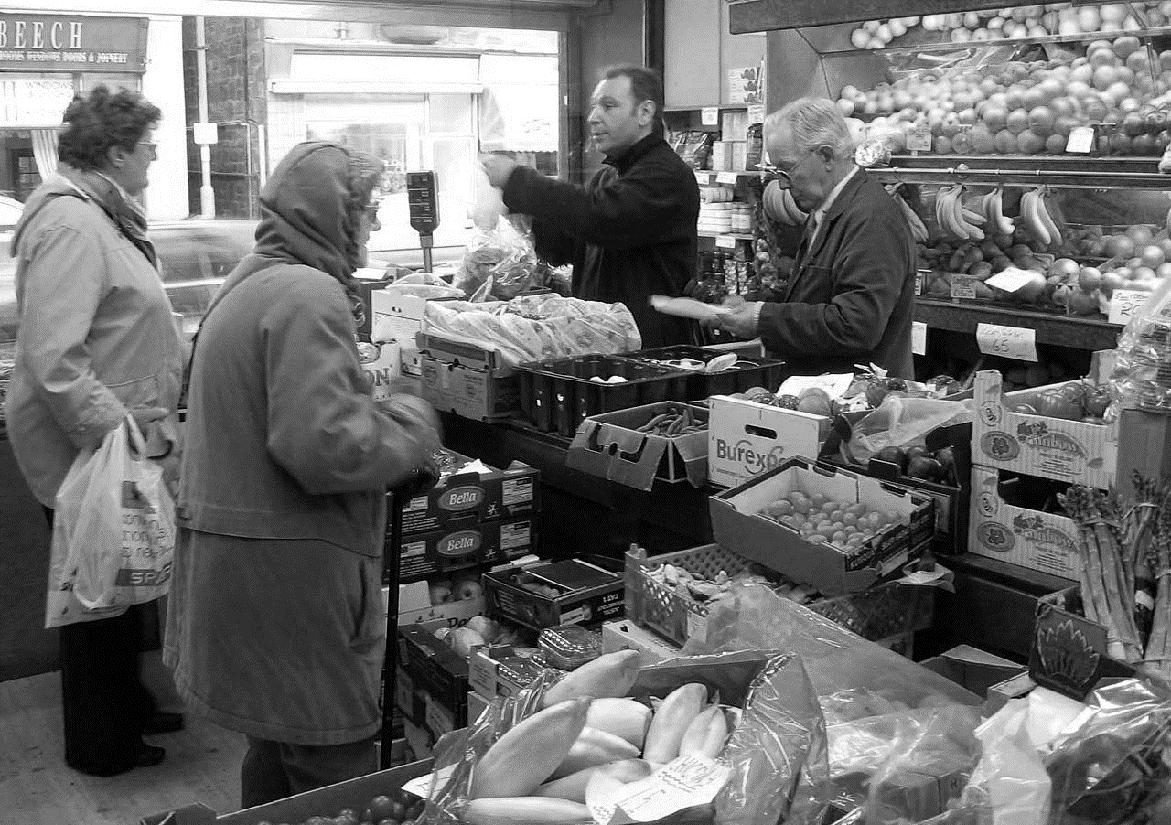
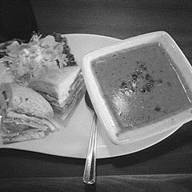

The factors influencing price elasticity of demand
Availability of substitutes

Frequency of purchase

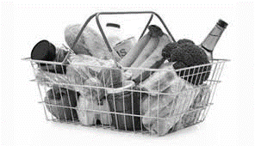

Necessities (staple goods)

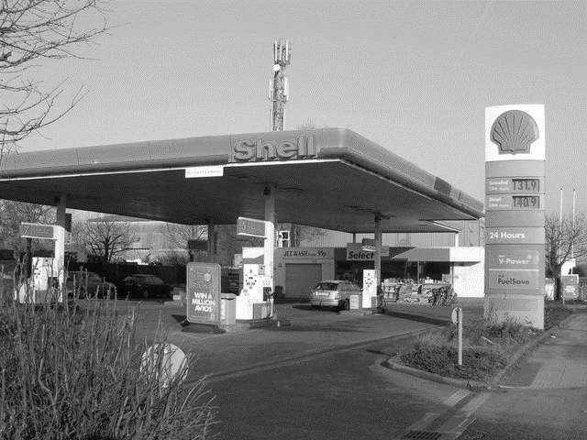

Luxury goods

The significance of price elasticity of demand to businesses in terms of implications for pricing

Competitive pricing
________________________________________________________________________________________________________________________________________________________________________________________________________________________________________________________________________________________________________________________________________
Skimming pricing
________________________________________________________________________________________________________________________________________________________________________________________________________________________________________________________________________________________________________________________________________

Calculation and interpretation of the relationship between price elasticity of demand and total revenue

PED and total Revenue
B
A

C

E
D

F

