Nigel Farage drops Ukip plan for ‘wag tax’ on luxury goods
Ukip leader says proposal for tax on shoes and handbags raised during party conference on Friday was just discussion point
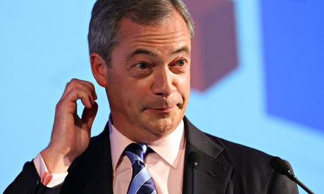
Nigel Farage: 'As far as I’m concerned it’s dead, it was a discussion point yesterday, it isn’t going to happen.'
Nigel Farage has ditched Ukip’s proposal for a tax on luxury goods such as shoes and handbags just 48 hours after it was floated at the party’s autumn conference.
It was the most eye-catching offering from the party aimed at wooing disillusioned Labour voters, but Farage said it was just a “discussion point” and was now “dead” as long as he was leader.
Ukip had promised during the conference – held at Doncaster racecourse in Ed Miliband’s backyard – to park its tanks on Labour’s lawn.
However, the major event of the conference was the defection to Ukip of Tory rightwinger Mark Reckless, and the main policy announcements appeared to be aimed at the right, including scrapping inheritance tax and lowering income tax rates in a way that would mainly benefit wealthier voters. The £12bn of proposed cuts would be paid for by slashing foreign aid and leaving the European Union.
Despite Farage promising to take those on the minimum wage out of tax, an analysis by the Equality Trust has found that the changes would do nothing for people earning £10,000 but save someone earning £1m a year about £43,000 in tax.
The luxury goods tax – quickly branded a “WAG tax” – was raised on Friday by Ukip’s new economy spokesman, Patrick O’Flynn, as a way of hitting the wealthy.
Asked about it afterwards, Farage said in the course of the last decade the rich had got remarkably richer. He added that it was “a slightly different direction and I think that is a recognition and a realisation that for millions of people life is a lot worse now that it was 10 years ago.”
However, speaking on the BBC’s Andrew Marr Show on Sunday, the Ukip leader said: “I have to say, I personally am very happy to give freedom to our spokesmen and spokeswomen to float ideas, but I’m pretty certain that while I am leader that will not be in our manifesto.
“It was never put forward as a policy. It was put forward as something that should be investigated … As far as I’m concerned it’s dead, it was a discussion point yesterday, it isn’t going to happen.”
Farage still insisted the party was appealing to former Labour voters and claimed there was a chance of MPs from all parties defecting. He promised to give Labour a “very big run for their money” in the Heywood and Middleton by-election, the former seat of the late Labour MP Jim Dobbin.
Steve Crowther, the Ukip chairman, said the party had just been flying a kite, and made the point that people like it being not as slick and polished as its rivals.
QUESTIONS
Give examples of the kinds of goods/services that Ukip may have targeted with the ‘WAG tax’.

What would the YED value be with these goods?

Draw the demand curve for such goods.

Who are Ukip trying to target with this tax and, considering the YED nature of luxury goods, how could this impact upon inequality?

