Revision questions
(30 marks; 30 minutes)
1 Explain why businesses prefer to do business in countries with relatively light government regulation.

2 Look at Table 33.2 and explain the difference between the current account balance and government net debt.
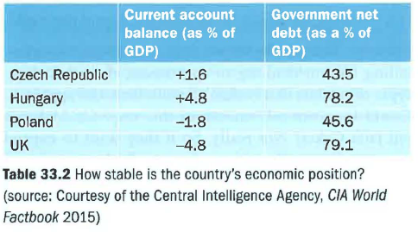

3 Assess two possible ways in which the quality of infrastructure would matter to a delivery business selling 'Fresh Dough Pizza'.

4 Poland seems to be the most heavily regulated of the three Eastern European countries (see Table 33.5) yet has the fastest growth. Explain why businesses prefer to do business in countries with relatively light government regulation. Assess two possible reasons for this.
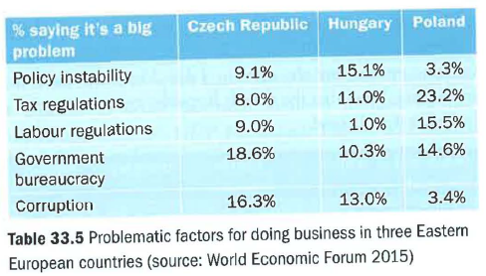

5 Explain why the exchange rate is unlikely to be important in deciding on the best country to set up a business in the long term.

