Rat-Tailed Maggot
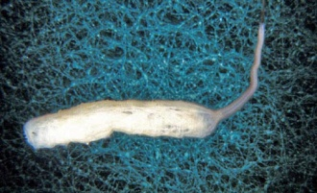

Rat-tailed maggots are the larvae of some species of hoverfly. It lives in stagnant, oxygen-deprived water, with a high organic content. It is tolerant of pollution and can live in sewage lagoons and cesspools.

Tubiflex worm (sludge worm)
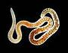
These worms ingest sediments, selectively digest bacteria, and absorb molecules through the body wall. The worms can survive with little oxygen. They can also survive in areas heavily polluted with organic matter that almost no other species can endure. They usually inhabit the bottom sediments of lakes, rivers, and occasionally sewer lines and outlets.

Caddis Fly Larvae
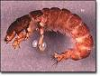
Caddisfly larvae and are found in a wide variety of habitats such as streams, rivers, lakes, ponds, spring seeps, and temporary waters. Although caddisflies may be found in waterbodies of varying qualities, species-rich caddisfly assemblages are generally thought to indicate clean water. This is because they require fairly high levels of oxygen to survive.

Stonefly Larvae
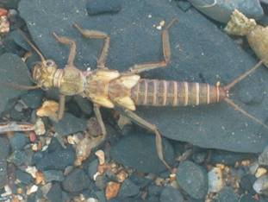
- About 500 species in North America
- Are found in cool, clean streams with high levels of dissolved oxygen
- Develop in the stream for periods of three months to three years
- Are either predators or feed on fungi and bacteria from rotting leaves

