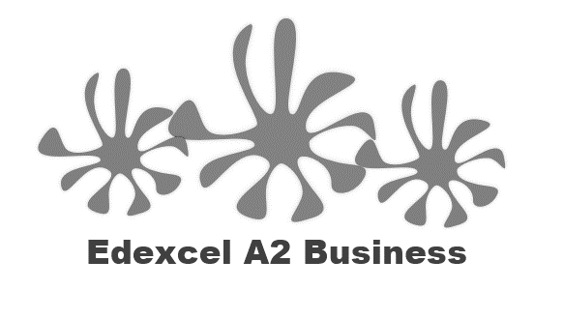
2.4.4 Quality management

Starter
How would you improve your day today?

How did others suggest you improve your day?

Write a definition of quality here:
________________________________________________________________________________________________________________________________________________________________________________________________________________________________________________________________________________________________________________________________________

Quality Control

Quality control – detecting faulty output
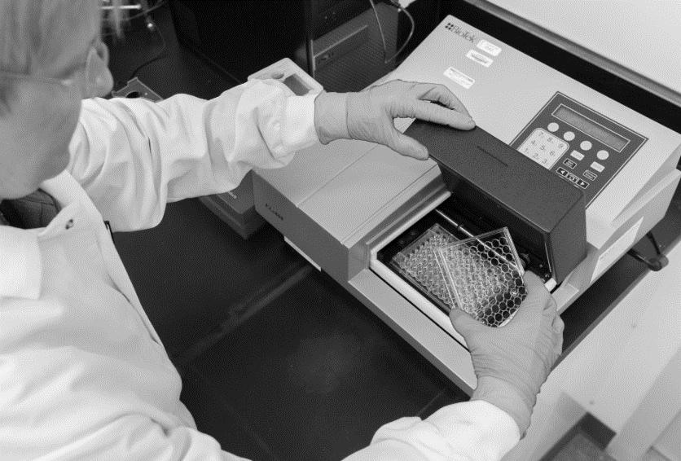

________________________________________________________________________________________________________________________________________________________________________________________________________________________________________________________________________________________________________________________________________
Examples of quality control
______________________________________________________________________________________________________________________________________________________________________________________________________________________________________________________
Cinema_________________________________________________________________________
Restaurant_____________________________________________________________________

Quality assurance
Quality assurance – quality designed in

_______________________________________________________________________________________________________________________________________________________________________________________________________________________________________________________________________________________________________________________________________
Quality Assurance – quality built in
________________________________________________________________________________________________________________________________________________________________________________________________________________________________________________________________________________________________________________________________________

Quality control vs Quality assurance
Quality control | Quality assurance

Total Quality Management (TQM)

Total Quality Management (TQM)

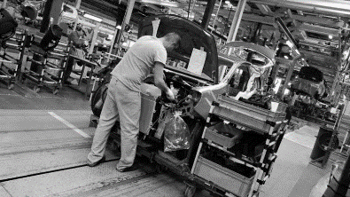
________________________________________________________________________________________________________________________________________________________________________________________________________________________________________________________________________________________________________________________________________
TQM – reducing waste

________________________________________________________________________________________________________________________________________________________________________________________________________________________________________________________________________________________________________________________________________

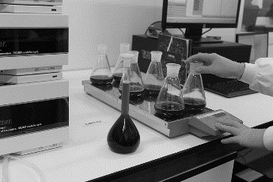
TQM – impact of inputs on quality

_______________________________________________________________________________________________________________________________________________________________________________________________________________________________________________________________________________________________________________________________________
Advantages and disadvantages of the TQM system
Advantages | Disadvantages
Quality circles

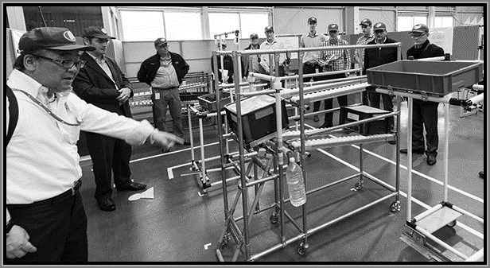

Kaizen
Kaizen - A Japanese approach to management
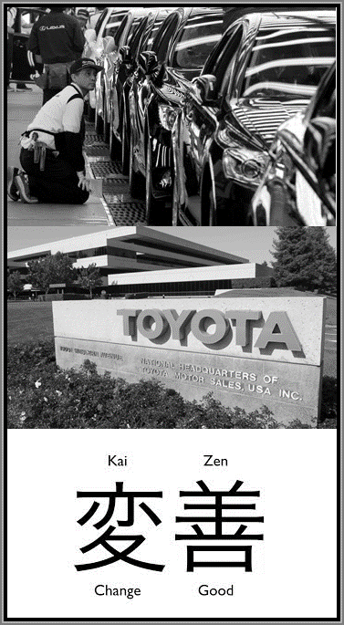

Kaizen – improvements based on small changes

Kaizen – responsibility of every employee

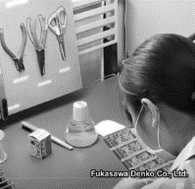

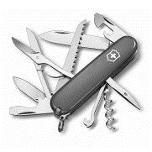
Competitive advantage from quality management

