Income Elasticity of Demand (YED)
What is YED?

How is YED calculated?

The YED coefficient can be either positive or negative depending on the type of good or service – unlike PED (where the coefficient is always negative) in YED this aspect is important to analyse.
Negative YED:

Positive YED:

Demonstrate a positive relationship between income and quantity demanded.

Demonstrate a negative relationship between income and quantity demanded.

Degrees of YED elasticity:
YED elastic:
YED inelastic:
Demonstrate an elastic YED diagram with a positive
coefficient below:
Annotations/extra info:

Demonstrate an inelastic YED diagram with a
positive coefficient below:
Annotations/extra info:

Type of good | Details | YED coefficient
Inferior
Normal
Necessities
Luxury

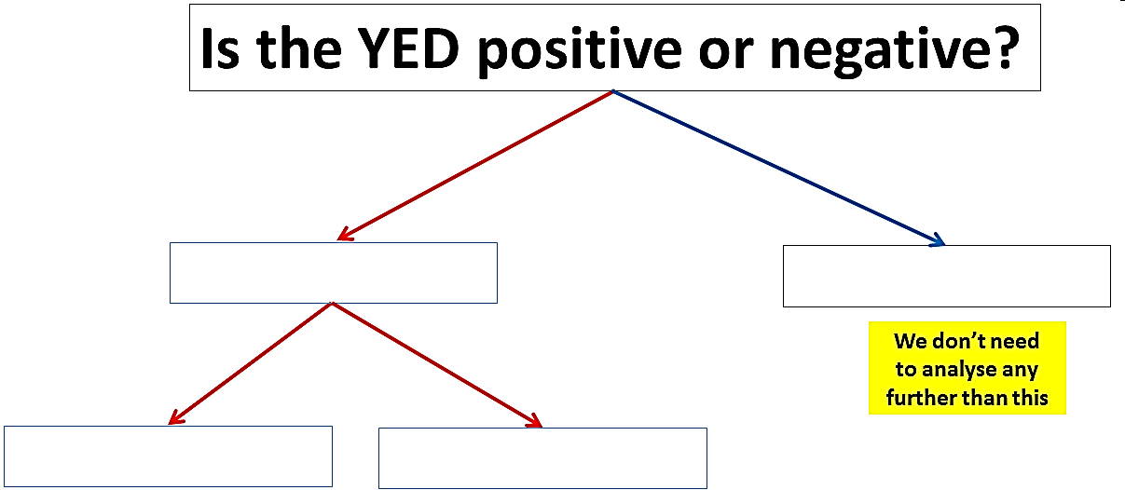

Calculate the YED for the following situations and comment upon the result
- Consumer incomes increase from an average of 30,000 per year to 33,000 per year. During the same year, the demand for cheese increased from 2.8bn to 2.856bn. What was the YED for cheese during this particular year? What kind of good was cheese during this particular year?
- Consumer incomes increase from an average of 25,000 per year to 30,000 per year. During the same year, the demand for smartphones increased by 40%. What is the YED for smartphones during this particular year? What type of good was the smartphone during this particular year?
- Consumer incomes increase by 10%. During the same year, the demand for coach travel decreased by 3%. What is the YED for coach travel during this particular year? What type of good was coach travel during this particular year?
Complete the table below
Product | Identify the type of product and explain why. | YED coefficient?  +/-  inelastic/elastic?
Toothpaste
Caviar
Poundland cheese
Internet
Mr Wilson’s Thinking Further Challenge
We do not distinguish between inelastic and elastic products with a negative YED – but if we did, how might you describe each type of good?
