3.2.1 Growth

Starter – write your answers in here:
1 | 2 | 3 | 4 | 5
6 | 7 | 8 | 9 | 10

Write a definition of business growth here:
____________________________________________________________________________________________________________________________________________________________________

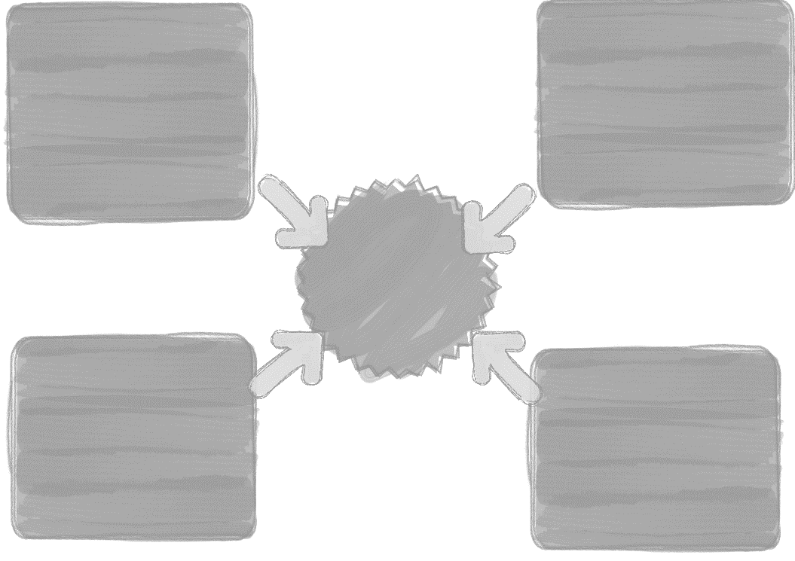

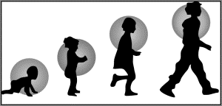
Objective of growth 1: To achieve economies of scale (internal and external)

________________________________________________________________________________________________________________________________________________________________________________________________________________________________________________________________________________________________________________________________________

Benefits of economies of scale
________________________________________________________________________________________________________________________________________________________________________________________________________________________________________________________________________________________________________________________________________

Economies of scale and average costs
________________________________________________________________________________________________________________________________________________________________________________________________________________________________________________________________________________________________________________________________________

Output in units | Variable cost per unit | Fixed costs for the production run | Total costs of production | Average cost per unit
100 | £2 | £500
300 | £2 | £500
400 | £2 | £500

1.Calculate the total costs of production for each of the three output levels (VC x output + FC)
2. Calculate the cost per unit (TC / output)
3. Identify at which level of output the business should operate

Financial Economies of Scale
Marketing Economies of Scale
Technical Economies of Scale
Managerial Economies of Scale
Risk- Bearing Economies of Scale

Bulk buying

Technical

Managerial
Financial

Marketing

Risk bearing

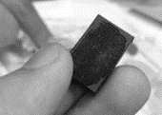
Objective 2: Increased market power over customers and suppliers

________________________________________________________________________________________________________________________________________________________________________________________________________________________________________________________________________________________________________________________________________
Write about the Tescopoly site here:

Objective 3: Increased market share and brand recognition

Increased market share and brand recognition
________________________________________________________________________________________________________________________________________________________________________________________________________________________________________________________________________________________________________________________________________

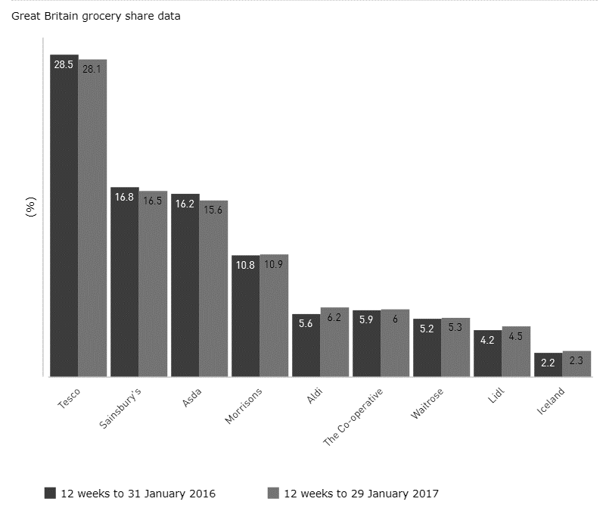

Objective 4: Increased profitability
____________________________________________________________________________________________________________________________________________________________________________________________________________________________________________________________

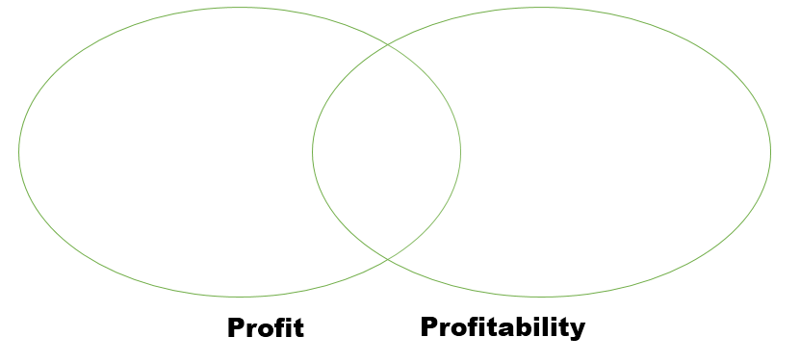

Problems arising from growth

____________________________________________________________________________________________________________________________________________________________________________________________________________________________________________________________
____________________________________________________________________________________________________________________________________________________________________________________________________________________________________________________________
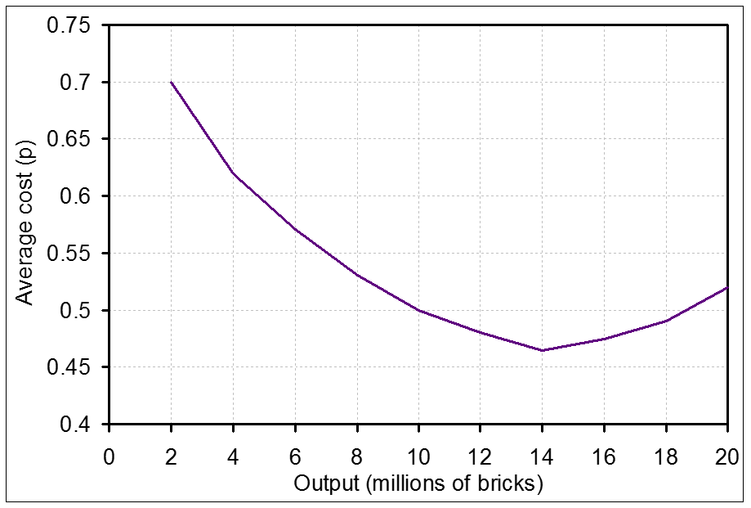

Problem 1 – diseconomies of scale (DEOS)

Lack of motivation through DEOS | Lack of co-ordination through DEOS
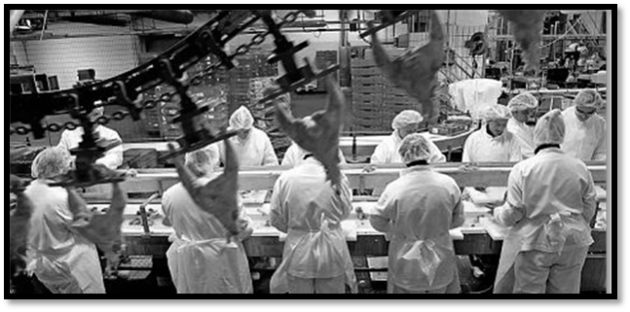

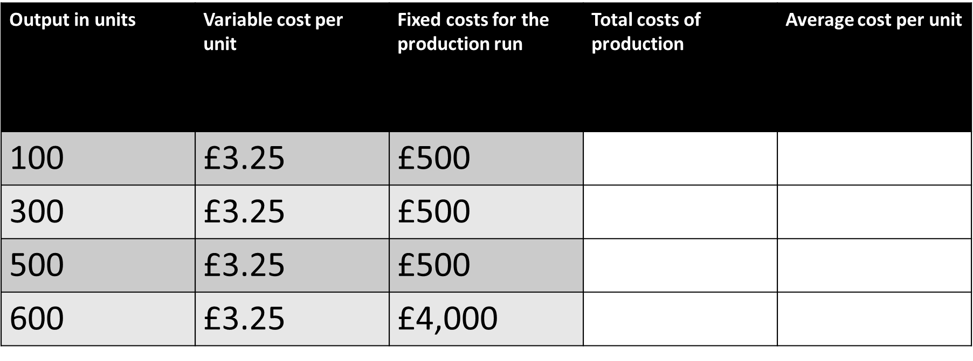

1.Calculate the total costs of production for each of the four output levels (VC x output + FC)
2. Calculate the cost per unit (TC / output)
3. Identify what happens at 600 items

Problem 2: Overtrading

________________________________________________________________________________________________________________________________________________________________________________________________________________________________________________________________________________________________________________________________________

Problem 3 internal communication

________________________________________________________________________________________________________________________________________________________________________________________________________________________________________________________________________________________________________________________________________

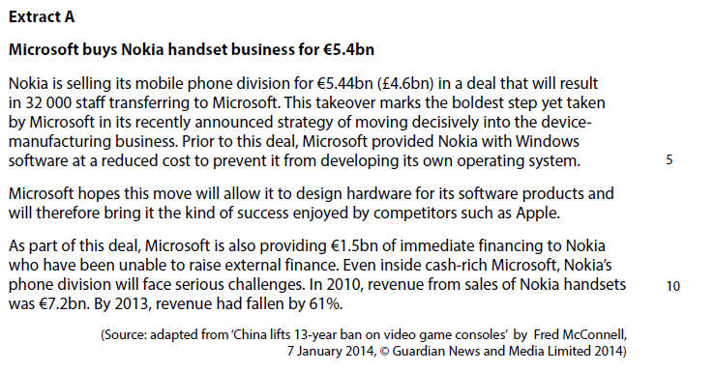

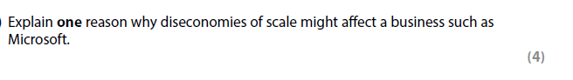

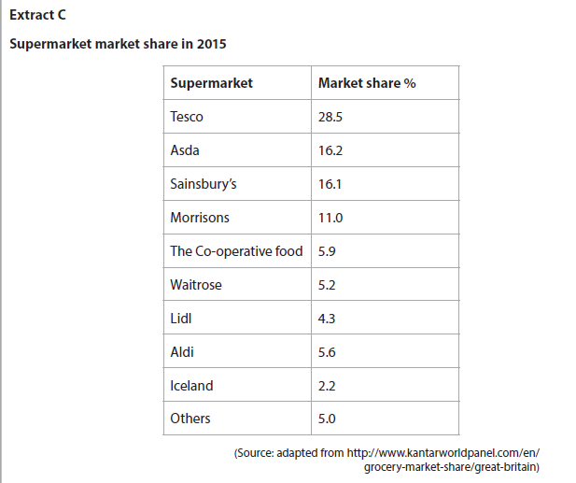

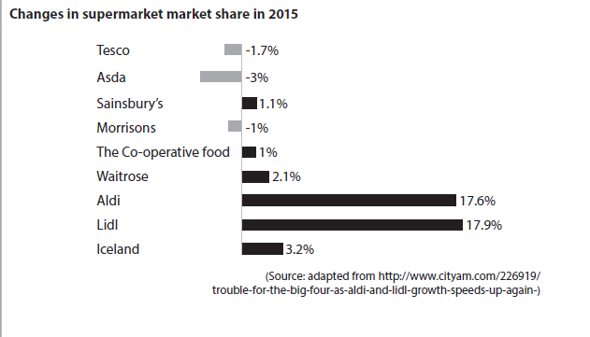

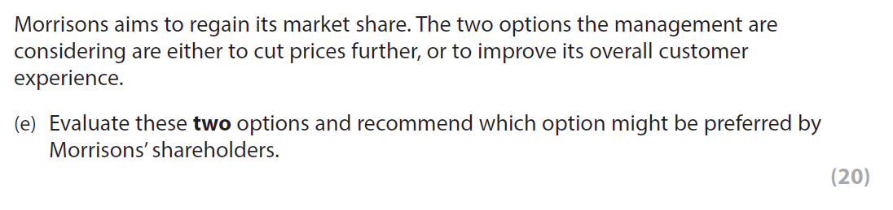

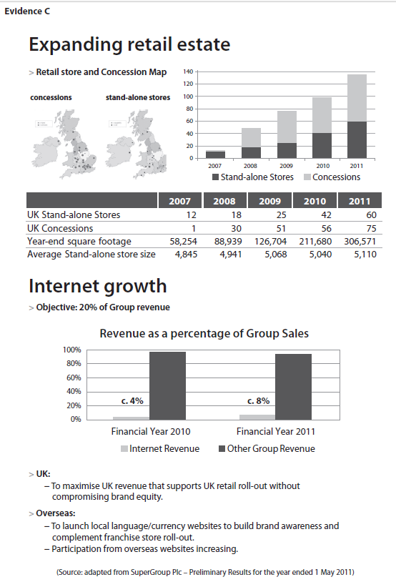
4

