4.1.3 Factors contributing to increased globalisation

Write a definition of globalisation here:

____________________________________________________________________________________________________________________________________________________________________________________________________________________________________________________________________________________________________________________________________________________________________________________________________________________________________________________________________________________________________________
Reduction of international trade barriers/trade liberalisation
Write a definition of trade liberalisation here:
________________________________________________________________________________________________________________________________________________________________________________________________________________________________________________________________________________________________________________________________________
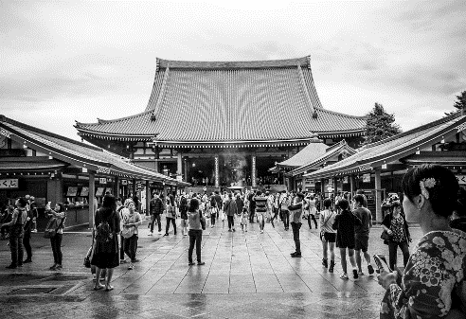
Trade liberalisation a quick history lesson

Benefits of GATT

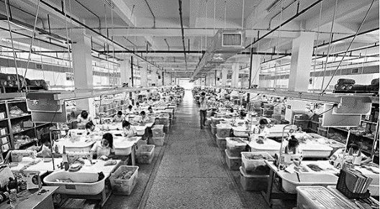

World trade organisation (WTO)

Trade liberalisation – why tariffs are imposed

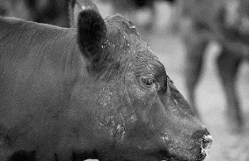

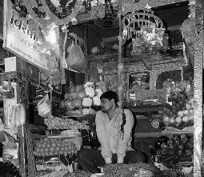
Benefits of trade liberalisation
________________________________________________________________________________________________________________________________________________________________________________________________________________________________________________________________________________________________________________________________________
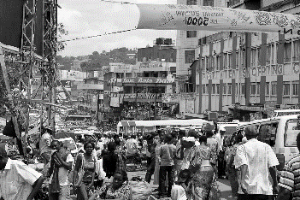
Benefits to business of trade liberalisation

________________________________________________________________________________________________________________________________________________________________________________________________________________________________________________________________________________________________________________________________________
Drawbacks of trade liberalisation
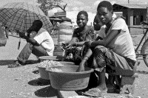

________________________________________________________________________________________________________________________________________________________________________________________________________________________________________________________________________________________________________________________________________

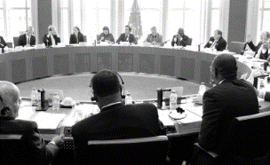
Political change
How political change has led to increased globalisation of markets
- Politics used to be only carried out by individual governments who wanted to _________________ the interests of their country.
- Politics now happens on a _______________________ scale with regular meetings between heads of state, _________________________, power devolved to governments in trading _____________________ such as the EU and organisations such as the WTO.
- This has led to less __________________________ policies (tariffs quotas etc.) and more open trade between nations. The planet is now one ________________.

Who are the G7 countries?
1
2
3
4
5
6
7

____________________________________________________________________________________________________________________________________________________________________

Reduced cost of transport and communication
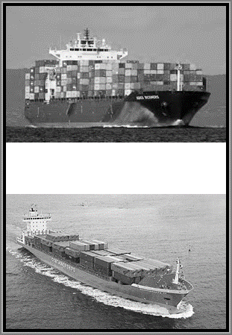
Reduced cost of transport

Reduced cost of communication

Increased significance of global companies
Globalisation caused by – increased significance of MNCs

Match the revenue to the company

GDP of poorer nations
Country | GDP | Population
Your answer here:
How do these GDP figures compare with the revenue figures of the MNCs?
Increased investment flows
Globalisation caused by - FDI
________________________________________________________________________________________________________________________________________________________________________________________________________________________________________________________________________________________________________________________________________

Migration
Globalisation caused by - migration
- Many countries maintain extensive _________________ barriers to prevent foreigners seeking work or residency from entering their __________________ borders.
- But in the EU there is free movement of ______________________ between nations to work (at the moment, may change after __________________)
- __________________________ provides a source of low income, able bodied ______________
Growth of the global labour force
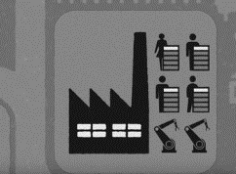
Globalisation caused by – Global labour force

- A global labour force is one that is ________________ to seek better jobs in other ______________________________
- This can cause ________________________ from host nations, where citizens feel that their jobs are being taken by ____________________________

Structural change
What is structural change?
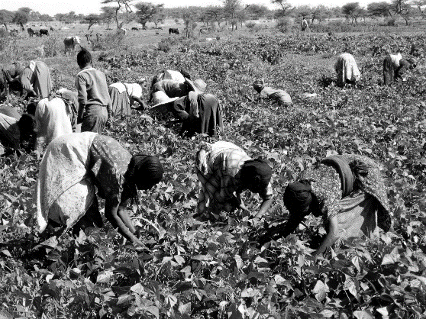
Globalisation caused by – structural change

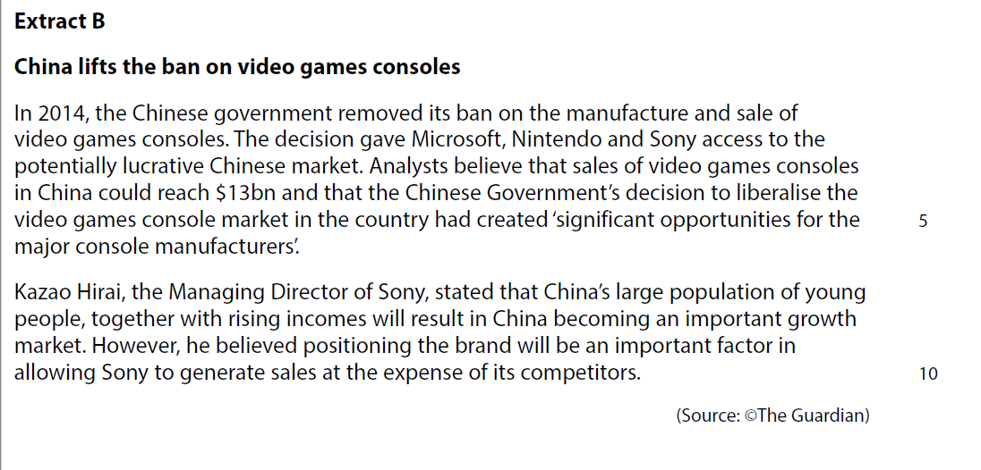
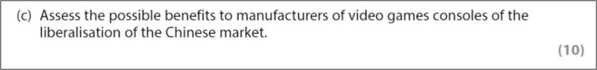

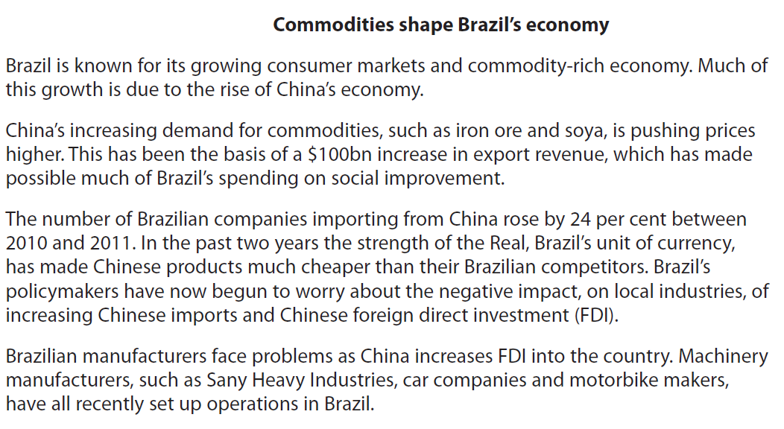

[12]

