Cross Elasticity of Demand - XED
Starter Activity – YED values and the types of goods?

What do we call products that are consumed together? Give an example.

What do we call products that can be used to replace existing ones? Give an example.

What might happen to demand for tyres, if the price of lollipos increased?

Define cross elasticity of demand
What is the formula in order to calculate XED?

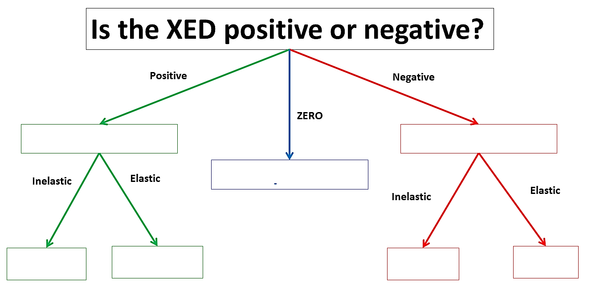
Complete the tree below to show how to interpret an XED answer:
Explain what a NEGATIVE XED coefficient means.
Can you give an example?

Explain what a POSTIVE XED coefficient means.
Can you give an example?

Draw diagrams for the following XED results:
Strong Complements: Weak Complements:
Price
Good Y
Quantity
Good X
Price
Good Y
Quantity
Good X

Strong Substitutes: Weak Substitutes:
Price
Good Y
Quantity
Good X
Price
Good Y
Quantity
Good X

Draw a diagram to represent the relationship between two goods with a zero XED coefficient
Explain what this result means:
Can you give an example?
Price
Good Y
Quantity
Good X

Calculation Questions XED:

- If the price of Coca Cola increases from 50p to 60p per can, and the demand for Pepsi Cola increases from 1m to 2m per year, the XED between the two products is? (Show your calculations and answer below)

What does this answer mean?

- If the price of Cinema Tickets increases from £5.00 to £7.50, and the demand for Popcorn decreases from 1000 tubs to 700, the XED between the two products will be? (Show your calculations and answer below)

What does this answer mean?

Good/Service | Substitute Goods | Complementary Goods
Bread
Pizza
Laptop
University Education
Xbox One
Private Healthcare
Car

Mr Wilson’s Thinking Further Challenge…
Explain how a firm could use XED to increase revenues. For instance, Xbox One and PS4 consoles are usually sold at loss – why is this and can you think of any other similar examples of XED usage?

Past Paper XED Exam Questions
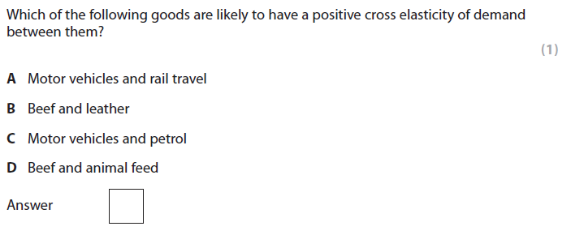
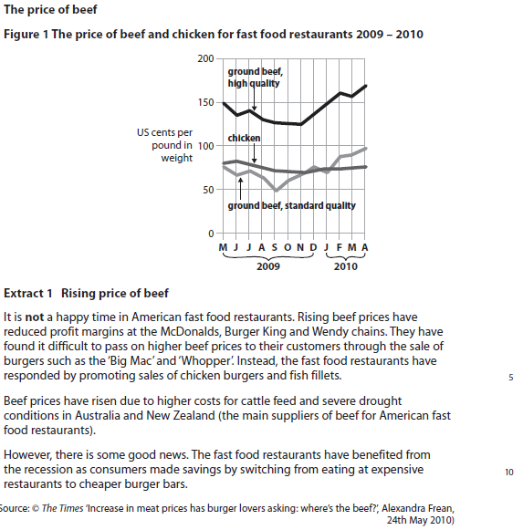

Question 9b, January 2012
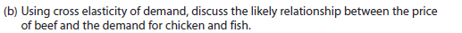
8 marks

1 KAA (6 marks) and 1 EV (2 marks)

