4.2.2 Assessment of a country as a market

Starter:
- You work in the marketing department for an international business. You have been given the task of identifying a new market where you can sell your company’s products. You are keen to impress at the first meeting with your boss to discuss the potential markets…
- What are the questions that you should be asking your boss before you make suggestions of what country to trade in?

________________________________________________________________________________________________________________________________________________________________________________________________________________________________________________________________________________________________________________________________________
Assessment of a country as a market
1
2
3
4
5

 | Venezuela | Russia | Switzerland
levels and growth of disposable income
ease of doing business
infrastructure
political stability
exchange rate

Disposable income
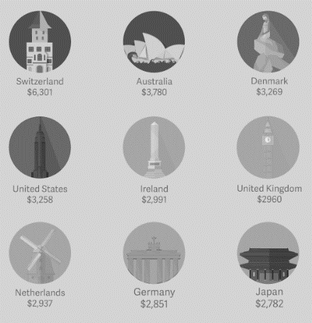
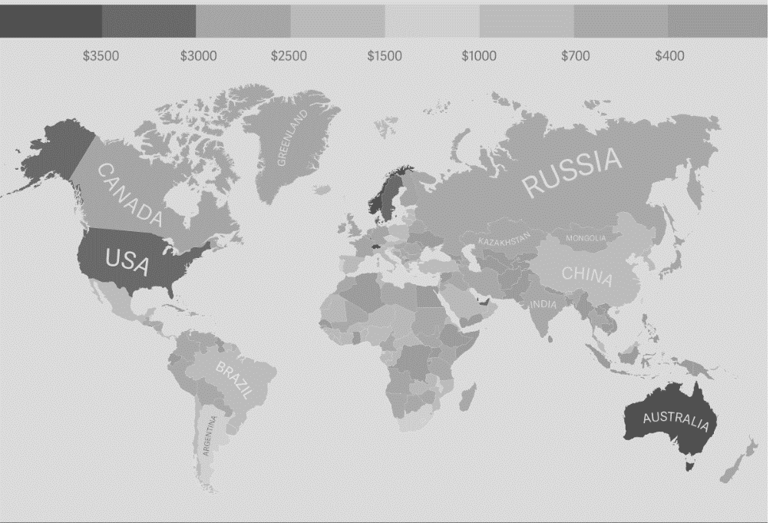

Disposable income per household

________________________________________________________________________________________________________________________________________________________________________________________________________________________________________________________________________________________________________________________________________
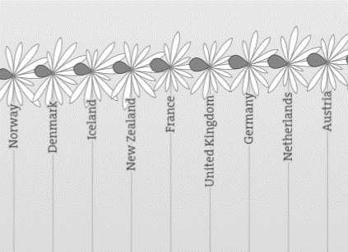
Disposable income – better life index

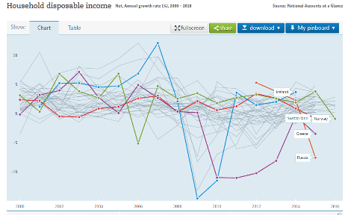
________________________________________________________________________________________________________________________________________________________________________________________________________________________________________________________________________________________________________________________________________
Growth of disposable income

________________________________________________________________________________________________________________________________________________________________________________________________________________________________________________________________________________________________________________________________________
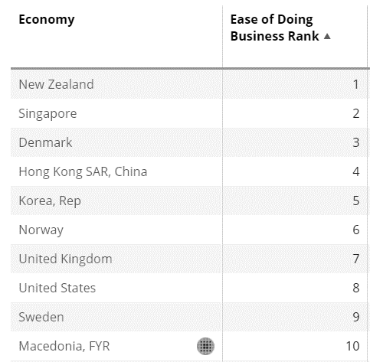
#2 Ease of doing business

________________________________________________________________________________________________________________________________________________________________________________________________________________________________________________________________________________________________________________________________________
#3 Infrastructure

________________________________________________________________________________________________________________________________________________________________________________________________________________________________________________________________________________________________________________________________________

Global competitiveness index
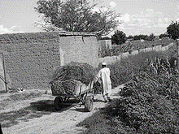
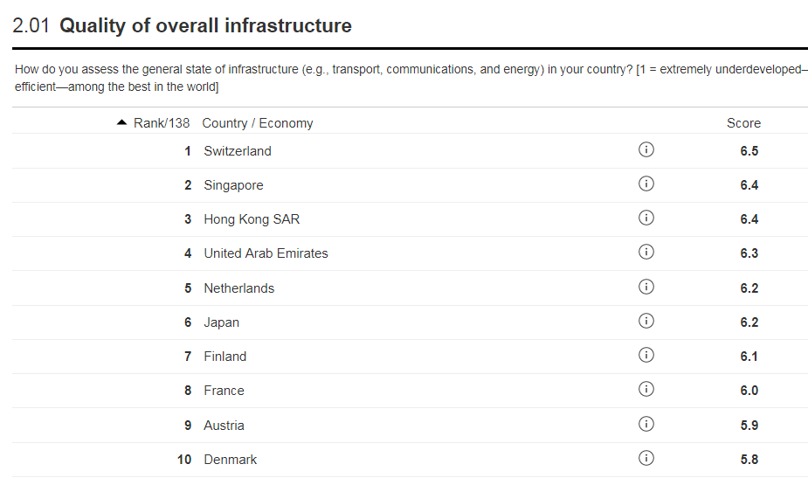
Why infrastructure is important to sales
________________________________________________________________________________________________________________________________________________________________________________________________________________________________________________________________________________________________________________________________________

#4 political stability
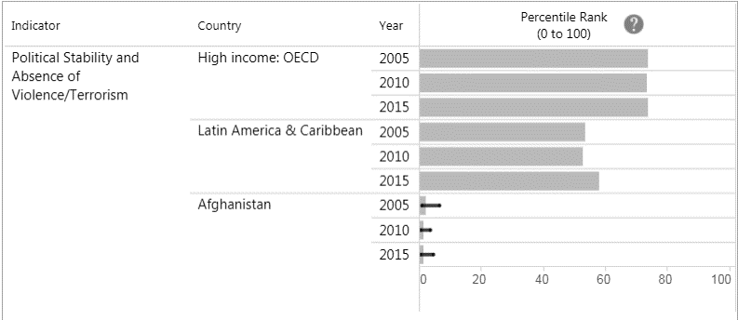
Political stability – risk factor
________________________________________________________________________________________________________________________________________________________________________________________________________________________________________________________________________________________________________________________________________
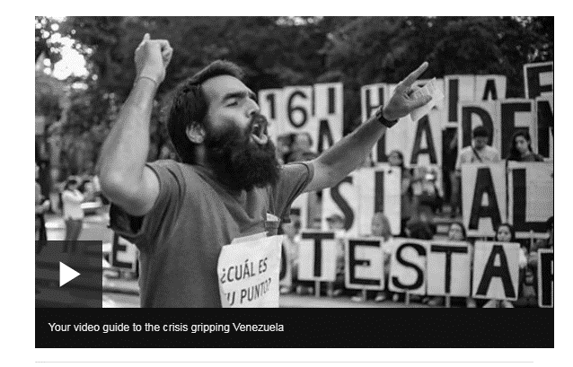
Why is political stability important?

________________________________________________________________________________________________________________________________________________________________________________________________________________________________________________________________________________________________________________________________________

Exchange rates – revision again!
S |  | W
P |  | P
I |  | I
C |  | D
E |  | E
D |  | C

More data?
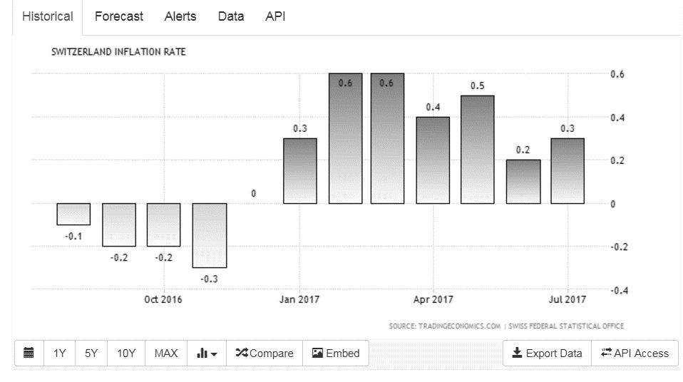

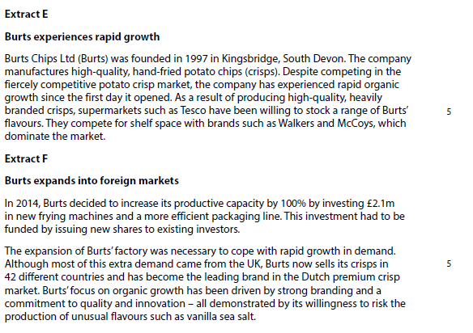
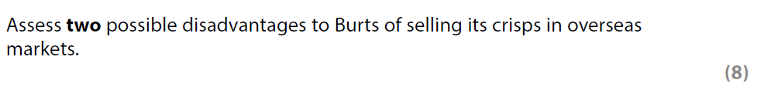

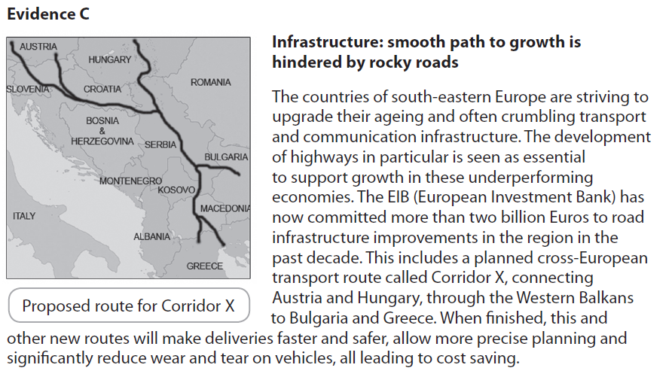

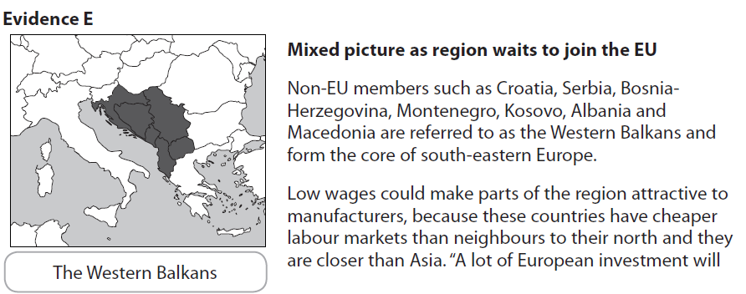
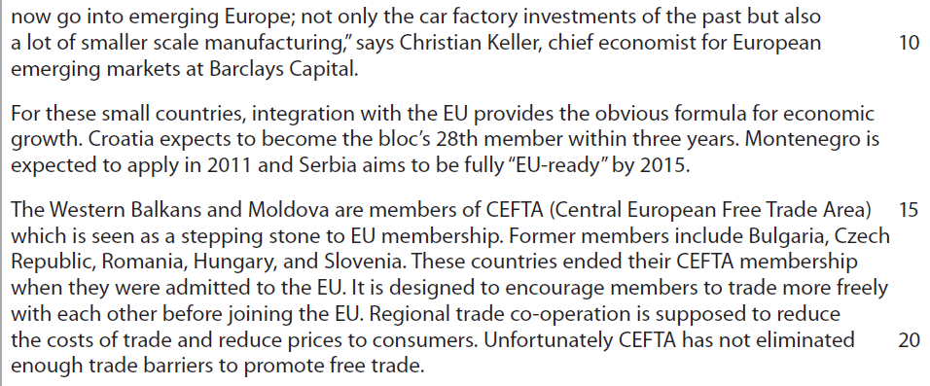

[10]

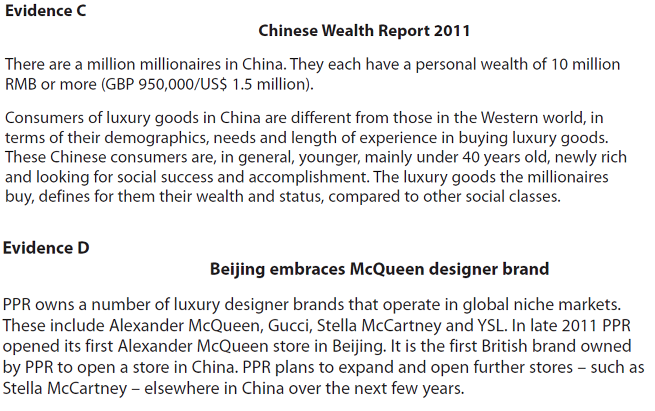
[6]

