2.5.1 Economic Influences

Starter

Write a definition of economic influence here:
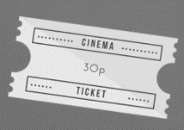
________________________________________________________________________________________________________________________________________________________________________________________________________________________________________________________________________________________________________________________________________

What is inflation?
________________________________________________________________________________________________________________________________________________________________________________________________________________________________________________________________________________________________________________________________________

CPI is the Consumer Price Index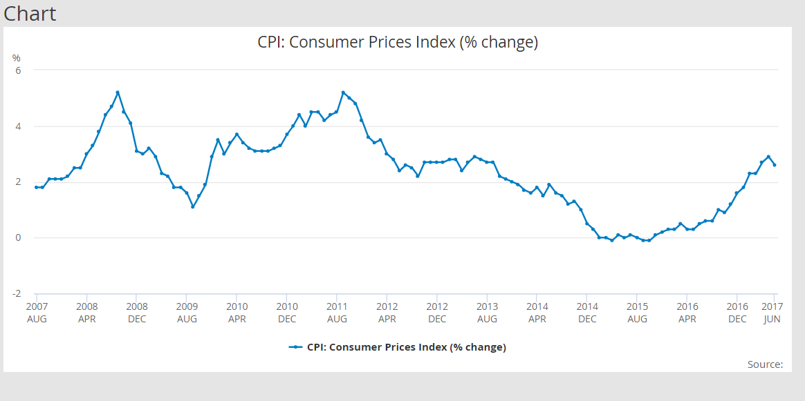
________________________________________________________________________________________________________________________________________________________________________________________________________________________________________________________________________________________________________________________________________

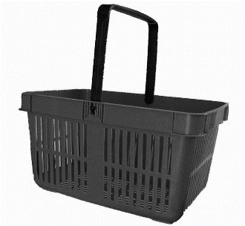
Inflation measured by Consumer Price Index
________________________________________________________________________________________________________________________________________________________________________________________________________________________________________________________________________________________________________________________________________

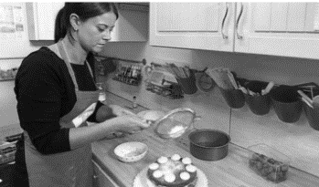
How is business affected by changes in inflation?

________________________________________________________________________________________________________________________________________________________________________________________________________________________________________________________________________________________________________________________________________
What are exchange rates?

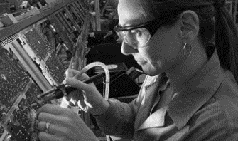
________________________________________________________________________________________________________________________________________________________________________________________________________________________________________________________________________________________________________________________________________
Exchange rates - appreciation

S
P
I
C
E
D

W
P
I
D
E
C
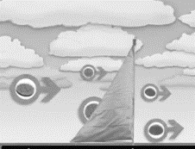
Interest rates and the Bank of England

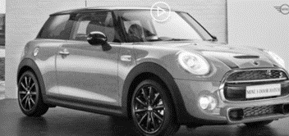
________________________________________________________________________________________________________________________________________________________________________________________________________________________________________________________________________________________________________________________________________
Interest rates – cost of borrowing

________________________________________________________________________________________________________________________________________________________________________________________________________________________________________________________________________________________________________________________________________

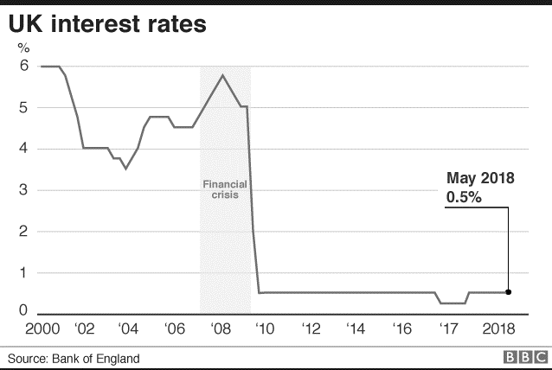
How is business affected by changes in interest rates?

Taxation

What is taxation?

How is business affected by changes in taxation?

Taxation and VAT

UK taxation for small businesses

UK taxation for larger businesses

UK taxation- excise duties

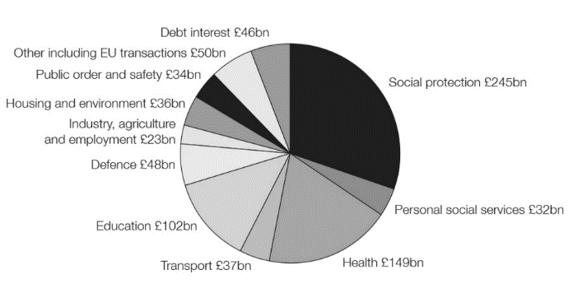
What is government spending?

How is business affected by changes in government spending?

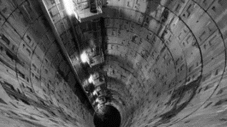

Economic activity

Time

Time

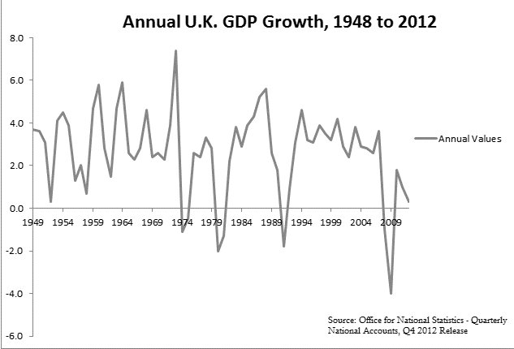
The business cycle
____________________________________________________________________________________________________________________________________________________________________________________________________________________________________________________________________________________________________________________________________________________________________________________________________________________________________________________________________________________________________________

Boom
Recession
Slump
Recovery

Economic uncertainty
____________________________________________________________________________________________________________________________________________________________________________________________________________________________________________________________________________________________________________________________________________________________________________________________________________________________________________________________________________________________________________

