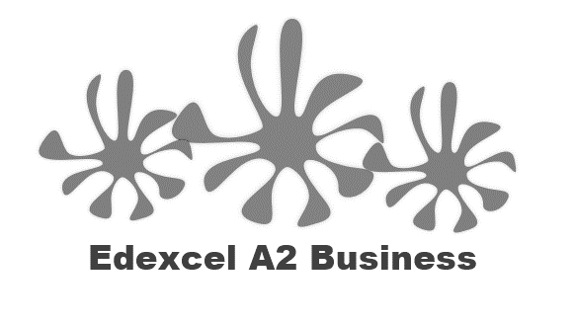
1.1.3. Market positioning

Starter
Write your Mars Bar product ideas here:

Write your definition of market maps here:
________________________________________________________________________________________________________________________________________________________________________________________________________________________________________________________________________________________________________________________________________
Market mapping – example

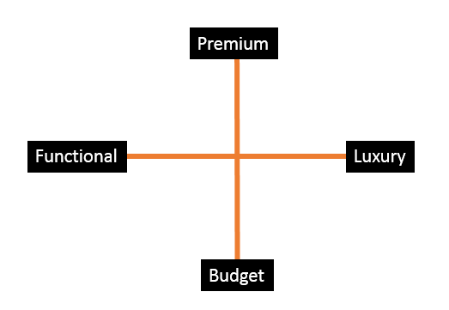

Market mapping activity

Uses of market mapping

________________________________________________________________________________________________________________________________________________________________________________________________________________________________________________________________________________________________________________________________________

Write your definition of competitive advantage here:
________________________________________________________________________________________________________________________________________________________________________________________________________________________________________________________________________________________________________________________________________

Ways that a business can achieve competitive advantage:

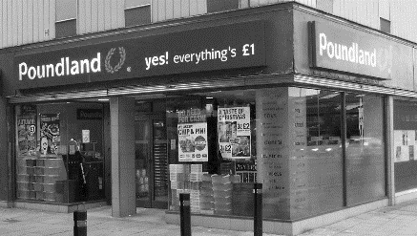 | Price
 | Added value
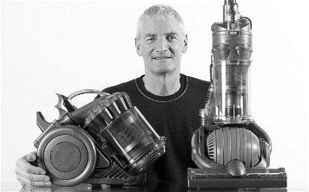 | Innovation
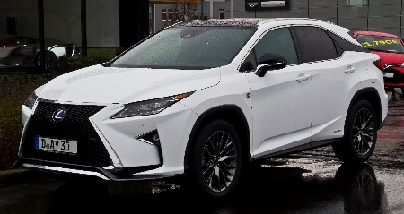 | Reliability
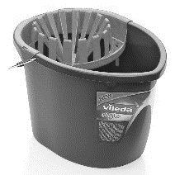 | Quality
 | Reputation
 | Advertising
 | Branding
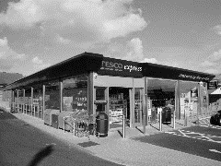 | Convenience
 | Customer service

Product differentiation
________________________________________________________________________________________________________________________________________________________________________________________________________________________________________________________________________________________________________________________________________

Methods of differentiation

Write your definition of added value here:
________________________________________________________________________________________________________________________________________________________________________________________________________________________________________________________________________________________________________________________________________
How can a business add value?
- Design – develop new technology/design features to make their product unique (__________________________ advantage)
- Production – achieving quality and efficiency adds ________________.
  - Quality will ensure a _______________________ price can be charged (differentiation advantage)
  - ______________________ helps cut costs of the input (cost advantage)
- Marketing – creating an ____________________ that makes the product more _________________________, a brand differentiation advantage
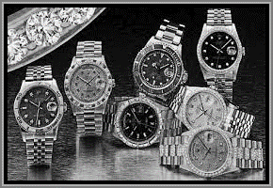

Adding value – potato exercise

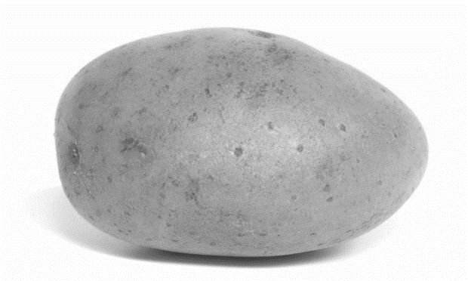
Ways to add value to a potato:

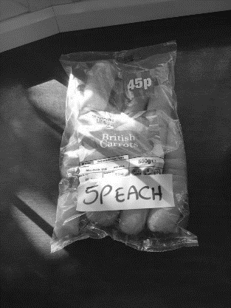
How Value can be added:

Benefits of adding value
1

2

3

