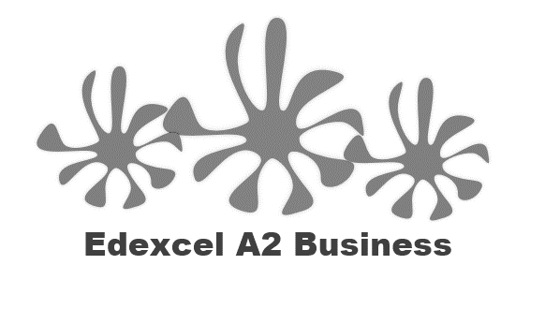
1.2.2. Supply

Starter – articles to read
What did the two articles tell you about supply in business?

Write your definition of supply here:
________________________________________________________________________________________________________________________________________________________________________________________________________________________________________________________________________________________________________________________________________
Price determines levels of supply
________________________________________________________________________________________________________________________________________________________________________________________________________________________________________________________________________________________________________________________________________

- Cost of production
- Introduction of new technology
- Indirect taxes (e.g. VAT)
- Government subsidies
- External shocks

Plenary game – increase or decrease in supply?

Increase or decrease in supply?
- Increase in oil price
- Increase in minimum wage
- Increase in orders
- Increase in productivity
- Increase in VAT rate
- Decrease in inflation
- Introduction of robots
- Introduction of new labour laws

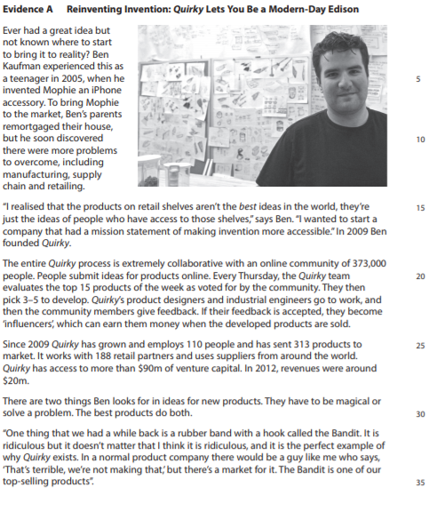
Case study for this question continues on next page

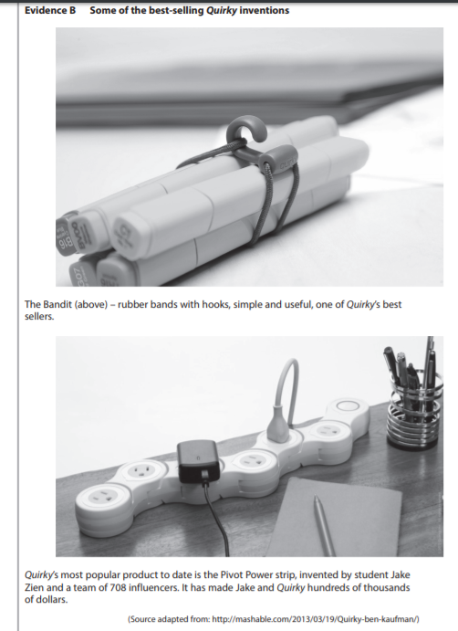

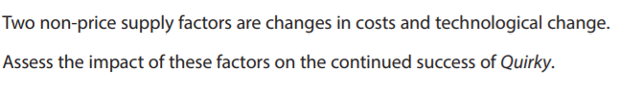
[12]

