Production Possibility Frontier – Worksheet 1
Draw the following PPF scenarios on each axis:
- A firm has decided to dedicate more resources to beer than corn.
Corn
Beer
In this scenario, where has an opportunity cost occurred?

- Sticking with beer and corn again - A more efficient production process has been developed to produce more beer and corn, while still using the same amount of resources.
Let’s presume the production process in question is labour intensive. How might the production process be developed in order to produce more beer and corn?

Corn
Beer

- Sticking with beer and corn, all of the oil in this economy has been exhausted. What would the impact be upon the production possibility frontier?
Now that this economy has no oil, explain why you have adapted the PPF curve in the way you have. What might the economy now have to do instead?

- Look the at the PPF diagram below a) for each of the economies labelled A-E, describe their current circumstances.
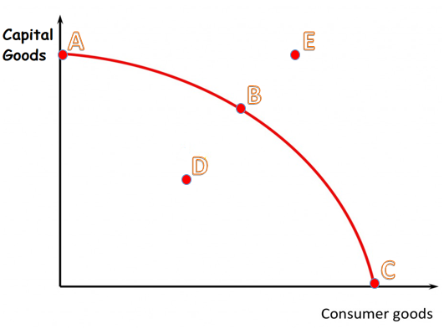

A =
B =
C =
D =

E =

