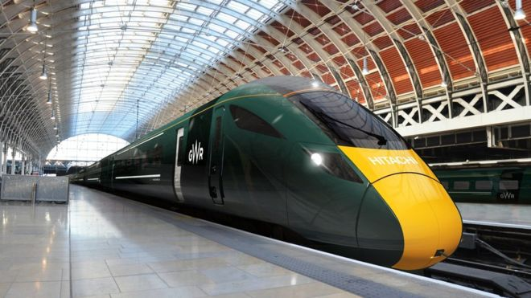
Train operators pay £200m to shareholders after £4bn subsidy
Figures released by Office for Rail Regulation put plans to re-privatise east coast rail line under fresh scrutiny
Saturday 21 June 2014
The planned reprivatisation of the east coast rail line is under fresh scrutiny after figures showed that train operators paid more than £200m in dividends to their shareholders last year, when taxpayers ploughed £4bn into the railways.
Three train operators – Virgin, Northern Rail and Transpennine – handed almost £100m to shareholders.
Unions said the numbers, published on Wednesday in a comprehensive review of railway financing by the Office for Rail Regulation (ORR), showed rail was run with "the economics of the madhouse".
However, operators said their finances were open and transparent and profit margins averaged 3%.
Virgin Rail, which runs the west coast service and is one of three bidders shortlisted to run the east coast line, paid the highest dividends: £40m to its shareholders, Sir Richard Branson and Stagecoach.
Northern Rail paid £36m in dividends with subsidies totalling £713m. Transpennine returned £21m in dividends to owners First Group and Keolis, having received £52m in payments from the government.
The TUC general secretary, Frances O'Grady, said the report highlighted again how private train operators relied upon public subsidies. "Rail franchising has provided train companies with the perfect cover to use taxpayers' money to line their shareholders' pockets," she said.
"It is laughable for ministers to carry on insisting that rail privatisation is delivering value for money. The government's decision to re-privatise the east coast mainline looks more foolish by the day."
A spokesman for the Rail Delivery Group said: "Any dividends paid by train companies need to be viewed against the £7.7bn they generate in revenue and against the phenomenal growth in passengers since franchising was introduced. This has enabled operators to increase fourfold the amount of money they return to government."
Virgin Trains claimed it could double East Coast's payments to government if it was not paying more to Network Rail and was running newer trains, saying: "It is a myth that public ownership of the railways would leave the taxpayer better off. The huge investment which has gone into the west coast means Virgin Trains paid £318m more than East Coast.
Mary Creagh, the shadow secretary of state, warned that the government's net contribution to train operating companies would "skyrocket" next year. She said: "Passengers and taxpayers are picking up the tab for this out-of-touch government's franchising fiasco with higher fares and more public subsidy."
The ORR's report also showed that despite the £4bn subsidy, passengers are shouldering an ever-increasing proportion of industry costs in fares – now 59.2%, compared with 55.6% in 2010-11. Running costs have also fallen by 6.2% in that two-year period.

What is meant by re-privatisation?

Using your own knowledge and ideas, state two reasons why the government would want to subsidise rail travel.

How much were the subsidies paid by the taxpayer to the railway industry?

Why does the Rail Delivery Group argue that the subsidies are beneficial in financial terms?

What are the criticisms of the current subsidy arrangements? Refer to rail customers and profit-making railway companies in your answer.

How the solar panel subsidy cuts will affect you
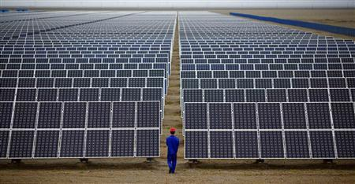
Should you go ahead with an installation, and what if you’ve already got panels?
What’s the big announcement?
The Department of Energy & Climate Change (DECC) is consulting on plans that would see subsidies for some new solar farms end by 2016. It is also undertaking a review of the whole structure that has so far led to panels being installed on 1.5% of UK homes.

Solar power subsidies cut might save just 50p on average electricity bill
Our support has driven down the cost of renewable energy significantly. As costs continue to fall it becomes easier for parts of the renewables industry to survive without subsidies.”
Are solar panels still worth it for householders?
When Fits were first launched in 2010, a typical large domestic photovoltaic system cost £15,000-£18,000 to install. Early adopters were promised 41.3p per kilowatt hour (kWh) generated for 25 years, plus generous savings on their electricity bills worth up to £160 a year.
Price falls in PV panels over the past five years mean that the same system can now be installed for £5,000-£6,000 – and the government has responded by cutting the income paid accordingly.
Someone installing a £6,000 panel system on such a roof in Hertfordshire can expect an income and electricity bill savings of around £600 a year. Payments are index linked and are guaranteed for the next 20 years.
How much power does solar produce?
According to the Solar Trade Association, 670,000 UK homes have solar panels, along with thousands of businesses, farmers, schools and community groups, producing 7-8GW of power. At its recent peak, solar generated around 15% of UK electricity demand. Overall, the UK has enough solar to power the equivalent of 2.4m homes.
The Japanese company Panasonic, which is a major supplier of solar panels in Britain, said it normally tried to avoid intervening in political decisions but could not stand by and watch the industry being attacked. Panasonic urged ministers to think again about their proposals, which involve some subsidies being cut by almost 90%.
“Let’s keep [the industry] alive, let’s help it further develop to become fully independent from state support, with energy storage and a closer involvement of utilities. But let’s not push the bird out of the nest before it can properly fly,” he said.

Why are the government deciding to cut subsidies to solar panels now?

By how much are some subsidies being cut?

In what way have people been benefitting from the subsidies?

Why are Panasonic so concerned about the subsidies being cut?

Using your own knowledge and ideas, state two reasons why the government would want to subsidise solar panels.

Wind farm subsidy cut putting off lenders, research suggests
- 14 September 2015

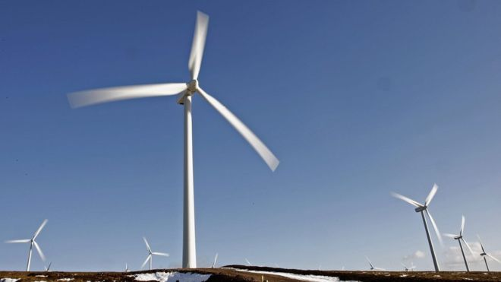
- Investment in onshore wind energy is already being hit by the early withdrawal of government subsidies.
In June, UK ministers said new onshore wind farms would be excluded from a subsidy scheme from 1 April 2016. Investors are now less willing to lend to projects.
The UK government said it was taking urgent action to address the projected overspend on subsidies.It has previously said there are already enough subsidised wind energy projects in the pipeline.
A survey, carried out on its behalf by EY, asked 10 major lenders about their willingness to provide investment.
Of the seven who responded, more than half said they were not prepared to lend.
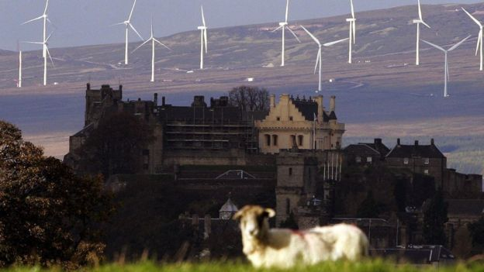
Michael Rieley, senior policy manager at Scottish Renewables, said the expected loss of the subsidy "had a clear and negative impact on the ability of developers to attract finance to their projects".idised wind farms in the p
"Our members have already expressed concern that they were entering an investment hiatus and this survey of lenders would indicate their suspicions are well founded," he said.
"These are projects that could bring around £3bn of investment and provide enough generation to meet the equivalent electricity demand of 1.2 million Scottish homes."
Matthew Yard, assistant director at EY, said: "The results of the survey indicate that raising project finance for UK onshore wind RO projects has become more complex, more expensive and increasingly difficult since the announcement of the early closure of the RO.

Falling costs
A spokeswoman for the Department of Energy and Climate Change said: "We're taking urgent action to address the projected overspend on subsidies for renewables and to protect bill payers.
"Government support has driven down the cost of renewable energy significantly. As costs continue to fall and we move towards sustainable electricity investment, it becomes easier for parts of the renewables industry to survive without subsidies."
WWF Scotland director Lang Banks said: "This survey provides further evidence that the UK government's energy plans are damaging investor confidence in the cheapest form of renewable technology.
"And, it's not just investment and jobs that are at risk by their reckless policies, but our ability to cut carbon emissions. Even the government's own analysis shows that an early ending of support for onshore wind could drive up power sector emissions in the UK by up to 63 million tonnes."

How will the cut in subsidies impact upon developers?

Why do the government argue that now is a good time to cut subsidies for wind farms?

What do WWF Scotland say the consequences of cutting subsidies could be?

Using your own knowledge and ideas, state two reasons why the government would want to subsidise wind farms.

Using your own knowledge, why might subsidies be negative for a company?

