2.3.3 Business failure

Starter
Why does Blockbuster no longer trade?

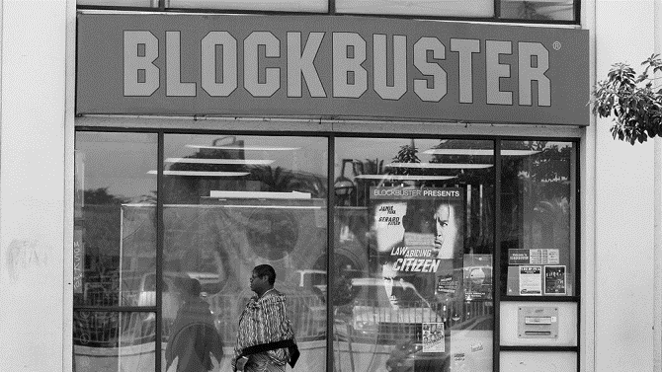
________________________________________________________________________________________________________________________________________________________________________________________________________________________________________________________________________________________________________________________________________

Write a definition of business failure here:
________________________________________________________________________________________________________________________________________________________________________________________________________________________________________________________________________________________________________________________________________

Internal causes of business failure

#1 Poor efficiency
________________________________________________________________________________________________________________________________________________________________________________________________________________________________________________________________________________________________________________________________________
#2 Poor marketing

________________________________________________________________________________________________________________________________________________________________________________________________________________________________________________________________________________________________________________________________________
#3 Failure to innovate

________________________________________________________________________________________________________________________________________________________________________________________________________________________________________________________________________________________________________________________________________

#4 Poor management of working capital

________________________________________________________________________________________________________________________________________________________________________________________________________________________________________________________________________________________________________________________________________

External causes of business failure

#1 Economic recession

________________________________________________________________________________________________________________________________________________________________________________________________________________________________________________________________________________________________________________________________________
#2 Strong Pound
________________________________________________________________________________________________________________________________________________________________________________________________________________________________________________________________________________________________________________________________________

Business failure challenges

