Marketing: Introduction to Marketing Strategy
Marketing strategies explain how the marketing function fits in with the overall strategy for a business. Examples of marketing strategies could be:
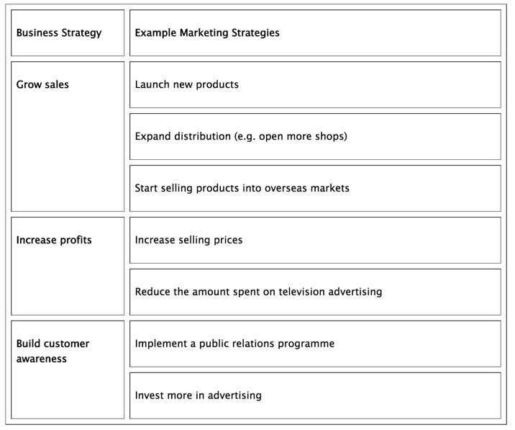
Once a strategy has been identified, then the business must develop an action to turn the strategy into reality. The starting point for this plan is the setting of marketing objectives.
Marketing objectives are the specific targets for marketing set by the business to achieve their corporate objectives.
Examples of marketing objectives might be:
- Increase sales by 10%
- Launch a new product by the end of the year
- Achieve a 95% customer satisfaction rating
- Increase the number of retail outlets selling our products by 250 within 12 months
It is important for a business to set marketing objectives because managers can then have targets for their work. They can then measure more effectively the success or failure of their marketing strategies to achieve these objectives.

