3.6.2 Key factors in change
Key factors in change:
a) Organisational culture
b) Size of organisation
c) Time/speed of change
d) Managing resistance to change

a) Reasons for Changing Organisational Culture

BUSINESS PERFORMANCE

When the sales and profits of a business decline sharply or when even the survival of the business is threatened, that is a clear signal that things need to change - including the culture. Whilst the culture might not itself be the cause of poor business performance, it can be a powerful symptom of the need for change. Perhaps a business has lost its edge by becoming too complacent about the need to innovate, or through a bureaucratic culture allowed competitors to gain an advantage by becoming more agile or efficient.

NEW LEADERSHIP / STRATEGY

New leaders often align a change in strategy with a call for a change in culture. Usually this is because the existing culture is identified as a potential restraining force (Lewin) which might reduce the chances of successful change management. Satya Nadella (at Microsoft) and Moya Greene (Royal Mail) both identified the need for cultural change to accompany changes in strategic direction.

CHANGE IN EXTERNAL ENVIRONMENT

External shocks can be a powerful facilitator of cultural change. For example, following the banking and financial crisis of 2007-9, and the subsequent business failures of market leaders such as Lehmann Brothers and the bank bailouts, it became clear that significant cultural change was required in firms that survived. A culture had developed (and was fostered by senior management) that encouraged and rewarded excessive risk-taking. For businesses like RBS, rescued by the UK government, the arrival of new leadership soon led to a very different culture being required.

TO SUPPORT CHANGE MANAGEMENT

As mentioned above, an attempt to change culture is often part of major (step) change projects. These may include new leadership, but not always. It is perfectly possible for existing management to identify the need for culture change as part of change initiatives designed to improve the competitiveness of a business,
For example, new processes and/or incentives to encourage innovation might be introduced. Similarly, a business might change from a centralised to a decentralised approach to decision-making - with the need for changes in how the business communicated identified as a key part of the required culture change.

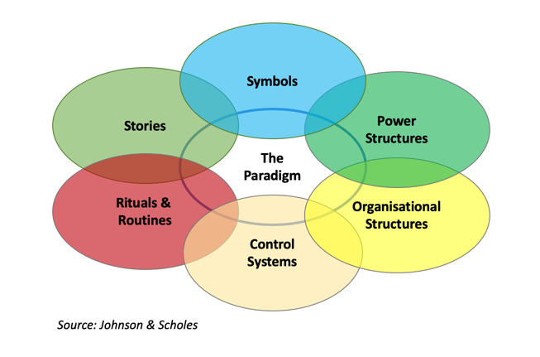
a) Problems of Changing Organisational Culture
It is one thing identifying the need for and then deciding to attempt to change the organisational culture of a business. However, it is perhaps easier said than done.

The key problem facing management wanting to change organisational culture is that the culture will usually be deeply embedded or engrained in the organisation.

Two key models of how organisational culture is shaped and formed - reproduced below - hint at the challenge’s management will face:

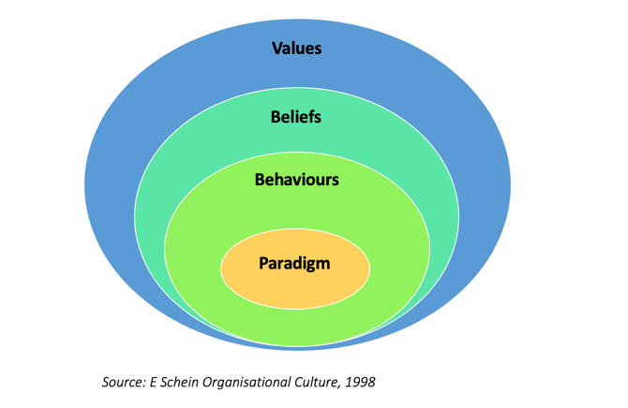
Johnson & Scholes point to a variety of features of organisational culture that might prove resistant to attempted change. For example, the power structures and control systems which determine who has authority in a business and how decisions are made are likely to be threatened by culture change. That might suggest that new leadership is required at the same time in order to increase the chance of success.

Similarly, the routines and rituals that are embedded in a culture might also be hard to change. These are the daily actions and behaviours of individuals within the organisation. Routines indicate what is expected of employees on a day-to-day basis - for example how employees deal with customers, communicate with each other etc. As we all know from trying to make New Year resolutions, habits and routines are hard to break!

Schein's famous model of organisational culture also helps explain why culture change is tough. The model (represented above) is often described as an onion model as it has different layers. The outer layer of organisational culture is relatively easy to adapt or change. The deeper the layer, the harder it becomes to change.
At the centre of Schein's onion (sorry - model) is the "paradigm". This is the unspoken, generally accepted way of doing things that is prevalent in a business' culture. It is hard to identify or to describe - except that people in the business recognise it when they see it, or perhaps more likely, know when something is not consistent with the cu b)

b) Size of organisation

- As a business grows there will be inevitable changes within the organisation
- For example, as a business grows from ltd to plc so that they can raise more finance by floating share on the stock market this will mean huge changes for the business

c) Time/speed of change

Two types of change
Planned change
- Refers to change which is planned by the top management of a business
This could be:
- Board of Directors
- The Owners
- Senior leadership team
Emergent change
- This is change that happens at any level in the organisation and is the result of an event or need
- E.g. Computer back-up system has failed so a new IT system must be installed which will require training for all staff

- One of the main problems with change is to align expectations with reality
- Changes that happen too quickly will mean that employees may experience stress
- “I didn’t know it would happen so fast”
- “I can’t keep up with the all the changes”
- “I haven’t had time to adjust to all the improvements the business has made”

d) Why Change is Resisted (Kotter & Schlesinger)

There are many reasons why change is resisted by people working in business. This study note outlines the four main reasons as identified by Kotter & Schlesinger.
Self-interest

- Self-interest is a powerful motivator
- Arises from a perceived threat to job security, status and financial position
- Understandable - why would you want to lose something you believe to be valuable?
- Individuals often place their own interests ahead of those of their organisation, particularly if they do not feel a strong loyalty to it

Misinformation & Misunderstanding

- People do not understand why change is needed, perhaps because they are misinformed about the real strategic position of the business
- Perception may be widespread that there is no compelling reason for change
- Perhaps even an element of people fooling themselves that things are better than they really are

Different Assessment of the Situation

- Here there is disagreement about the need for change or what that change needs to be
- Some people may simply disagree with the change proposed, or they may feel they have a better solution
- This is different from “self-interest” – the resistance here is based on disagreement about what is best for the business

Low Tolerance and Inertia

- Many people suffer from inertia or reluctance to change, preferring things to stay “the way they are”
- Many people need security, predictability & stability in their work
- If there is low tolerance of change (perhaps arising from past experience) then resistance to change may grow

d) Overcoming Resistance to Change (Kotter & Schlesinger)

How can senior management overcome the inevitable resistance to change when change is required? This study note outlines the six approaches suggested by Kotter & Schlesinger.
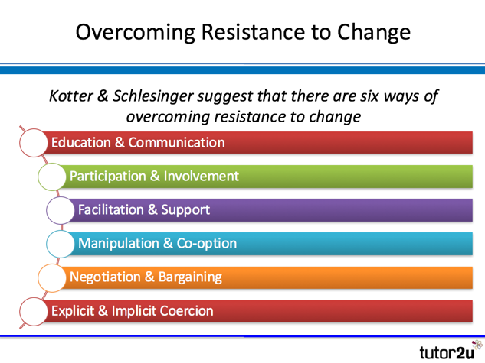

Education & Communication

- The starting point for successful change is to effectively communicate the reasons why change is needed!
- Honest communication about the issues and the proposed action helps people see the logic of change
- Effective education helps address misconceptions about the change, including misinformation or inaccuracies
- Education and communication are unlikely to achieve very short-term effects. They need to be delivered consistently and over a long period for maximum impact

Participation & Involvement

- Involvement in a change programme can be an effective way of bringing “on-board” people who would otherwise resist
- Participation often leads to commitment, not just compliance
- A common issue in any change programme is just how much involvement should be permitted. Delays and obstacles need to be avoided.

Facilitation & Support

- Kotter & Schlesinger identified what they called “adjustment problems” during change programmes
- Most people (though not all) will need support to help them cope with change
- Key elements of facilitation and support might include additional training, counselling, and mentoring as well as simply listening to the concerns of people affected
- If fear and anxiety is at the heart of resistance to change, then facilitation and support become particularly important.

Co-option & Manipulation

- Co-option involves bringing specific individuals into roles that are part of change management (perhaps managers who are likely to be otherwise resistant to change)
- Manipulation involves the selective use of information to encourage people to behave in a particular way
- Whilst the use of manipulation might be seen as unethical, it might be the only option if other methods of overcoming resistance to change prove ineffective.

Negotiation & Bargaining

- The idea here is to give people who resist an incentive to change – or leave
- The negotiation and bargaining might involve offering better financial rewards for those who accept the requirements of the change programme
- Alternatively, enhanced rewards for leaving might also be offered
- This approach is commonly used when a business needs to restructure the organisation (e.g. by delayering).

Explicit & Implicit Coercion

- This approach is very much the “last resort” if other methods of overcoming resistance to change fail
- Explicit coercion involves people been told exactly what the implications of resisting change will be
- Implicit coercion involves suggesting the likely negative consequences for the business of failing to change, without making explicit threats
- The big issue with using coercion is that it almost inevitably damages trust between people in a business and can lead to damaged morale (in the short-term).

