“Free school meals for children at infant school will reduce the cost burden in the future for the NHS’.”

What is meant by the phrase ceteris paribus?
What do economic models attempt to do and how do they do this?

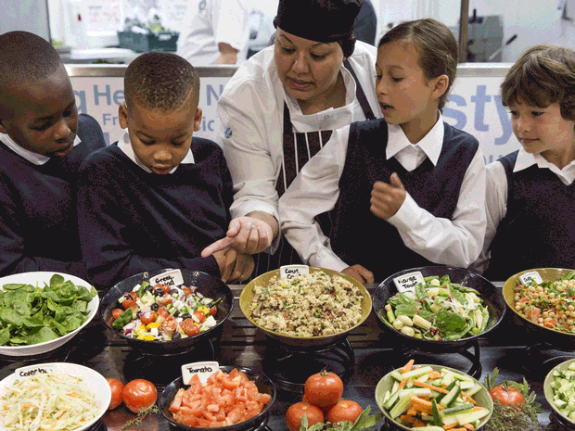
Free school meals for infants 'set to be scrapped' under Osborne's spending review

Jamie Oliver has called the possible decision a 'disaster'
Sunday 20 September 2015
Free meals for infant school pupils are likely scrapped in George Osborne’s November spending review, it has been reported.
According to Sky News, the government is considering the cut despite pledging to continue the policy in the 2015 Conservative manifesto.
Free hot school meals for all schoolchildren between four and seven, regardless of their parent’s income, were introduced by former Deputy Prime Minister Nick Clegg in 2014. It was estimated that it would cut costs to parents by £400 per year, per child.
Government departments were ordered by the Chancellor to cut their budgets by up to 40 per cent in July, under his spending review due in November.
The Department for Education has the majority of its spending budget protected.
However, £14 billion of spending within early years education is subject to cuts and the Universal Infant Free School Meals programme (UIFSM), which is estimated to cost between £600m and £800m per year, falls under this category.
Healthy eating campaigner, Jamie Oliver called the possible decision a “disaster”, saying the policy had been a “major step forward for children’s health and academic performance” as homemade packed lunches often got “nowhere near the nutritional standards set for school meals".
Liberal Democrats leader Tim Farron said: “All the evidence suggests that children who have a school meal every day are two months further on in their studies than those that don’t. [To take away the policy] is damaging to children, it’s an insult to our schools.”
The initiative previously faced criticism over the costs and preparations of fitting some schools with kitchens.
According to Sky News, the government refused to rule out cutting the scheme, but a spokesperson said: “We believe that every child, regardless of their background, should have the same opportunities.
“That is at the heart of what we are doing with school food – no child should be hindered because they are not eating a nutritious meal at lunchtime.”

