2.4.1 Production productivity
and efficiency

Starter
How productive are you?
A) on a Monday morning first lesson ______________________________________
B) on a Wednesday afternoon last lesson _________________________________
C) on a Friday lunch time?__________________________________________________

Write a definition of productivity here:
____________________________________________________________________________________________________________________________________________________________________
Write a definition of production here:
____________________________________________________________________________________________________________________________________________________________________
Methods of production

#1 Job production
- Job production is where one ______________ product is made at a time
- Products are made for a _________________ client or customer
- Products made are high _________________________, which means higher _______________________ can be charged
- However, the production process can be ___________ and labour _________________________
Job production
____________________________________________________________________________________________________________________________________________________________________
Examples of job production: Write the examples that you see in the images:
________________________________________________________________________________________________________________________________________________________________________________________________________________________________________________________________________________________________________________________________________

When to choose job production
Building a _________________________
Hand knitting a ______________________________
Building a ______________________________ over a river
Writing a _____________________________________

Job production – advantages and disadvantages
Advantages | Disadvantages

#2 Batch production
________________________________________________________________________________________________________________________________________________________________________________________________________________________________________________________________________________________________________________________________________
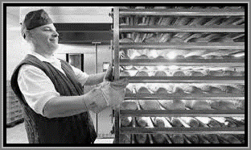
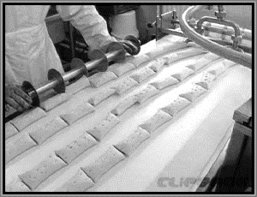

Advantages | Disadvantages

#3 Flow production
________________________________________________________________________________________________________________________________________________________________________________________________________________________________________________________________________________________________________________________________________
When to choose flow production

________________________________________________________________________________________________________________________________________________________________________________________________________________________________________________________________________________________________________________________________________

Advantages | Disadvantages

#4 Cell production
________________________________________________________________________________________________________________________________________________________________________________________________________________________________________________________________________________________________________________________________________
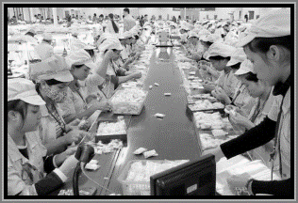
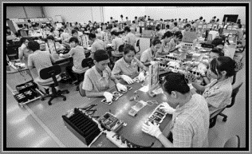

Advantages | Disadvantages
Productivity
________________________________________________________________________________________________________________________________________________________________________________________________________________________________________________________________________________________________________________________________________
Ways to improve productivity

#1 Productivity bonus
________________________________________________________________________________________________________________________________________________________________________________________________________________________________________________________________________________________________________________________________________

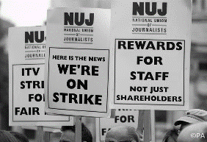
#2 Productivity deal
________________________________________________________________________________________________________________________________________________________________________________________________________________________________________________________________________________________________________________________________________
#3 Staff training

________________________________________________________________________________________________________________________________________________________________________________________________________________________________________________________________________________________________________________________________________
#4 Investment in new machinery and equipment

________________________________________________________________________________________________________________________________________________________________________________________________________________________________________________________________________________________________________________________________________
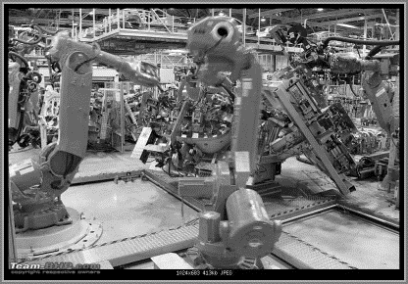
Factors influencing productivity

________________________________________________________________________________________________________________________________________________________________________________________________________________________________________________________________________________________________________________________________________
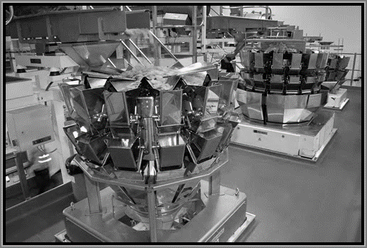
Link between productivity and competitiveness

________________________________________________________________________________________________________________________________________________________________________________________________________________________________________________________________________________________________________________________________________

Efficiency – draw the average cost curve here:

Costs and revenues
output

output

________________________________________________________________________________________________________________________________________________________________________________________________________________________________________________________________________________________________________________________________________

Productivity and efficiency

Labour costs and the impact on production choice:

